**Department of Computer Science**

Mid Term Project Proposal, Spring 20-21



|  |  |  |  |
| --- | --- | --- | --- |
| Course Title | ADVANCED PROGRAMMING IN WEB TECHNOLOGY | Section | A |

**Group Members:**

|  |  |  |
| --- | --- | --- |
| **Student ID** | **Name** | **Signature** |
| 18-37927-2 | Md. Ishtiyak Ali Rifat | Rifat |
| 18-37857-2 | Ahmmed, Ehsanul | Ehsan |
| 18-38341-2 | Rimon, Tajbiur Shahrior | Rimon |
| 18-38542-2 | Rahman, Mirza Md. Yasinur | YASINUR |

**Project Title:**

**Fundraising for Charity**

**Short Description:**

|  |  |
| --- | --- |
| Role Name | Description |
| Admin | Admin can sign-in, log-out, and check the organization's transaction report. Can enable, disable user accounts; beside creating the manager account. Can check all users account details. Admin can approve events by assigning managers. Can remove, approve pending events. Can check donor and organizer reports. Can check details of all the active, inactive and events. Can search for any event. Check notifications, send messages to managers. Can check top organizers and donors. Can check donors and organizers without any activities. Can check, remove any review for any event. Can change event requirements, such as changing managers. |
| Manager | Manger Can login into the system with Email and Password.Manager can edit information of his own. Manager can handle any info of any event assigned by Admin. Manager can see the organizer list and Donor list. He can also search for any donor and search for any organizer. Manager can recommend any donor about any events.Manager can send notices to any user. He can also publish the calculation monthly and annually. |
| Organizer | Organizer can sign up to the system and also can login into the system by providing an email and password. An organizer can view/edit/delete/donate/comment to a specific event or campaign. Mainly an organizer will organize the event of donation. Also the organizer can view a donor-wise summary of any event. |
| Donor | Donors can login to the system. They provide an email and password to login to the system. Donors edit their personal information and search the event list. Donors see details of any event and donate any amount.When Donors face any problem then contact the manager. The manager solved this problem. Donors can see their previous donation list and check their payment status. Donors can review the event summary report. |

**Modules:**

|  |  |  |
| --- | --- | --- |
| **Login Module (M1)** | |  |
| **Function** | Description | Database |
| **M1F1** | In the view of **Login page** in the route of  **“/login”** and there’ll be a html form having fields like **email & password,** and a login button to submit the form to the same route with post request. | N/A |
| **M1F2** | After receiving the **POST** request, the following form validation will be applied,  Validates using  **App\Http\Requests\loginRequest**   * Email validation. * Empty field validation. * Email existence validation (From database users table). | Match data from db table **“users”** and email and password columns **.** |
| **M1F3** | PHP Manual validation for password cross checking (From database users table). | Match data from db table **“users”** and columns **email** and **password.** |
| **M1F4** | If **email, password** are correct then the user will login to the system according to their roles and also the name will be stored in session | N/A |

|  |  |  |
| --- | --- | --- |
| **Logout Module (M2)** | |  |
| **Function** | Description | Database |
| **M2F1** | There is a logout function in our project which will flush all the data that were saved in session | N/A |

|  |  |  |
| --- | --- | --- |
| **Signup Module (M3)** | |  |
| **Function** | Description | Database |
| **M3F1** | In the view of Module **M1F1** a Register link will be added referring to the route **“/signup”** | N/A |
| **M3F2** | In the view there’ll be a html form having fields **name, email, gender, Address, Phone, Password, Confirm Password** and a **Signup** button to submit the form to the same route with a post request. | N/A |
| **M3F3** | Validates using Laravel  **App\Http\Requests\createCampaign**   * Empty field validation * Email validation * Existing email valid   Password and Confirm password validation  If everything is fine, your **name, email, gender, Address, Phone, Password** will be stored in the database. After that user will redirect to **M1F1** | Match data from db table **“users”.**  Stores **name=name, email=email, gender=gender, phoneNo=Phone, password=password**, to the db table **“users”** |

|  |  |  |
| --- | --- | --- |
| **Organizer Dashboard module (M4)** | |  |
| **Function** | Description | Database |
| **M4F1** | After completing the **M1(login)** module, the organizer will automatically redirect to the organizer’s dashboard with a route address **“org_dashboard”.** Here he can see many running and active campaigns that were approved by the admin. | show all the values of the **events** table where status = **“active”** |

|  |  |  |
| --- | --- | --- |
| **Organizer Profile Details module (M5)** | |  |
| **Function** | Description | Database |
| **M5F1** | In the Organizer’s dashboard **M1 module** there is a **Profile** Button that will show all the Profile details of the organizer and the route of this functionality is **“org/details”.** | find the value of **“id”** column of the db table **“org”** |
| **M5F2** | In the view there’ll be an html form having fields **name, email, gender, address, phone, picture** and a Edit button to move to the Edit section | take all properties like **name, email, gender, address, phone, picture** from **“org”** table |

|  |  |  |
| --- | --- | --- |
| **Organizer Profile Edit module (M6)** | |  |
| **Function** | Description | Database |
| **M6F1** | In the List of Module **M5F1** a **Edit** Button will be added to Edit row referring the route  **“org/{id}/editProfile”.**  Here the id parameter holds the organizer id. Also it will show the previous data. | Uses the value of **“id”** column of the db table **“org”** |
| **M6F2** | In the view there’ll be an Update button. After giving input to the field a POST request will be triggered and update all the previous data according to thor id | Used the value **“id”** column of the DB table **“org”** and update name=newName, email=newMail, gender=newGender, address=newAddress, phone=newPhone, image=newImage. |

|  |  |  |
| --- | --- | --- |
| **Organizer Campaign Search module (M7)** | |  |
| **Function** | Description | Database |
| **M7F1** | In the module of **M4 (organizer dashboard)** there is a search bar where the organizer can give input as a string to find a specific event or campaign. | N/A |
| **M7F2** | After pressing the search button with a valid input, a post request will be reported in the route of **M4F1 (dashboard)** and show the events according to its Title | Select **all the data** from the table **event** where  **title=searchedTitle** |

|  |  |  |
| --- | --- | --- |
| **Organizer Create Campaign module (M8)** | |  |
| **Function** | Description | Database |
| **M8F1** | In this module, there is a dropdown option in the navbar called **“manage”** also under that option there is “**Create New”** that will redirect to the new html form to create new campaign with a route **“org/create”.** | N/A |
| **M8F3** | Validates using Laravel  **App\Http\Requests\createCampaign**   * field required   After submitting the html form correctly , a POST request will be triggered in the same route address and save all the information into the event table in the database. | insert into **events** where title=title, startdate=sDate, endDate=eDate, raiseAmount=raiseGoal, description=desc, image =img |

|  |  |  |
| --- | --- | --- |
| **Organizer’s Created Campaign display module (M9)** | |  |
| **Function** | Description | Database |
| **M9F1** | In this module, there is a dropdown option in the navbar called “manage” also under that option there is “**My Campaign”** that will redirect to the Campaigns that was created by that specific organizer | Show all the data from the eventtable where **orgID={id}** |

|  |  |  |
| --- | --- | --- |
| **Organizer Edit Campaign module (M10)** | |  |
| **Function** | Description | Database |
| **M10F1** | In the **display module** there is an Edit button for a specific event. after pressing the edit button it will redirect to the event edit page with a html form holding all the event details information from the session with a route address **“/org/edit/{eventId}”.** | N/A |
| **M10F2** | After submitting the html form correctly , a POST request will be triggered in the same route address and save all the updated information into the event table in the database and automatically redirect to the user's dashboard | update data into **events** where title=title, startdate=sDate, endDate=eDate, raiseAmount=raiseGoal, description=desc. |

|  |  |  |
| --- | --- | --- |
| **Organizer Delete Campaign module (M11)** | |  |
| **Function** | Description | Database |
| **M11F1** | In this function, after pressing the delete button of an event it will generate a request to the admin/manager to delete this specific module | Update **status** in the table “event” |

|  |  |  |
| --- | --- | --- |
| **Organizer Event Donate Module (M12)** | |  |
| **Function** | Description | Database |
| **M12F1** | In the **organizer Dashboard M4F1** module thereis a button named **“Donate Now”.** This button will redirect to the Campaign details page with a route address  **“ /campaignDetails/{eventId}”** | Select **all the data** from the table **event** where **eventId=eventId** |
| **M12F2** | Also there is a **“Donate”**  button that will redirect to the transaction page with html form with a route address  **“/donate/transaction/{eventId}”** | N/A |
| **M13F3** | After submit the form with a valid amount it will create a POST request and save the raised amount in **“eventdonations”** table | insert amount=amount where **eventId=eventId** from the table **event and event donations.** |

|  |  |  |
| --- | --- | --- |
| **Organizer Donor List View Module (M13)** | |  |
| **Function** | Description | Database |
| **M13F1** | In the **Campaign Details Module** there is an option showing the total donor number. Basically it’s a link that will redirect you to the Donor-List for a specific Campaign with a route address “/donorlist/**{eventId}**”. | N/A |
| **M13F2** | In this function it will fetch data from “evendonation” table and show the donorId, Amount and Donation Date | Select DonorId, Amount, Date from “eventdonation” table where eventId=eventId |

|  |  |  |
| --- | --- | --- |
| **Organizer Comment Module in a specific Campaign (M14)** | |  |
| **Function** | Description | Database |
| **M14F1** | the organizer can comment on a specific Campaign. The comment option is in the router of  **“/campaignDetails/{eventId}”** | N/A |
| **M14F2** | After pressing the comment button it will generate a POST request and save the information in **“comments”** table | Insert into **comments** table where userId=uId,  description =comment, date=current date & time(); |
| **M14F3** | After posting a event an user can see all the comments for that specific event or Campaign | Select userId, description & date from comment where eventId=eventId; |

|  |  |  |
| --- | --- | --- |
| **Organizer Password Change Module (M15)** | |  |
| **Function** | Description | Database |
| **M15F1** | the user can Change his password with the help of his email address and the route address is **“/org/forgotPass”** | N/A |
| **M15F2** | After submitting the html form, a POST request will be generated and edit the password field in both **“users”** and **“org”** tables. | Update pass=newPass where email=mail from users and  org table |

|  |  |  |
| --- | --- | --- |
| **Manager event list module (M16)** | |  |
| **Function** | Description | Database |
| **M16F1** | **Event’s** listing view can be access by route **“/man_eventslist”** . In the view there will be a card having informations **Event_ID,Event_title,Ending_Date,Event’sInformation and Event Picture**. All the respective data will be shown from database. There will be a button call Event details. By clicking this any manger can see the Event details briefly. | Card will show the information **Event_ID,Event_title,Ending_Date,Event’sInformation and Event Picture**. |
| **M16F2** | Here anyone can see the details of any event brief details according to event ID in **/event_details/{Event_ID}** | Card will show the information **Event_ID,Event_title,Ending_Date,Event’sInformation and Event Picture**. |

|  |  |  |
| --- | --- | --- |
| **Manager Finished event module (M17)** | |  |
| **Function** | Description | Database |
| **M17F1** | in this **M17F1** module manager will see the view of Finished events and active events in one page and there will be a button called **add one** in **/man_eventdone** url | This page will show the active events and finished events with the event details . |

|  |  |  |
| --- | --- | --- |
| **Manager Eventreport (M18)** | |  |
| **Function** | Description | Database |
| **M18F1** | It will use the view of **M18F1**. There will be Three field called “**Event_ID” ,”Description” and “Amount”** . This will edit the data in database’s Event table. and the url will be /man_eventreport.   * Event_ID : Required * Description: Required * Amount: Required | Editing the value of **“Event_ID”,“Event_Description”,“RaisedAmount”** column of the db table **“events”** |
| **M18F2** | It will use the view of **M18F2**. There will be a card which will show the info of any events which will be taken from Database . This page will show in the url /man_eventreportinfo. | Uses the value of **“Event_ID”,“Event_Description”,“RaisedAmount”,“Event_title”,“Assigned_manager”** column of the db table **“events”** |

|  |  |  |
| --- | --- | --- |
| **Manager donorlist module (M19)** | |  |
| **Function** | Description | Database |
| **M19F1** | It will use the view of **M19F1**. There will be a table list view which will show the list of donors from Database. This page will show the information of Donor’s like **“Donor_id”**,**”Donor_Name”**,**”Email”,”Status”**. and the url will be **/man_donorlist.** | Showing the value of **“Donor_id”**,**”Donor_Name”**,**”Email”,”Status”** column of the db table **“users”** |

|  |  |  |
| --- | --- | --- |
| **Manager donor searching module (M20)** | |  |
| **Function** | Description | Database |
| **M20F1** | It will use the view of **M20F1**. There will be Two field called **donor_Id** ,**donor_name**. This will edit the data in database’s user table. and the url will be **/man_donorsearch**   * user_Id: Required * user_name: Required | searching the value of **“user_Id** **”,“user_name”** column of the db table **“users”** |
| **M20F2** | It will use the view of **M20F2**. There will be some fields which will show the info of any Donors which will be taken from Database table users . This page will show in the url **/man_donorsearch** | shows the value of **“user_Id** **”,“user_name”,“email”,”status”** column of the db table **“users”** |

|  |  |  |
| --- | --- | --- |
| **Manager organizer list module (M21)** | |  |
| **Function** | Description | Database |
| **M21F1** | It will use the view of **M21F1**. There will be a table list view which will show the list of donors from Database. This page will show the information of Donor’s like **“org_id”**,**”org_Name”**,**”Email”,”Status”**. and the url will be **/man_orglist.** | Showing the value of **“org_id”**,**”org_Name”**,**”Email”,”Status”** column of the db table **“org”** |

|  |  |  |
| --- | --- | --- |
| **Manager organizers searching module (M22)** | |  |
| **Function** | Description | Database |
| **M22F1** | It will use the view of **M22F1**. There will be Two field called **org_Id** ,**org_name**. This will edit the data in database’s user table. and the url will be **/man_orgsearch**   * org_Id: Required * org_name: Required | searching the value of **“org_Id** **”,“org_name”** column of the db table **“org”** |
| **M22F2** | It will use the view of **M22F2**. There will be some fields which will show the info of any Donors which will be taken from Database table orgs. This page will show in the url **/man_orgsearch** | shows the value of **“org_Id** **”,“org_name”,“email”,”status”** column of the db table **“org”** |

|  |  |  |
| --- | --- | --- |
| **Manager monthly calculation module (M23)** | |  |
| **Function** | Description | Database |
| **M23F1** | It will use the view of **M23F1**.There will be a table list which will show the information of **“TotalAmount”,”EventId”,”TransactionAmount”,”TransactionId”,”CommissionAmount”,”Date”** for monthly calculation.Each row will provide a button called **“Update”.** This will take to another page. This will show the data from database’s transaction table. and the url will be **/monthly_calc** | showing the value of **“TotalAmount”,”EventId”,”TransactionAmount”,”TransactionId”,,”CommissionAmount””Date”** column of the db table **“transactions”** |
| **M23F2** | It will use the view of **M23F2**. This page will take some value in different fields like **“TotalAmount”,”,”CommissionAmount””,”Date”** which will update in Database table **“Transactions”**. This page will show in the url /**man_monthlycalcupdate/{Transaction_id}**   * TotalAmount: Required * CommissionAmount: Required * Date: Required | Updates the value of **“TotalAmount”,”,”CommissionAmount””,”Date”** column of the db table **“Transactions”** |

|  |  |  |
| --- | --- | --- |
| **Manager Annual calculation module (M24)** | |  |
| **Function** | Description | Database |
| **M24F1** | It will use the view of **M24F1**.There will be a table list which will show the information of **“TotalAmount”,”EventId”,”TransactionAmount”,”TransactionId”,”CommissionAmount”,”Date”**for yearly calculation.Each row will provide a button called **“Update”.** This will take to another page. This will show the data from database’s transaction table. and the url will be **/yearly_calc** | showing the value of **“TotalAmount”,”EventId”,”TransactionAmount”,”TransactionId”,,”CommissionAmount””Date”** column of the db table **“transactions”** |
| **M24F2** | It will use the view of **M24F2**. This page will take some value in different fields like **“TotalAmount”,”,”CommissionAmount””,”Date”** which will update in Database table **“Transactions”**. This page will show in the url /**man_yearlycalcupdate/{Transaction_id}**   * TotalAmount: Required * CommissionAmount: Required * Date: Required | Updates the value of **“TotalAmount”,”,”CommissionAmount””,”Date”** column of the db table **“Transactions”** |

|  |  |  |
| --- | --- | --- |
| **Manager notices module (M25)** | |  |
| **Function** | Description | Database |
| **M25F1** | It will use the view of **M25F1**. There will be some fields which will insert the notices into the notices table in Database .This page will take the information of Notices like **“Notification_Id”**,**”Notification_Title”**,**”userId”,”Date”**. and the url will be /**man_notices**   * Notification_Id :Required * Notification_Title:Required * userId:Required * Date:Required | Showing the value of **“org_id”**,**”org_Name”**,**”Email”,”Status”** column of the db table **“notices”** |

|  |  |  |
| --- | --- | --- |
| **Manager feedback module (M26)** | |  |
| **Function** | Description | Database |
| **M26F1** | It will use the view of **M26F1**. There will be some fields which will insert the notices into the notices table in Database .This page will take the information of Notices like **“user_Id”**,**”Event_name”**,**”userId”,”Date”**. and the url will be **/man_feedback**   * user_Id:Required * Event_name:Required * userId:Required * Date:Required | Showing the value of **“org_id”**,**”org_Name”**,**”Email”,”Status”** column of the db table **“comments”** |

|  |  |  |
| --- | --- | --- |
| **Manager profile edit module (M27)** | |  |
| **Function** | Description | Database |
| **M27F1** | It will use the view of **M27F1**. This profile edit page will show the information about the manager logged into the system. It will take the information of the Manager from the Database table “**users”.**  The url is **/man_Profile** | Showing the value of **“user_id”**,**”user_Name”**,**”Email”,”Type”** column of the db table **“users”** |
| **M27F1** | It will use the view of **M27F1**. This profile edit page will update the information about the manager logged into the system. It will update the information of Manager from Database table “**users”**   * user_id : required * user_Name : required * Email: required * Type: required   The url is **/man_updateprof** | Updating the value of **“user_id”**,**”user_Name”**,**”Email”,”Type”** column of the db table **“users”** |

|  |  |  |
| --- | --- | --- |
| **Manager Sign-up done by Admin Module (M28)** | |  |
| **Function** | Description | Database |
| **M28F1** | In the Admin home page, in navigation bar, there is a link “Add Manager” which redirects referring to the route “/addManager” | N/A |
| **M28F2** | In the view there’ll be a html form having fields like **name, email, password. ‘Register’** button to submit the form to the same route with a post request. | N/A |
| **M28F3** | Validates using Laravel   * Empty field validation * Email validation * Existing email valid | Match data from db table **“users”** and email column**.** |
| **M28F4** | If everything is fine, user**name, email, password, type,** will be stored in the database. After that user will redirect to module User List(M30) | insert userName, email, password, type to “manager”, status = 1 in the users table |

|  |  |  |
| --- | --- | --- |
| **Transaction Report(M29)** | |  |
| **Function** | Description | Database |
| **M29F1** | In the Admin home page, in navigation bar, there is a link “Transactions” which redirects referring to the route “/transactions”, a get request | N/A |
| **M29F2** | The Yearly Transaction Report is shown such as Date, Organizer, Event Title, Commission, Amount, in table format. | find from users, transactions, events which matches the transactions eventId with events eventId and users userId with events userId |

|  |  |  |
| --- | --- | --- |
| **User List (M30)** | |  |
| **Function** | Description | Database |
| **M30F1** | In the Admin home page, in navigation bar, there is a link “Transactions” which redirects referring to the route “/userList”, a get request | N/A |
| **M30F2** | In the view there’ll be a html table contains User Name, Email, Type along with a button named “Check Profile”, which has a link ‘/user/profile/**userId**’, a get request. If the button is clicked, it redirects to that link. | find from users table. |

|  |  |  |
| --- | --- | --- |
| **Check user Profile and Change User Status (M31)** | |  |
| **Function** | Description | Database |
| **M31F1** | In the List of Module **M10,** if the ‘Check Profile’ button is clicked, it redirects to ‘/user/profile/**userId**’. In that view, there’ll be a html table contains Name, Email, Type, Status along with a button named “Change Status”. | find from users table. |
| **M31F2** | If the user status is active then status becomes inactive, vice versa; whenever the button is clicked. It then redirects to the same page, that is ‘/user/profile/**userId**’. | update column ‘status’ to 1 if 0; 0 if 1 from users table. |

|  |  |  |
| --- | --- | --- |
| **Donation Report (M32)** | |  |
| **Function** | Description | Database |
| **M32F1** | In the Navigation bar, there is a ‘Donation Report’ which redirects referring to the route “/donationReport/yearly”, a get request. | N/A |
| **M32F2** | In the view there’ll be a html table which consists ‘Year’ and ‘total amount’. The ‘Year’ data includes values along with links of that particular year. If the year’s value is clicked then it redirects to ‘/donationReport/monthly/**yearValue**’. | find from table eventDonations which contains sum of total amount, date in the year format, formatting the data with group by date. |
| **M32F3** | After clicking year value, it will be redirected to ‘/donationReport/monthly/yearValue’. There will be a html table which consists Month, Total Donation Amount. | find from table eventDonations which contains sum of total amount, date in the month format, where the year matches, formatting the data with group by date. |

|  |  |  |
| --- | --- | --- |
| **Donor List (M33)** | |  |
| **Function** | Description | Database |
| **M33F1** | In the Navigation bar, there is a ‘Donor List’ which redirects referring to the route “/donorList’, a get request. | N/A |
| **M33F2** | In the view there’ll be a html table which consists ‘User Id’, ‘User Name’ and ‘Total Amount’. Also in the view there are two links named, ‘Top Donor Details’ and ‘Non Donor List’. | sum of total amount, userId, userName, email from eventDonations and users, which matches users userId to eventDonations userId |

|  |  |  |
| --- | --- | --- |
| **Top Donor Details (M34)** | |  |
| **Function** | Description | Database |
| **M34F1** | In module Donor List, there is a link named “Top Donor Details”, redirects to ‘/topDonor’, a get request. If it is clicked then the html will show a table which shows User Id, Name, Total Donation, type, Email, Status | sum of total amount, userId, userName, email, type, status from eventDonations and users, which matches users userId to eventDonations userId, group by userId. Taking 1. |

|  |  |  |
| --- | --- | --- |
| **Non Donors (M35)** | |  |
| **Function** | Description | Database |
| **M35F1** | In module Donor List, there is a link named “Non Donor List”, redirects to ‘/nonDonorList, a get request. If it is clicked then the html will show a table which shows User Id, Name, Email along with a button named ‘Check Profile’. If this button is clicked the it will use the module “**Check user Profile and Change User Status**”; | finds userId, name, email from users table and the userId which does not exists in eventDonations table. |

|  |  |  |
| --- | --- | --- |
| **Organizer list (M36)** | |  |
| **Function** | Description | Database |
| **M36F1** | In the Navigation bar, there is a ‘Organizer Report’ which redirects referring to the route “/organizerList/report”, a get request. | N/A |
| **M36F2** | In the view there’ll be a html table which consists ‘User Id’, ‘User Name’, ‘Email’ and ‘Total No. of Events’ along with button named “Yearly Report”.. | SELECT COUNT(eventId) as numOfEvents, users.userId, email, userName FROM events, users WHERE events.status <> -1 AND users.userId = events.userId GROUP by userId |
| **M36F3** | If the button “Yearly Report” is clicked, it redirects to ‘/organizerReport/yearly/yearNumber’ | N/A |
| **M36F4** | In the view there’ll be a html table which consists ‘Year’’ and ‘**Total Raised Donation**’. | sum amount, year in date wise from table eventDonations, events where events eventId matches with eventDonations eventId |

|  |  |  |
| --- | --- | --- |
| **Non Organizer (M37)** | |  |
| **Function** | Description | Database |
| **M37F1** | In the Navigation bar, there is a ‘Non Organizer Report’ which redirects referring to the route “/nonOrganizerList”, a get request. | N/A |
| **M37F1** | In the Html page there is a table consists ‘Id’, ‘User Name’, “Email” along with a button named “Check Profile” which works as module “**Check user Profile and Change User Status”.** Also a link named Top Organizer Details’ which redirects referring to the route “/topOrganizerList”, a get request. Also, a button named “Check Profile” which works as same as module “**Check user Profile and Change User Status**”. | SELECT userId, userName, email FROM users WHERE userId NOT IN (SELECT userId FROM EVENTS where status <> -1) AND type = 'user' |

|  |  |  |
| --- | --- | --- |
| **Top Organizer Details (M38)** | |  |
| **Function** | Description | Database |
| **M38F1** | In module Donor List, there is a link named “Top Donor Details”, redirects to ‘/topDonor’, a get request. If it is clicked then the html will show a table which shows User Id, Name, Total Donation, type, Email, Status | SELECT SUM(raisedAmount) as raisedAmount, users.userId, userName, email, type, users.status FROM events, users WHERE users.userId = events.userId AND events.status = 0 GROUP BY userId ORDER BY SUM(raisedAmount) DESC LIMIT 1 |

|  |  |  |
| --- | --- | --- |
| **Notification (M39)** | |  |
| **Function** | Description | Database |
| **M39F1** | In the Navigation bar, there is a ‘Notice’ which redirects referring to the route “/admin/notice”, a get request. | N/A |
| **M39F2** | There is a table consists Notice Title, email, status, date along with a button named “Check” which redirects to ‘/admin/readNotice/**notificationId**’. Also there are buttons named ‘Sent Notices’, ‘Create New Notice’ | show title, date, notificationId, status, email from table notifications, receivers, users which matches the notifications notificationId with user notificationId |
| **M39F3** | If the “Check” button is clicked, it redirects to ‘/admin/readNotice/**notificationId**’. In that view, the noticeTitle, date, and Notice Details is displayed. | show title, date and message from notifications table.  update status to 1 if 0 from receivers table. |

|  |  |  |
| --- | --- | --- |
| **Sent Notification (M40)** | |  |
| **Function** | Description | Database |
| **M40F1** | In the Module M39F2, if the “Sent Notices” is clicked, it redirects to ‘/notices/checkSentNotices’. | N/A |
| **M40F2** | There is a table consists Notice Title, email, status, date along with a button named “Read” which redirects to ‘/notice/readSentNotices/**notificationId**’.  Also there are buttons named ‘Create New Notice’ | show title, date, notificationId, status, email from table notifications, receivers, users which matches the notifications notificationId with user notificationId |
| **M40F3** | If the “Read” button is clicked, it redirects to ‘/notice/readSentNotices/**notificationId**’. In that view, the noticeTitle, date, and Notice Details is displayed. | show title, date and message from notifications table. |

|  |  |  |
| --- | --- | --- |
| **Create New Notification (M41)** | |  |
| **Function** | Description | Database |
| **M41F1** | In the Module M39F2, if the “Create New Notices” is clicked, it redirects to ‘/admin/createNotice’. | N/A |
| **M41F2** | In the view there’ll be a html form having fields like **title, message description, a manager list in drop-down and ‘Send Notice’** button to submit the form to the same route with a post request. | take managers from users where the status is 1 from the users table |
| **M41F3** | Validates using Laravel  · *** Empty field validation | N/A |
| **M41F4** | If everything is fine, notificationId**, title, message, userId, date** will be stored in the database. After that, with a successful message, user will redirected to module **Notification (M39)** | insert into notification and receivers. |

|  |  |  |
| --- | --- | --- |
| **Event Search (M42)** | |  |
| **Function** | Description | Database |
| **M42F1** | In the admin dashboard there is a search bar which searches events. if keyword typed in textarea and the button name ‘Search’ is clicked, Active Events will be appeared which takes to the link ‘/userHomePage/events’. | find eventTitle, targetAmount from table “events” |

|  |  |  |
| --- | --- | --- |
| **Event details and Report (M43)** | |  |
| **Function** | Description | Database |
| **M43F1** | In the admin dashboard if “Check Details” button is clicked, it redirects to ‘/campaignDetails/{**eventId}**’. | N/A |
| **M43F2** | It then takes to module **M12F1** along with a link called ‘Check Review in Details’, which redirects to ‘/event/detailReviews/{eventId}’ | N/A |
| **M43F3** | In the admin dashboard if “Check Report” link is clicked, it redirects to ‘/event/smallReport/{**eventId}**’. | N/A |
| **M43F4** | If the “Check Report” is clicked, the html displays a table consists “No. of donors”, “Total Amount Raised”, “UserId”, “Name”, “Email”, “Title”, “Start Date”, “End Date”. | find sum total amount, userId, userName, email, title, startDate, endDate from years, eventDonation, events which matches the users userId with events userId, events eventId with eventDonations eventId, taking on in descending order. |

|  |  |  |
| --- | --- | --- |
| **Remove Comment (M44)** | |  |
| **Function** | Description | Database |
| **M44F1** | In the module M43F2, if the link called ‘Check Review in Details’, which redirects to ‘/event/detailReviews/{eventId}’ | N/A |
| **M44F2** | In the page, it shows userName, email, date, description along with a button named “Remove Comment” | find userName, email, date, description from table users, comments, events where the users userId matches with the events userId and events eventId matches with the comments eventId |
| **M44F3** | If the “Remove Comment” button is clicked it removes the comment with a successful message and redirects to the same page, that is ‘/event/detailReviews/{eventId}’ | remove from comments where commentId is the id |

|  |  |  |
| --- | --- | --- |
| **Archived Event (M45)** | |  |
| **Function** | Description | Database |
| **M45F1** | In the Navigation bar, there is a ‘Archived Events’which redirects referring to the route “/event/archivedEvents”, a get request. | N/A |
| **M45F2** | In the view, list of events is displayed along with two buttons. If the button “Check Details” is clicked, module M43F1 will occur. If the button “Check Report” is clicked, module M43F4 occurs | find title, targetAmount from table events |

|  |  |  |
| --- | --- | --- |
| **Approve Event (M46)** | |  |
| **Function** | Description | Database |
| **M46F1** | In the Navigation bar, there is a ‘Event Request’ which redirects referring to the route “/events/eventRequest”, a get request. | N/A |
| **M46F2** | In the view, list of events is displayed along with two buttons. If the button “Check Details” is clicked, module M43F1 will occur. If the button “Check Report” is clicked, module M43F4 occurs | find title, targetAmount from table events |
| **M46F3** | If the button “Approve” is clicked, it redirects to “/eventRequest/approveForm/{eventId}” | N/A |
| **M46F4** | In the view page it show a form includes commission, select manager, starting date, ending date. It is also validated | find title, eventId from events |
| **M46F5** | If the “Approve” button is clicked, it validates the form. | N/A |
| **M46F6** | If Form is validated properly then it redirects to the admin dashboard with a successful message. | insert into events |

|  |  |  |
| --- | --- | --- |
| **Remove Event (M47)** | |  |
| **Function** | Description | Database |
| **M47F1** | In the module M43F2, if the button called ‘Remove Event’, which redirects to ‘/event/removeActiveEvent/{eventId}’ | N/A |
| **M47F2** | In the view, event title, target Amount data is shown | find title, targetAmount from table events |
| **M47F3** | If the button “Remove Confirm” is clicked, it redirects to the admin dashboard with a successful message. | update status to 0 for the eventId=eventId in the table events. |

|  |  |  |
| --- | --- | --- |
| **Update Event by assigning Manager(M48)** | |  |
| **Function** | Description | Database |
| **M48F1** | In the module M43F2, if the button called ‘Information’, which redirects to ‘/event/information/{eventId}’ | N/A |
| **M48F2** | In the view, event title, target Amount data along with existing Manger for event is shown, and can update event by changing the manager is shown | find title, targetAmount, userId, userName from table events, years where users userId matches with events userId and users userId status = 1 |
| **M48F3** | If the button “Update Event” is clicked, it redirects to the admin dashboard with a successful message. | update managerId in events |

|  |  |  |
| --- | --- | --- |
| **Search Event list Module(M49)** | |  |
| **Function** | Description | Database |
| **M49F1** | In the Donor home page, in the navigation bar, there is a link “Event_List” which redirects to the route “/Event_List”, a get request.  All the respective data of the Eventwill be shown from the database. | List will use db table  **“Event”** and columns **name, description, location.** |

|  |  |  |
| --- | --- | --- |
| **Donor Dashboard moduleModule (M50)** | |  |
| **Function** | Description | Database |
| **M50F1** | After completing the **M1(login)** module, the donor will automatically be redirected to the donor’s dashboard with a route address **“dashboard”.** Here he can see many running and active campaigns that were approved by the admin. | N/A |

|  |  |  |
| --- | --- | --- |
| **Modify Profile Information Module(M51)** | |  |
| **Function** | Description | Database |
| **M51F1** | After completing the **M1(login)** module, the will automatically redirect to the organizer’s dashboard with a route address **“org_dashboard”.** Here he can see many running and active campaigns that were approved by the admin.  It will use the view of **M51F1**. This profile edit page will show the information about the donor logged into the system. It will take the information of the Donor from the Database table “**user_table”.** | Showing the value of **“dname”**,**”password”**,**”gender”,”email”,”address”, ”phone”** column of the db table **“user_table”** |
| **M51F2** | In the view there’ll be a html form having fields **name, email, password** and a submit button to fire form submission to the same route with post request. | N/A |
| **M51F3** | It will use the view of **M51F1**. This profile edit page will update the information about the manager logged into the system. It will update the information of the Donor from the Database table “**user_table”**   * dname: required * password : required * gender : required * email: required * address:required * phone: required | Stores  **dname=name,password=password, gender=gender, email=email, address=address,phone=phone** to the db table **“user_table”** |

|  |  |  |
| --- | --- | --- |
| **See Organization Information (M52)** | |  |
| **Function** | Description | Database |
| **M52F1** | In the List of Module **M52F1** a **Organization Information** Button will be added to every row referring the route  **“/system/supportstaff/{id}/organization_information”.**  Here id parameter holds the staff id of a row. | Uses the value of **“id”** column of the db table **“Organization”.** |
| **M52F3** | After receiving the post request, the following form return will happen,   * Name: Required * email: Required | Valid Email | Unique * description: Required * location: Required | Length:4| Confirm     I | Find User from db table  **“Organization”** by **“id”**    return  **name=name,description=description, location=location, email=email, password=password** to the db table **“Organization”.** |

|  |  |  |
| --- | --- | --- |
| **Doner Information Delete (M53)** | |  |
| **Function** | Description | Database |
| **M53F1** | In the List of Module **M13F1** a **Delete** Button will be added to every row referring the route  **“/system/buscoutner/{id}/delete”.**  Here the id parameter holds the staff id of a row. | Uses the value of the **“id”** column of the db table **“user_table”** |
| **M53F2** | After confirm a virtual form will be submitted to the route of **M18F1** on **Delete** Request | N/A |
| **M53F3** | After receiving a delete request support staff will be retrieved from the database and will be removed. After then user will redirect to **M13F1** | Find User from db table **“user_table”** by **“id”**  Delete from db table  **“user_table”** by **“id”** |

**Access control:**

|  |  |
| --- | --- |
| **Role Name** | **Module(M), Functions(F)** |
| **Admin** | * **M1F1, M1F2, M1F3, M1F4** * **M2F1** * **M28F1, M28F2, M28F3, M28F4** * **M29F2, M29F1** * **M30F1, M30F2** * **M31F1, M32F2** * **M32F1, M32F2, M32F3** * **M33F1, M33F2** * **M34F1** * **M35F1** * **M36F1, M36F2, M36F3, M364** * **M37F1, M37F2** * **M38F1** * **M39F1, M39F2, M39F3** * **M40F1, M40F2, M40F3** * **M41F1, M41F2, M41F3, M41F4** * **M42F1** * **M43F1, M43F2, M43F3, M43F4** * **M44F1, M44F2, M44F3** * **M45F1, M45F2** * **M46F1, M46F2, M46F3, M46F4, M46F5, M46F6** * **M47F1, M47F2, M47F3** * **M48F1, M48F2, M48F3** |
| **Manager** | * **M1F1, M1f2, M1F3, M1F4** * **M2F2** * **M15F1,M15F2** * **M16F1,M16F2** * **M17F1** * **M18F1,M18F2** * **M19F1** * **M20F1,M20F2** * **M21F1** * **M22F1,M22F2** * **M23F1,M23F2** * **M24F1,M24F2** * **M25F1** * **M26F1** * **M27F1,M27F2** |
| **Organizer** | * **M1F1, M1f2, M1F3, M1F4.** * **M2F2.** * **M3F1, M3F2, M3F3.** * **M4F1.** * **M5F1, M5F2.** * **M6F2, M5F6.** * **M7F1, M7F2.** * **M8F1, M8F2.** * **M9F1.** * **M10F1, M10F2.** * **M11F1.** * **M12F1, M12F2, M12F3.** * **M13F1, M13F2.** * **M14F1, M14F2, M14F3.** * **M15F1, M15F2.** |
| **Donor** | * **M49F1** * **M50F1** * **M51F1 ,M51F2,M51F3.** * **M52F1, M52F2.** * **M53F1,M53F2,M53F3.** |

**Screenshots :**

**M1 (Login Module) :**

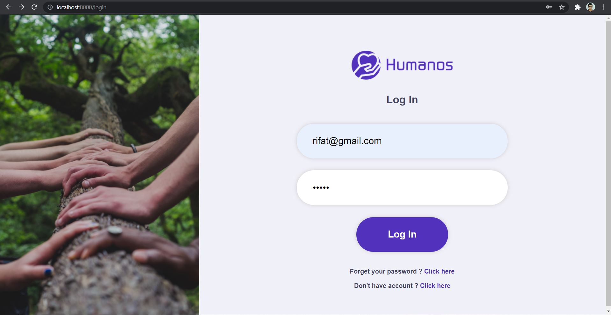

**M3 (SignUp Module) :**

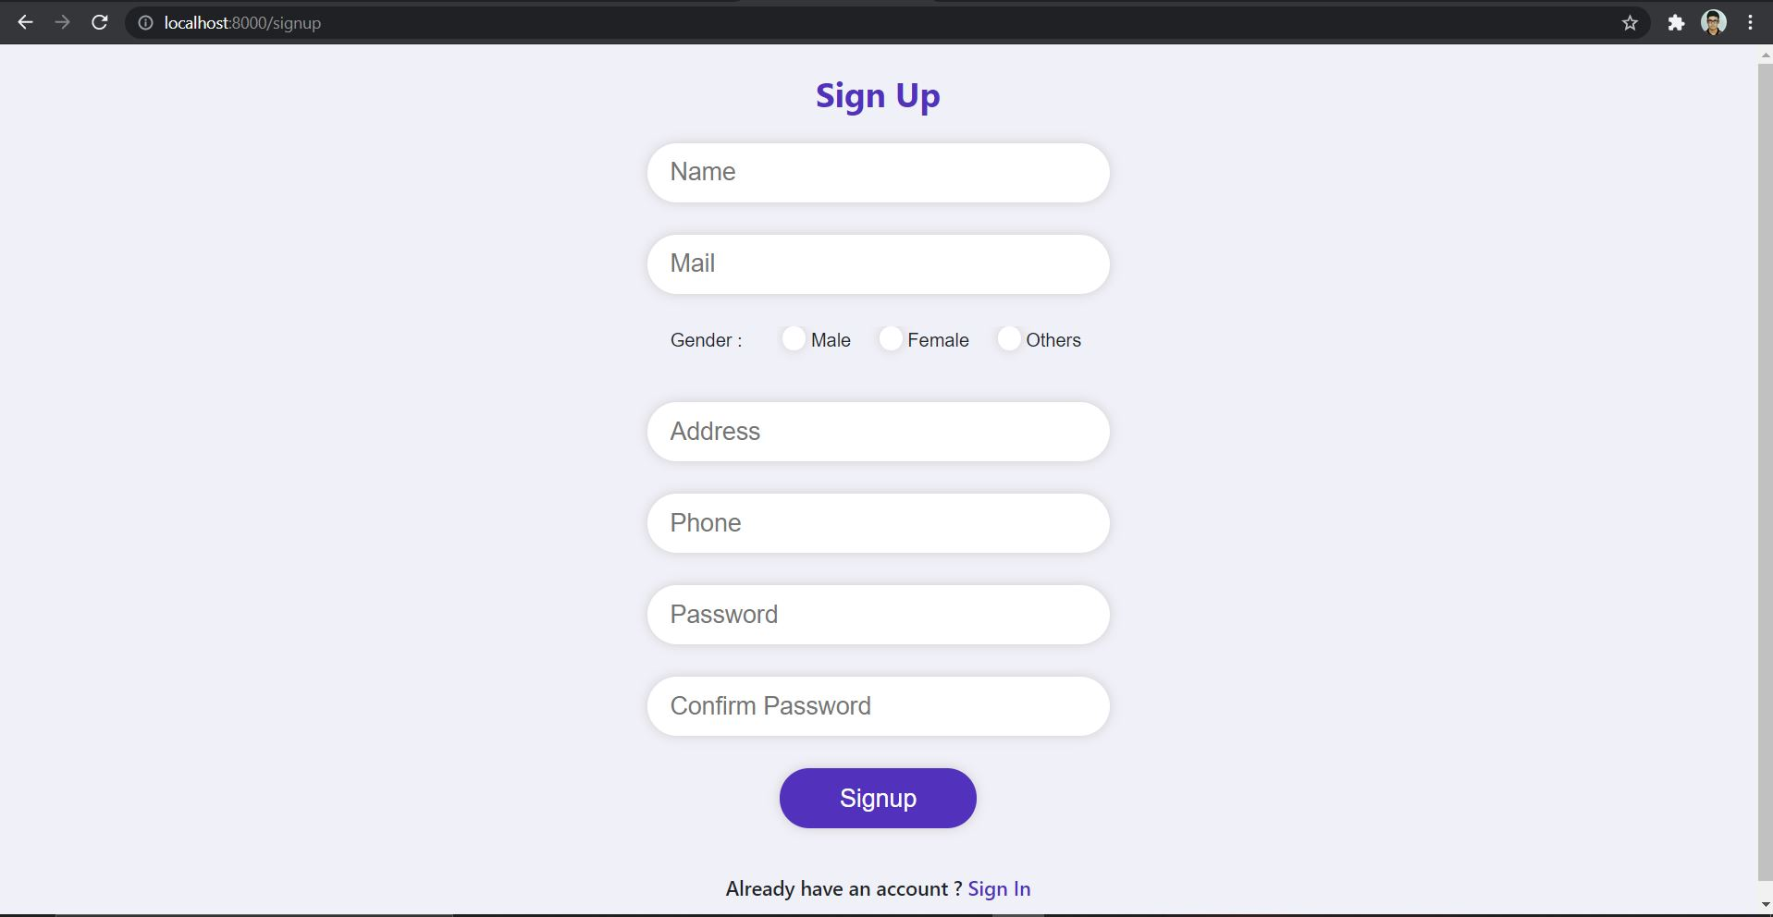

**M4 (Organizer Dashboard Module) :**

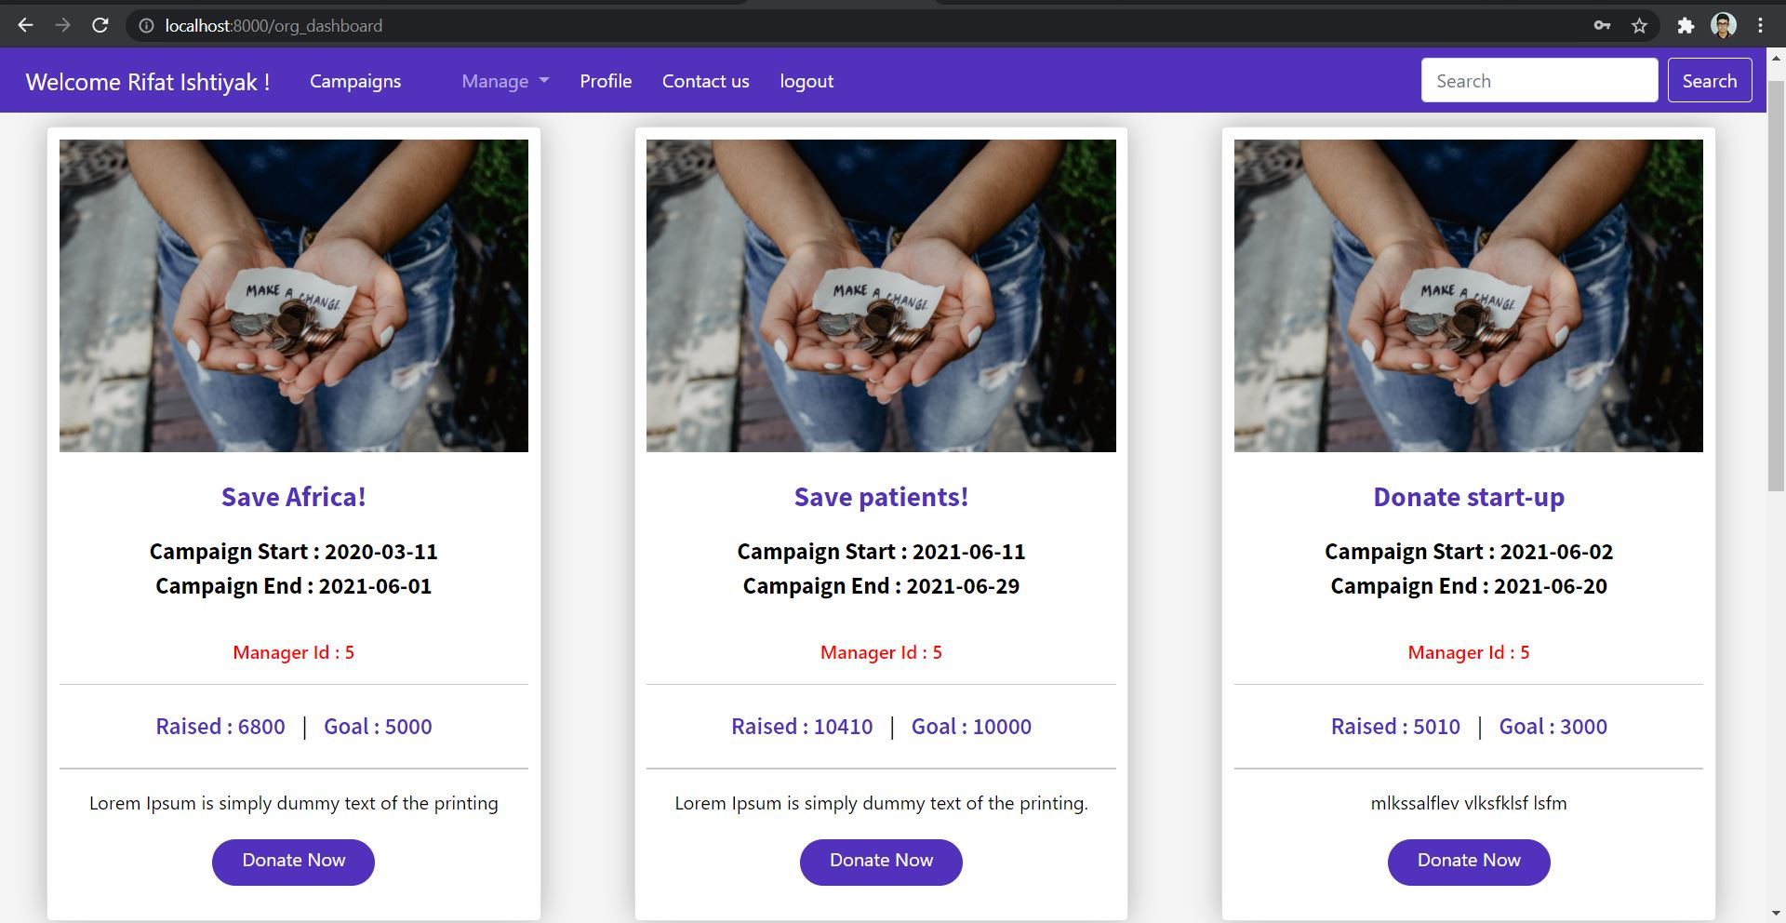

**M5 (Organizer Profile Details module) :**

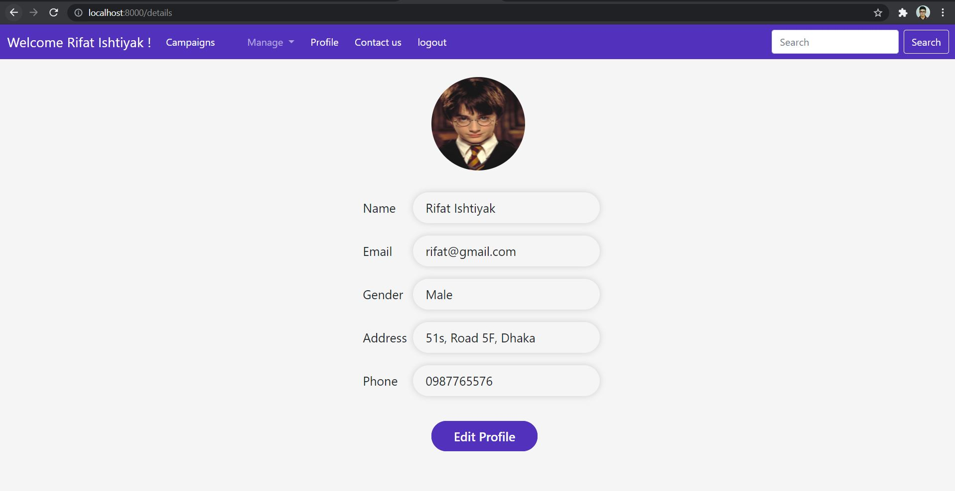

**M6 (Organizer Profile Edit module) :**

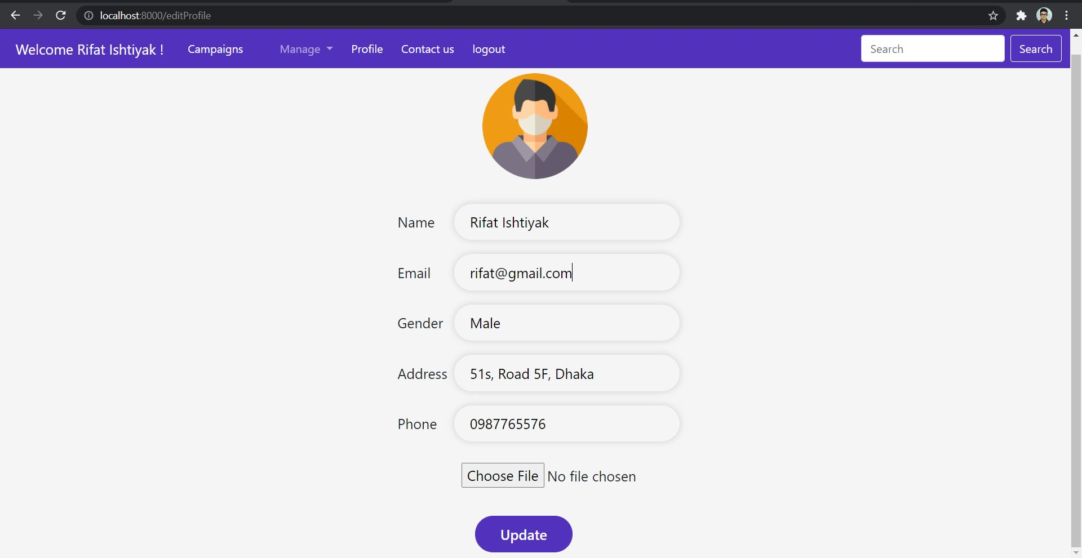

**M7 (Organizer Campaign Search module) :**

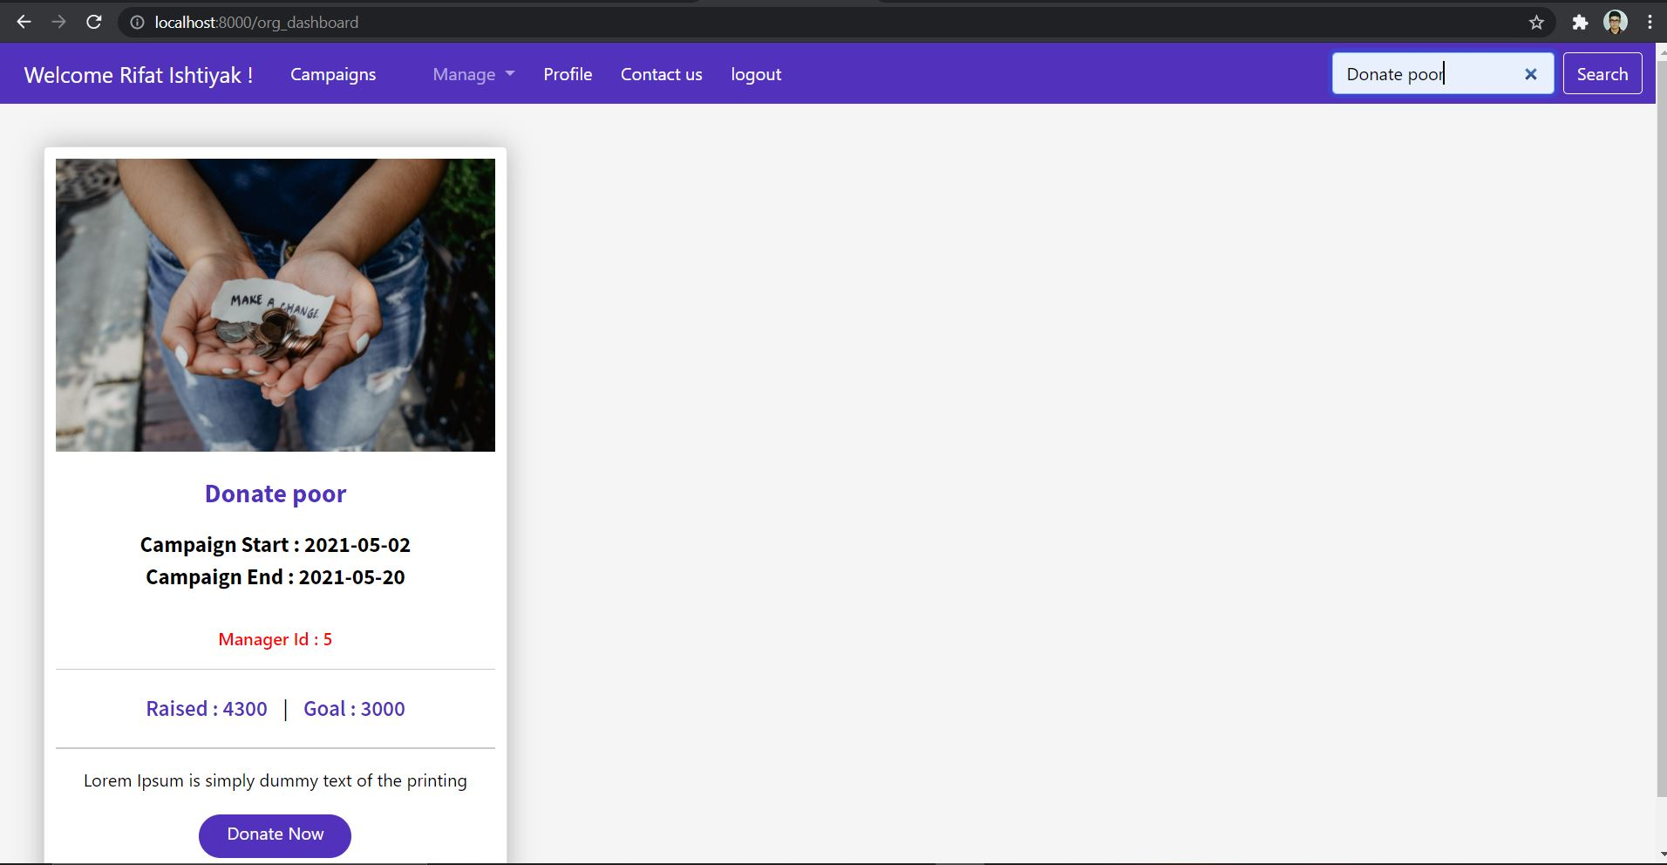

**M8 (Organizer Create Campaign module) :**

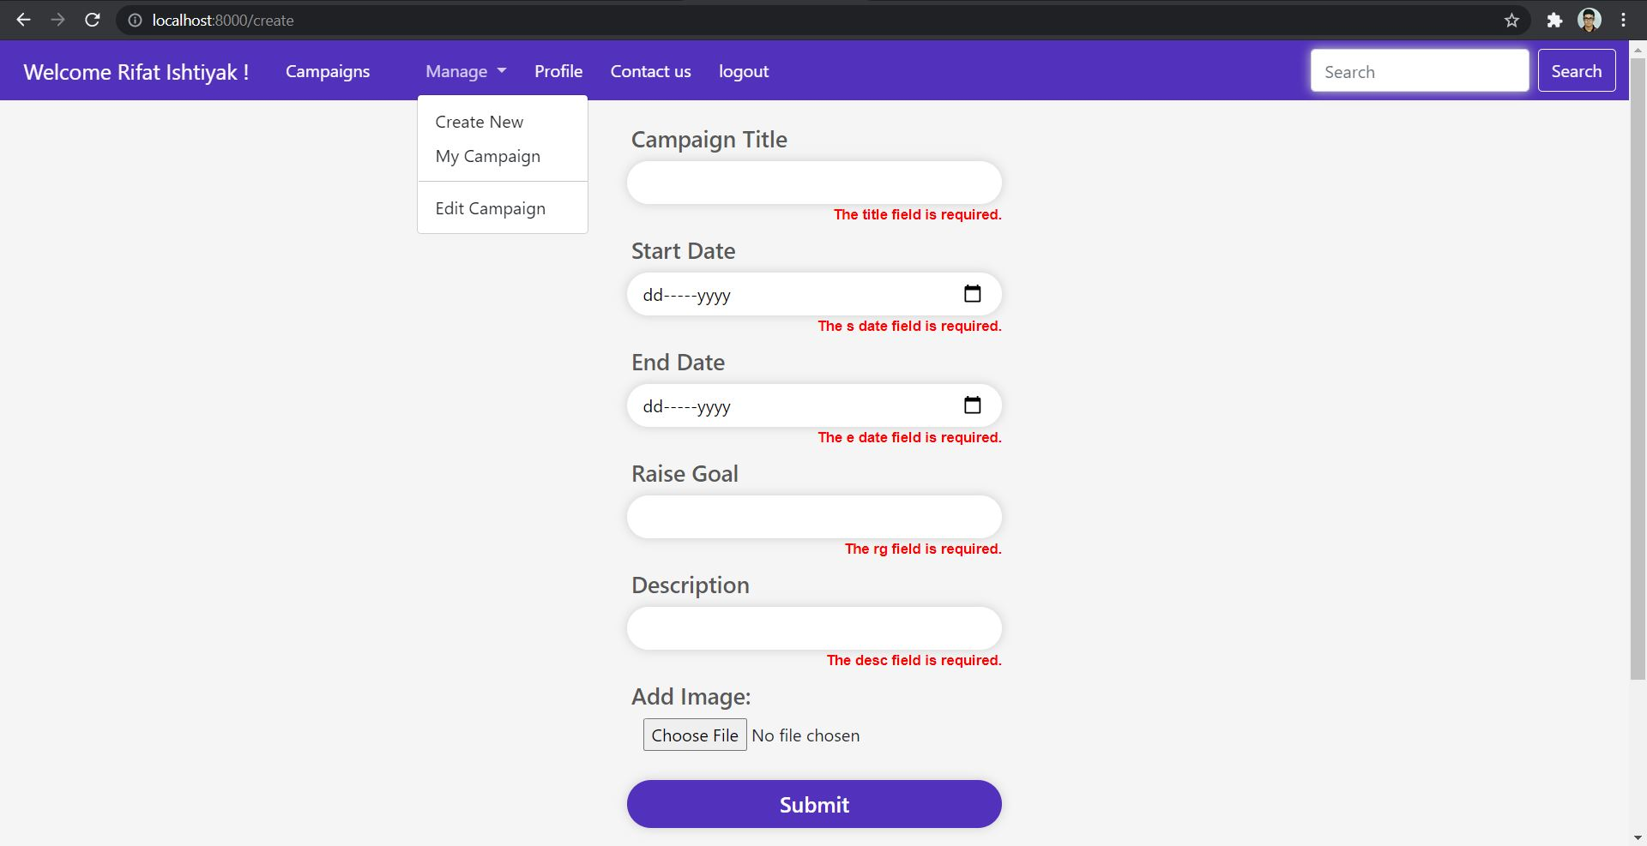

**M9 (Organizer’s Created Campaign display module) :**

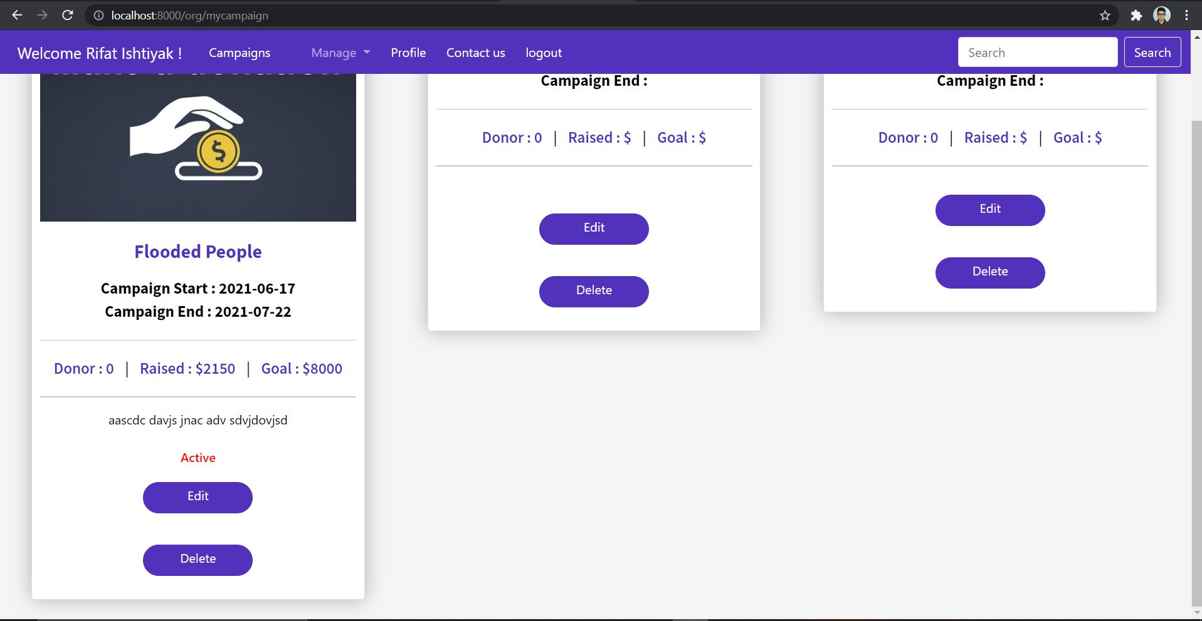

**M10 (Organizer Edit Campaign module) :**

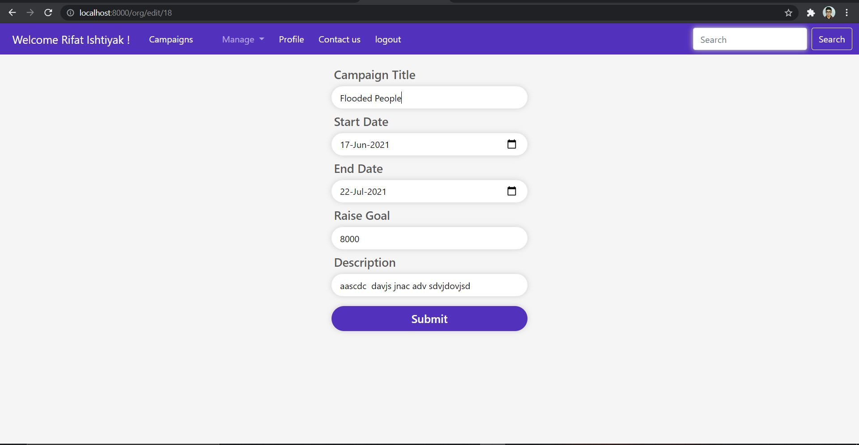

**M12 (Organizer Event Donate Module) :**

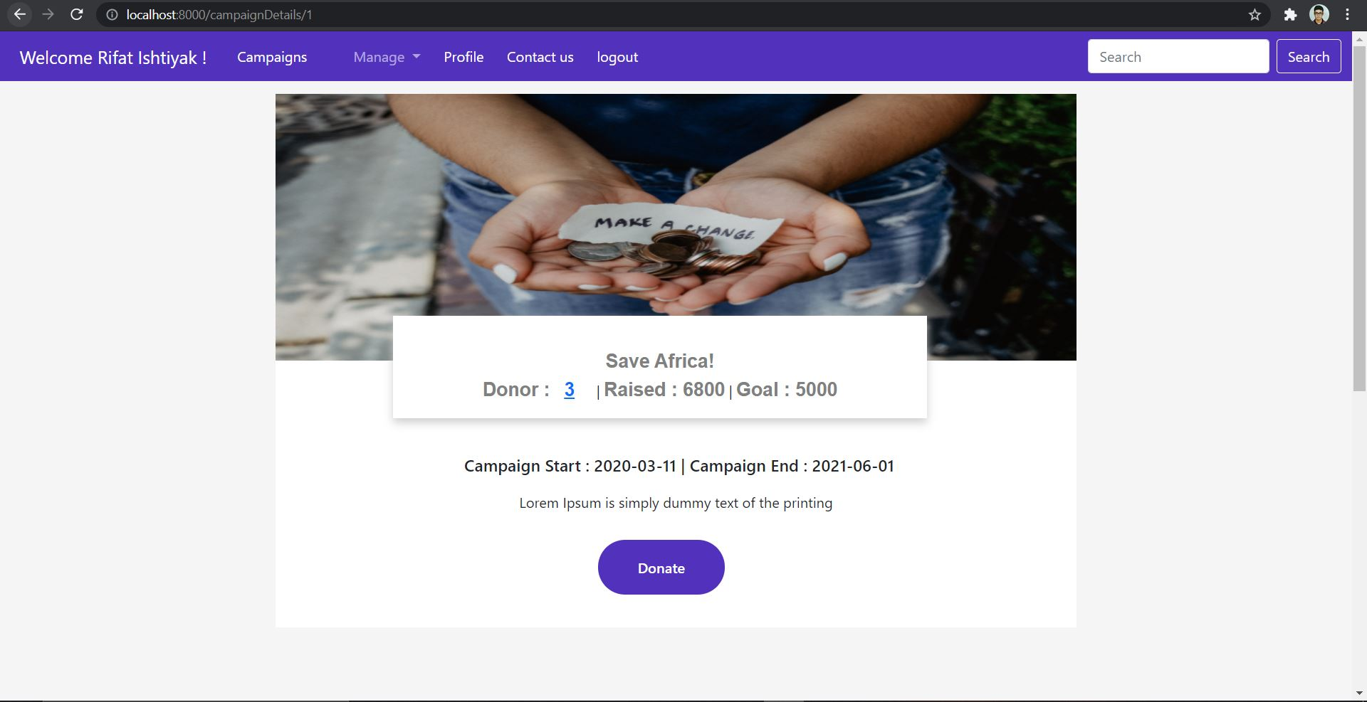

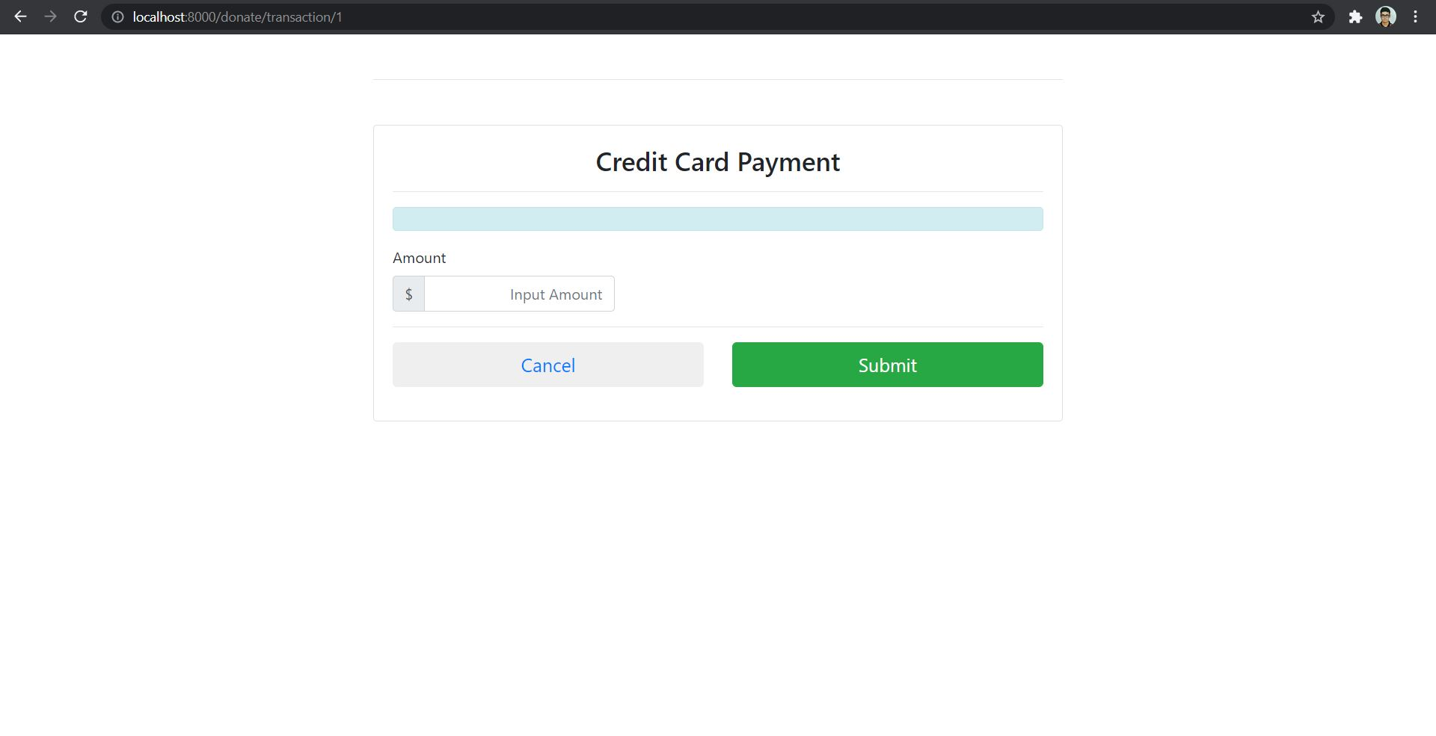

**M13 (Organizer Donor List View Module) :**

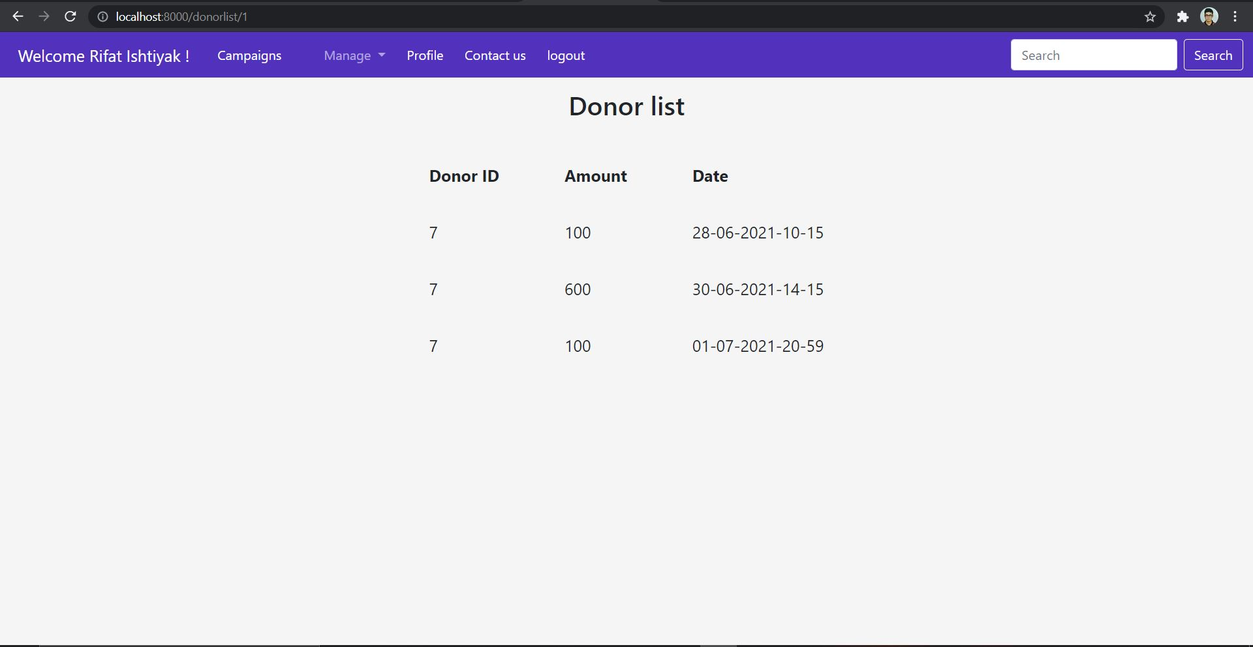

**M14 (Organizer Comment Module in a specific Campaign) :**

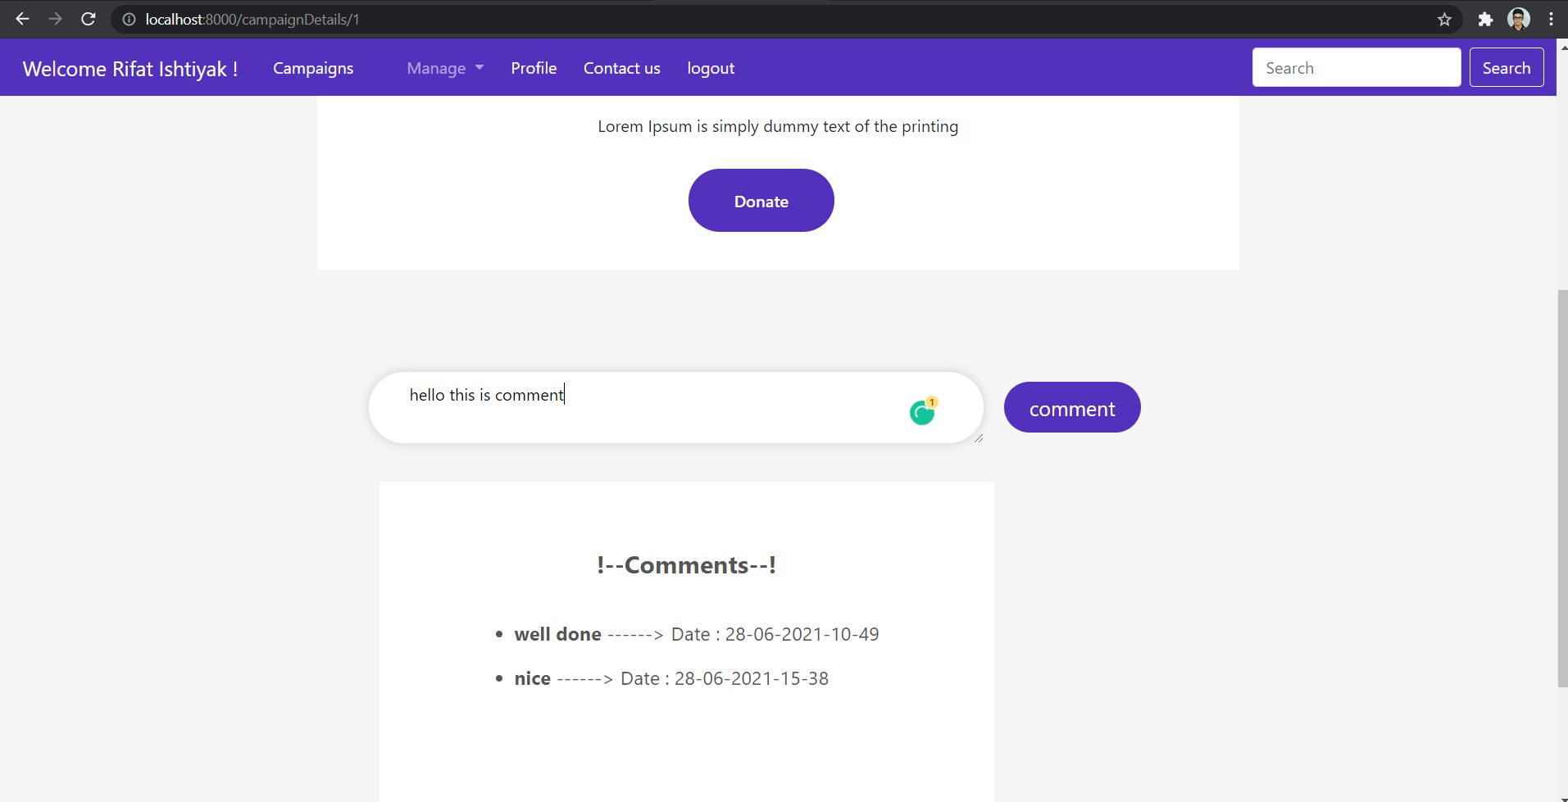

**M15 (Organizer Password Change Module) :**

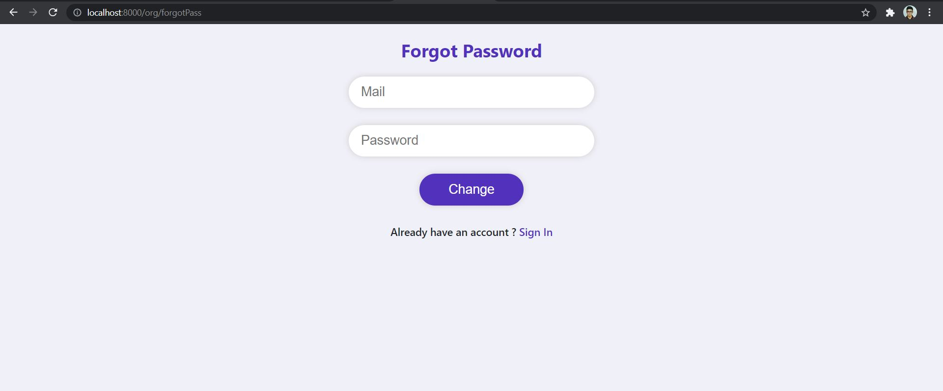

**M16F1(Manager_Events and dashboard):**

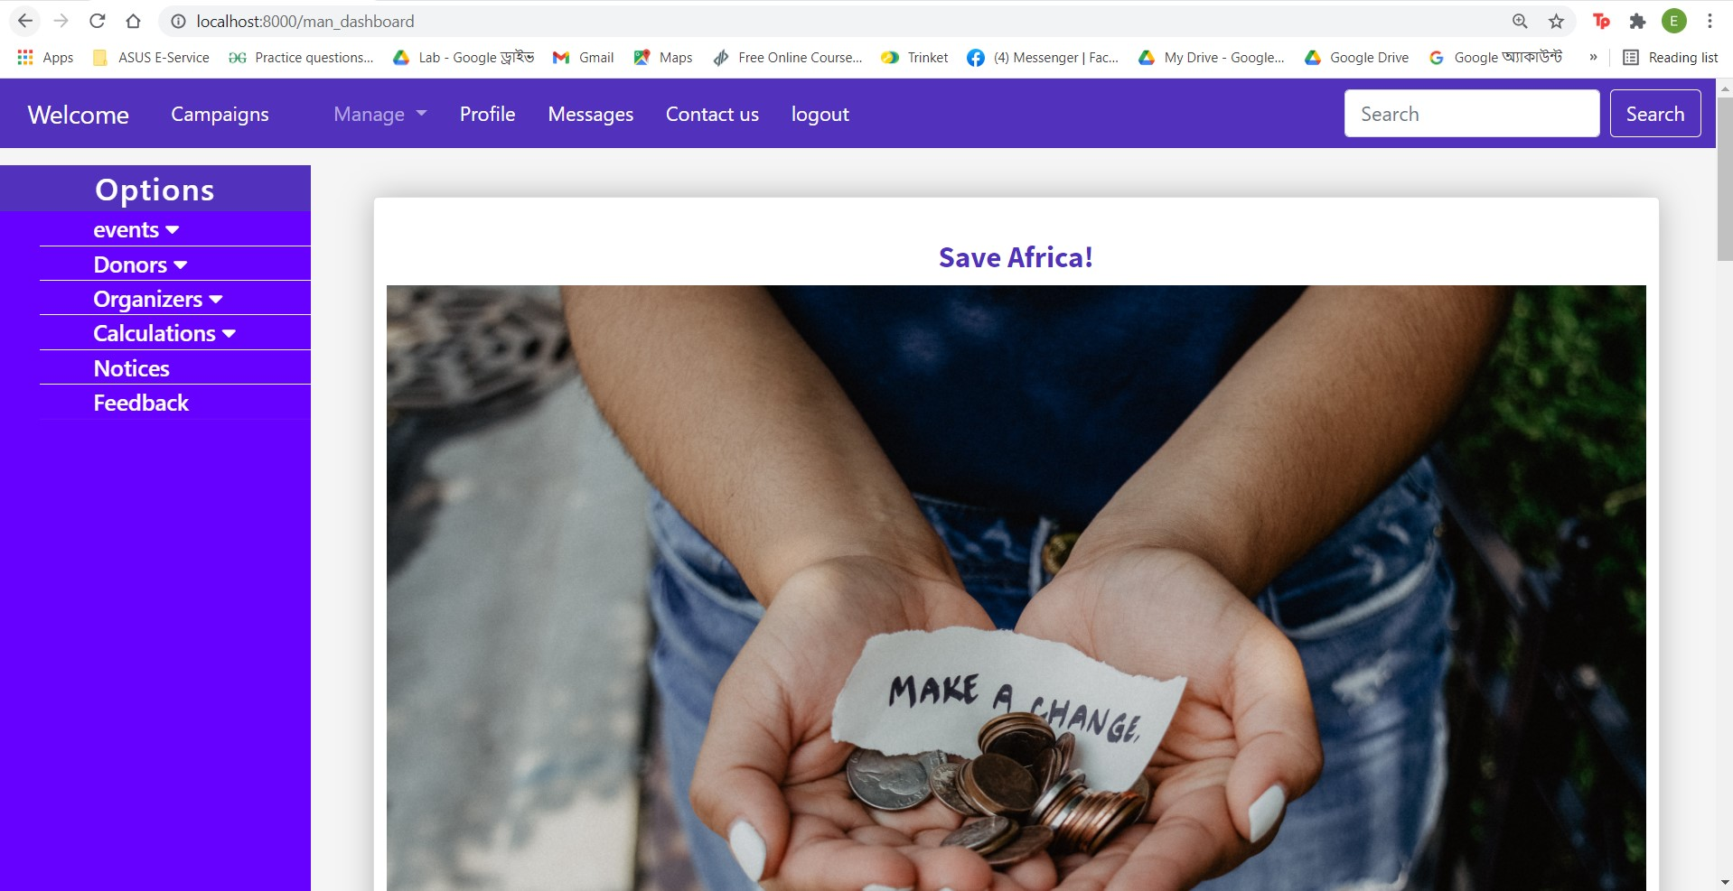

**Events_list:**

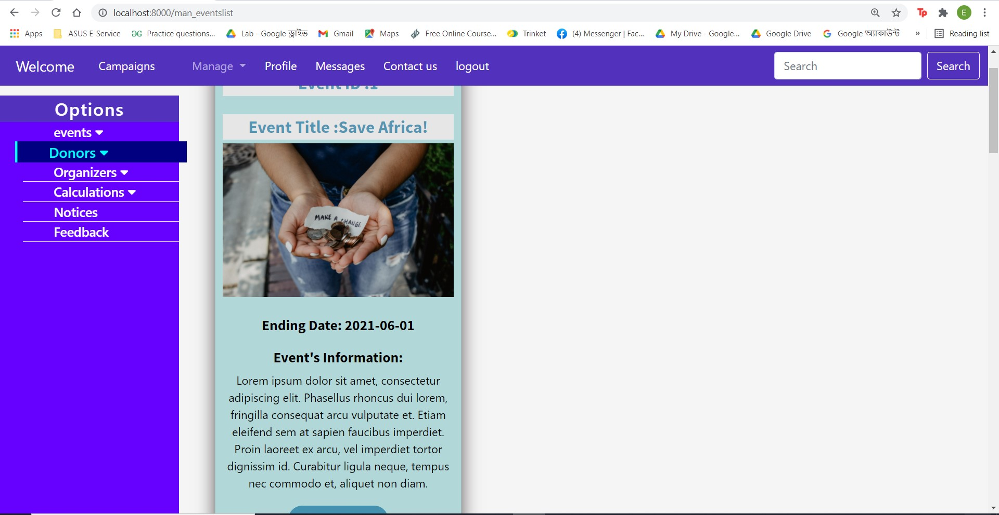

**M16F1( event list module):**

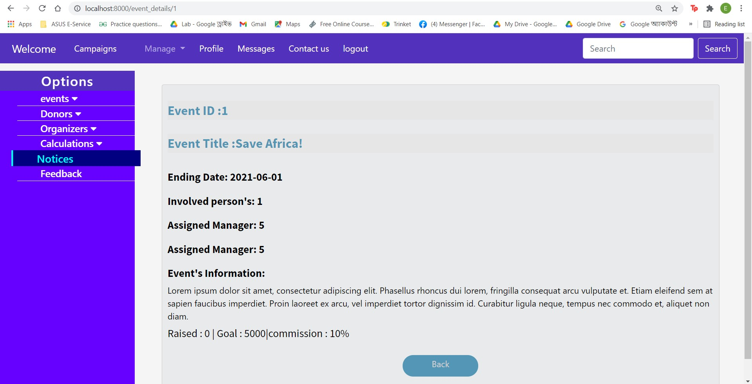

**M17F1:(Manager Finished event module):**

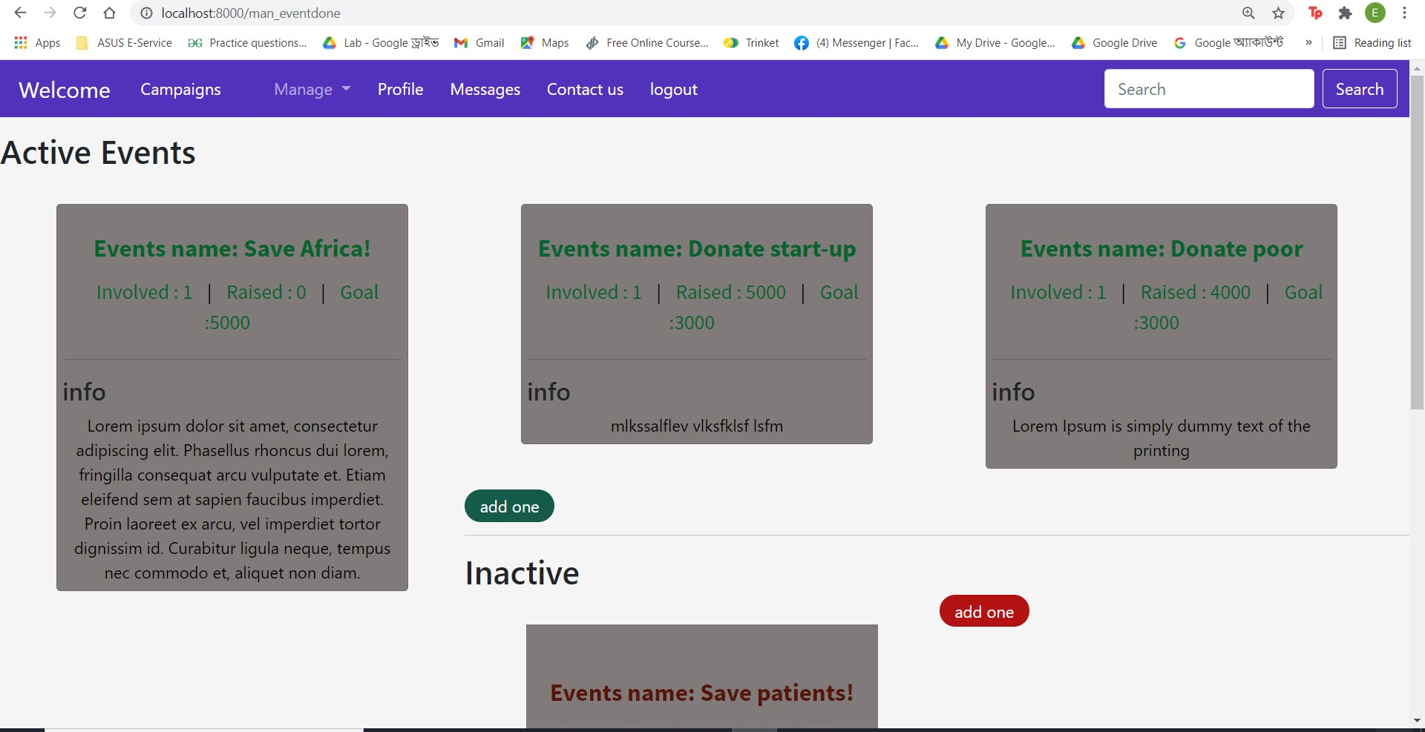

**M18F1 :(Manager Eventreport):**

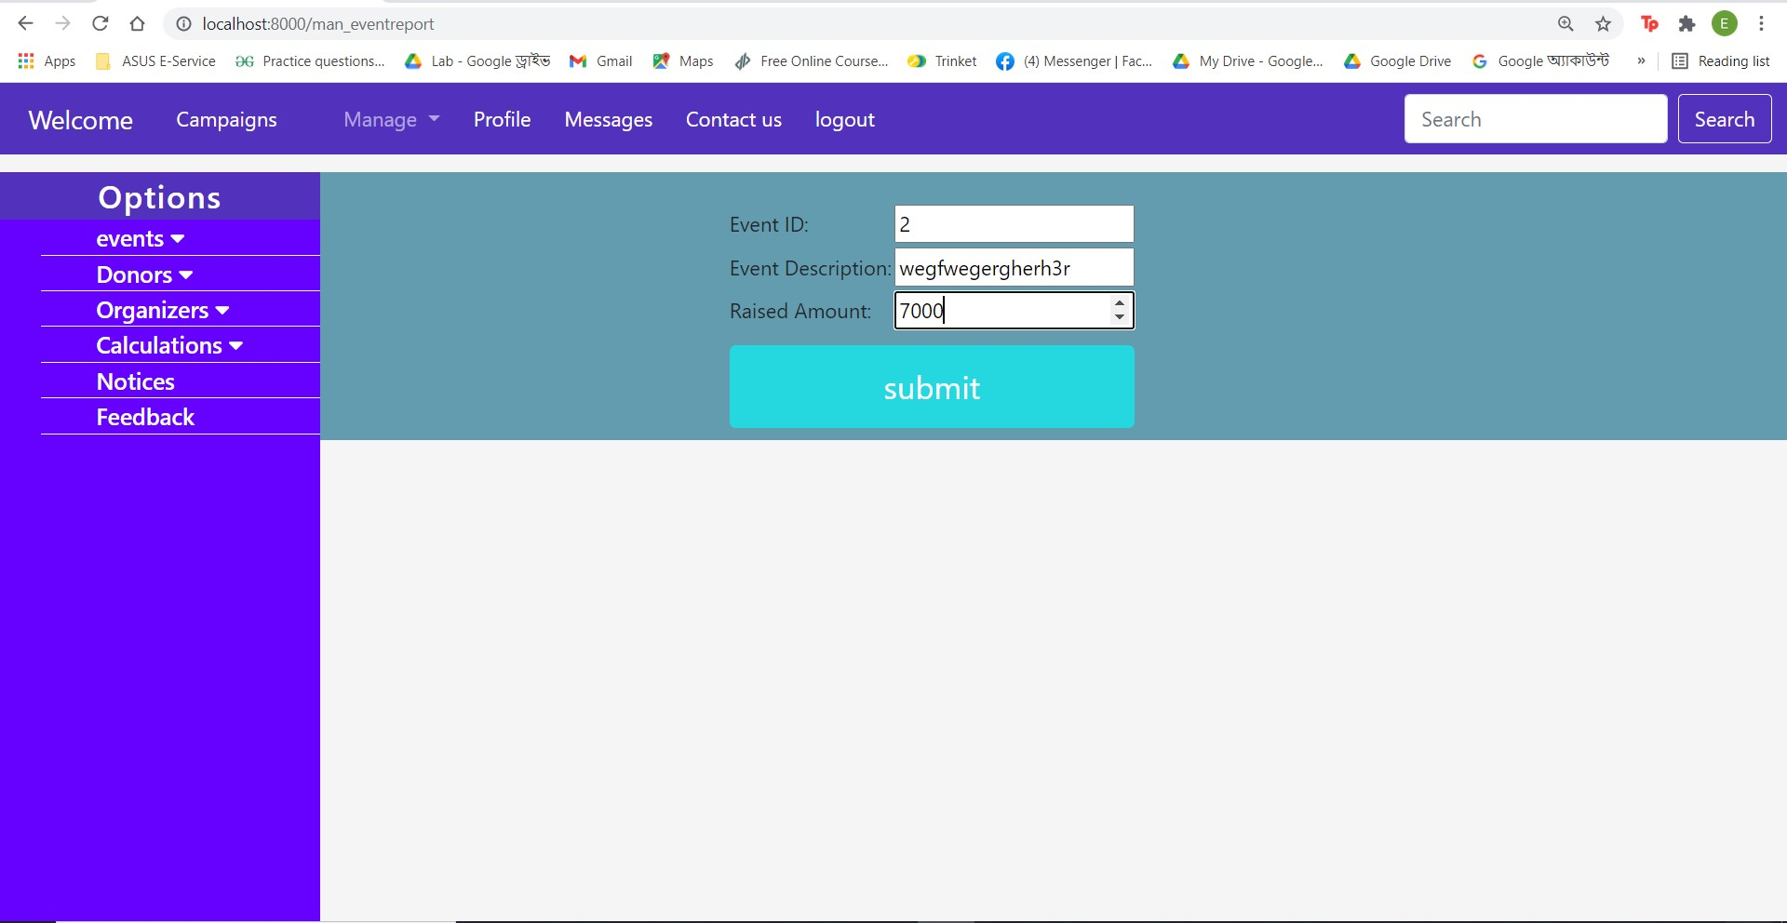

**M18F2:(Manager Eventreport):**

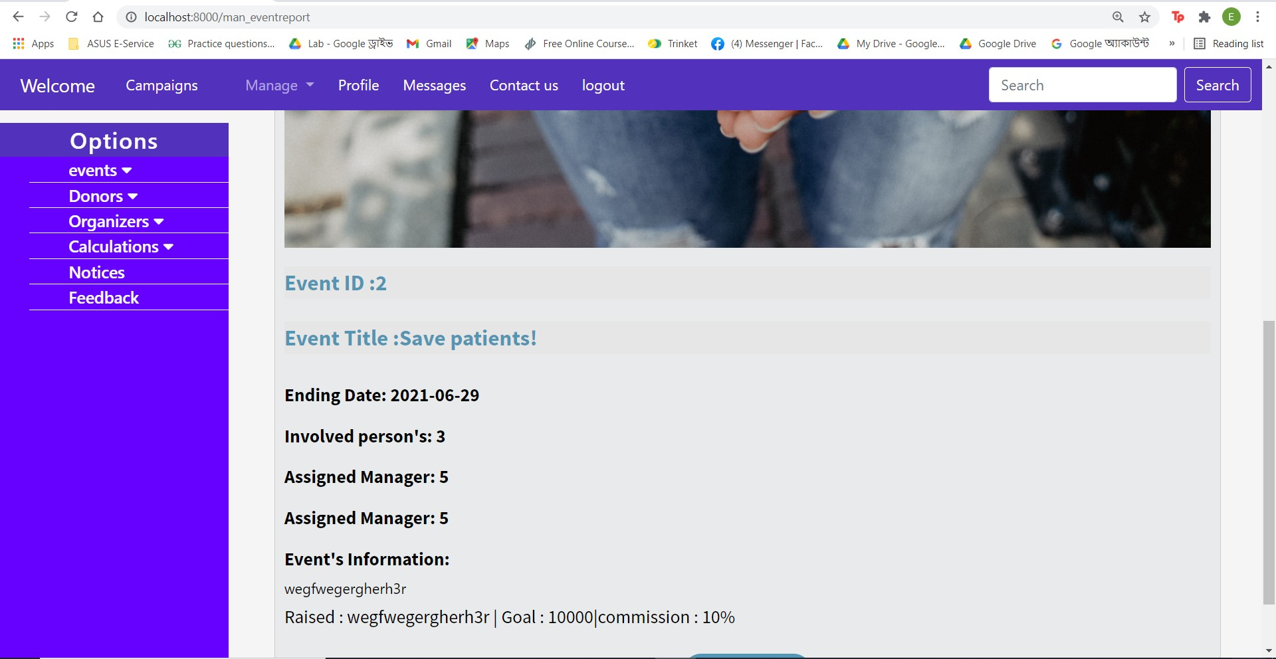

**M19F1:Manager donorlist module:**

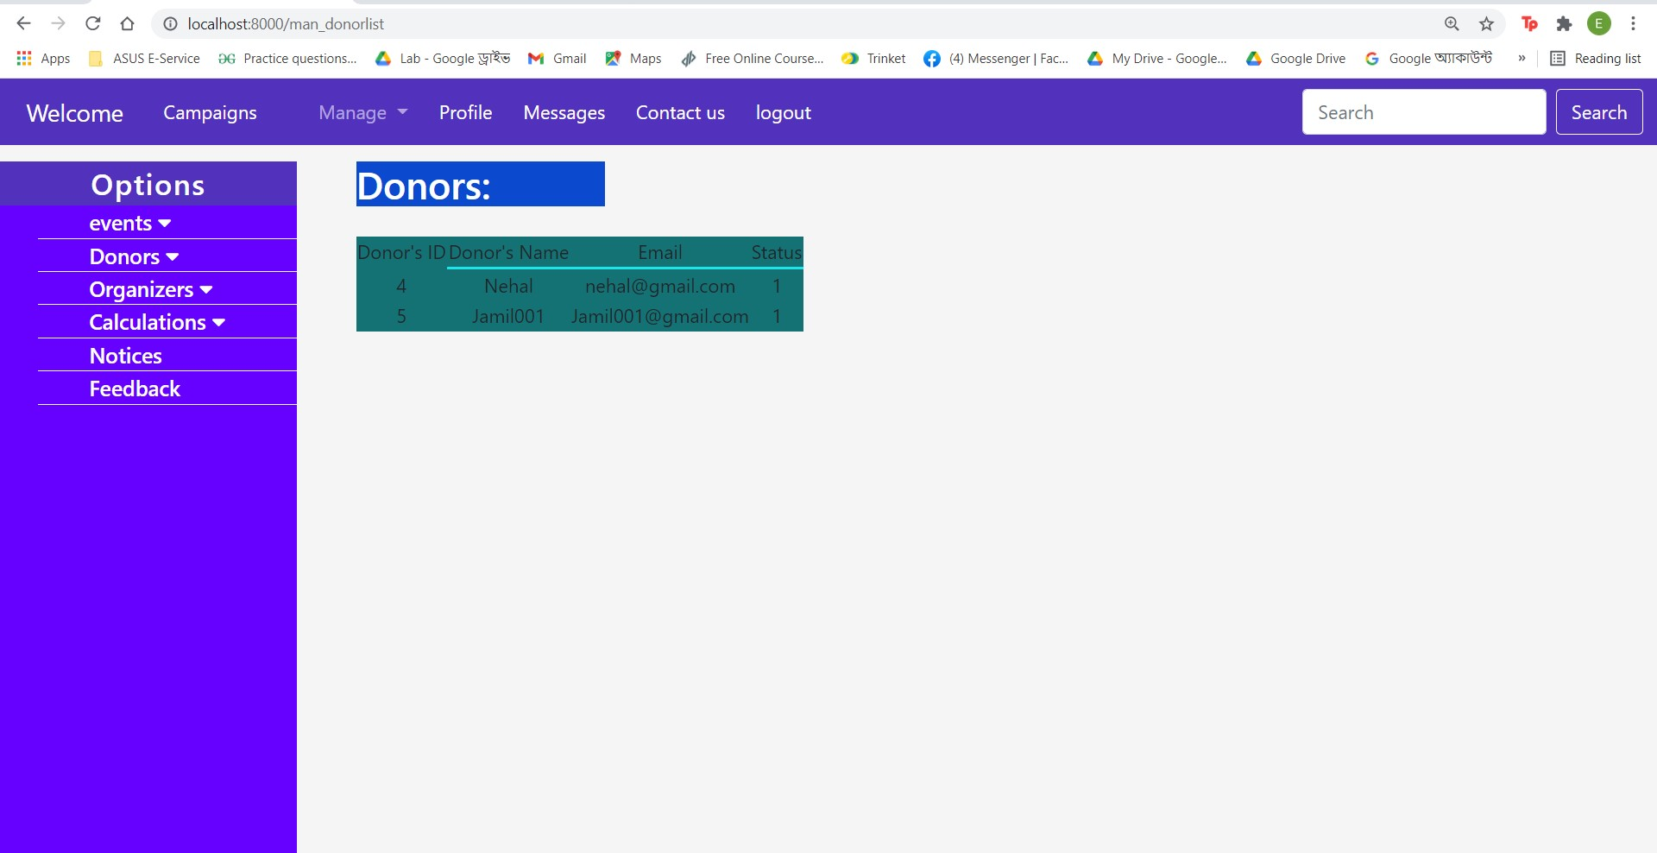

**M20F1:Manager donor searching module:**

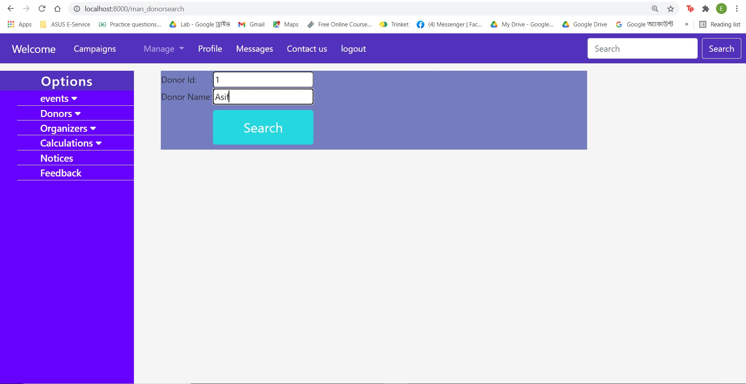

**M20F2:Manager donor searching module:**

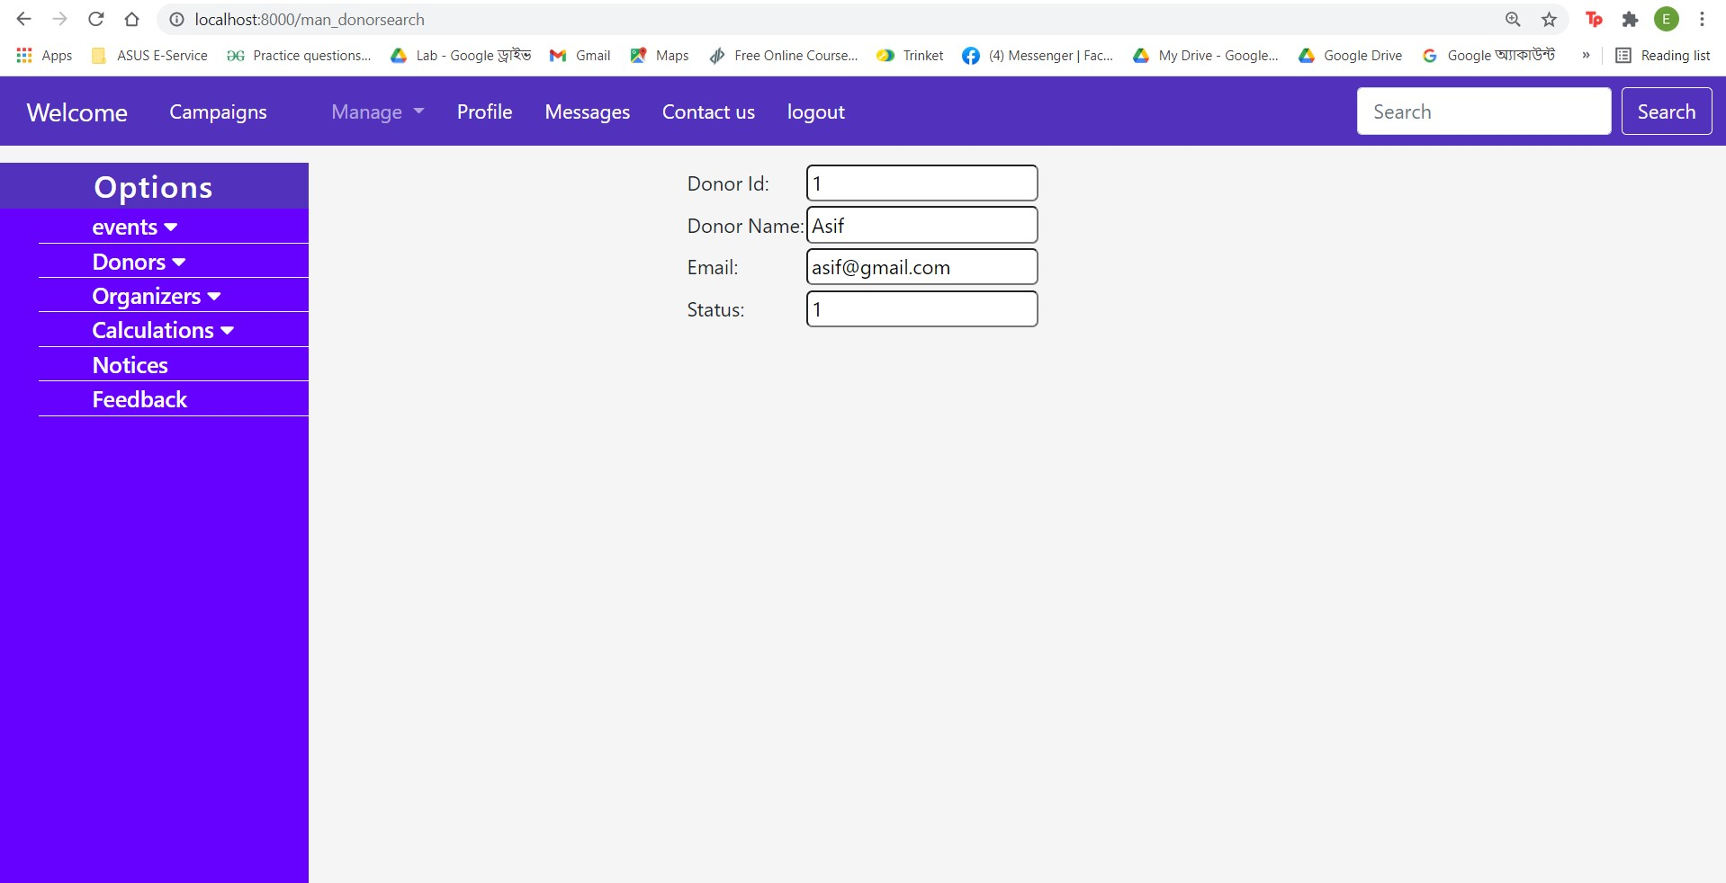

**M21F1:Manager organizer list module:**

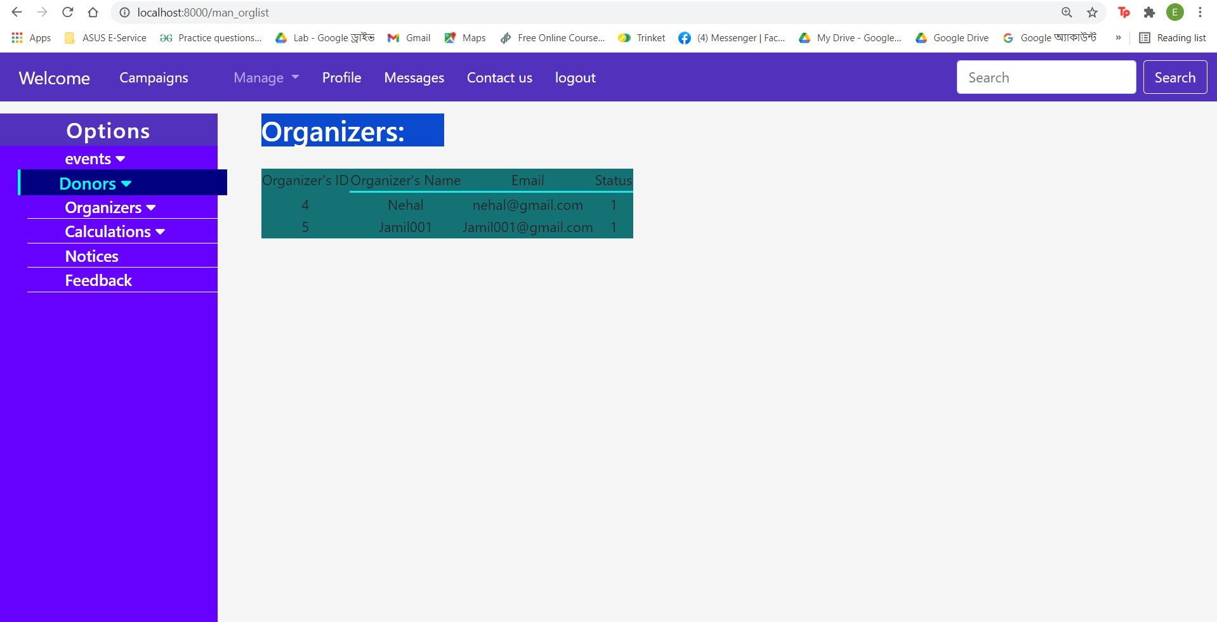

**M22F1:(Manager organizers searching module):**

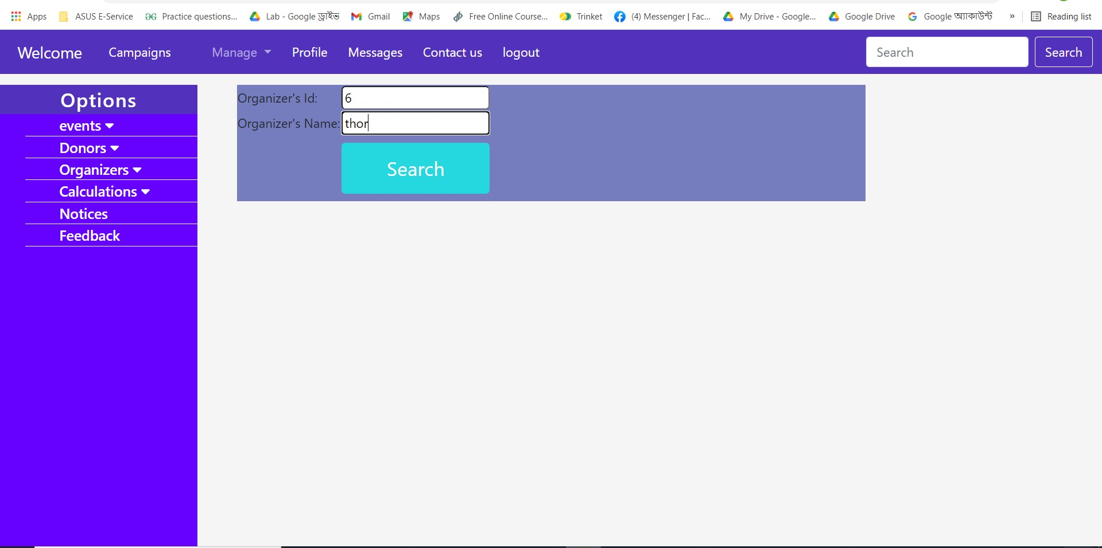

**M22F2:(Manager organizers searching module):**

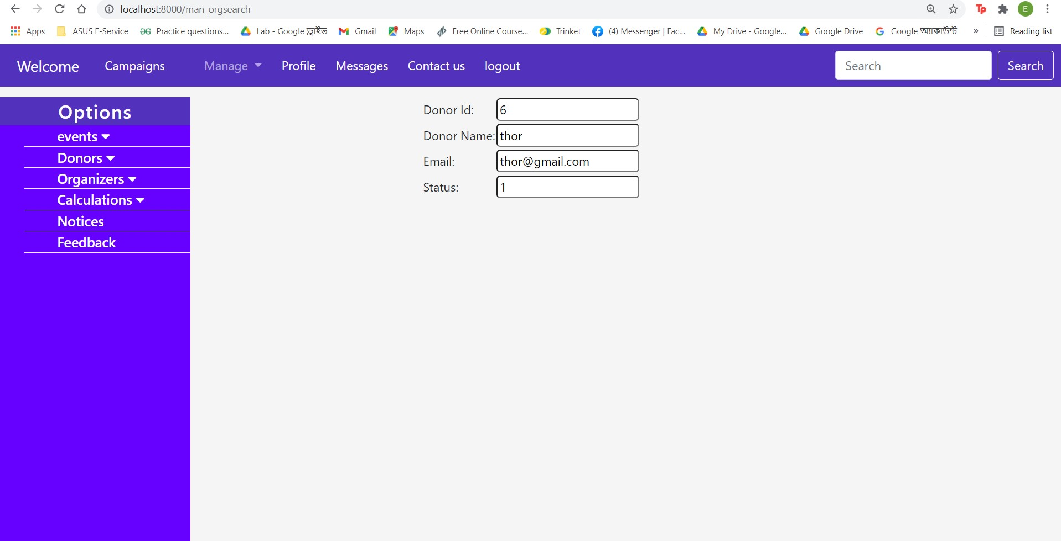

**M23F1:(Manager monthly calculation module):**

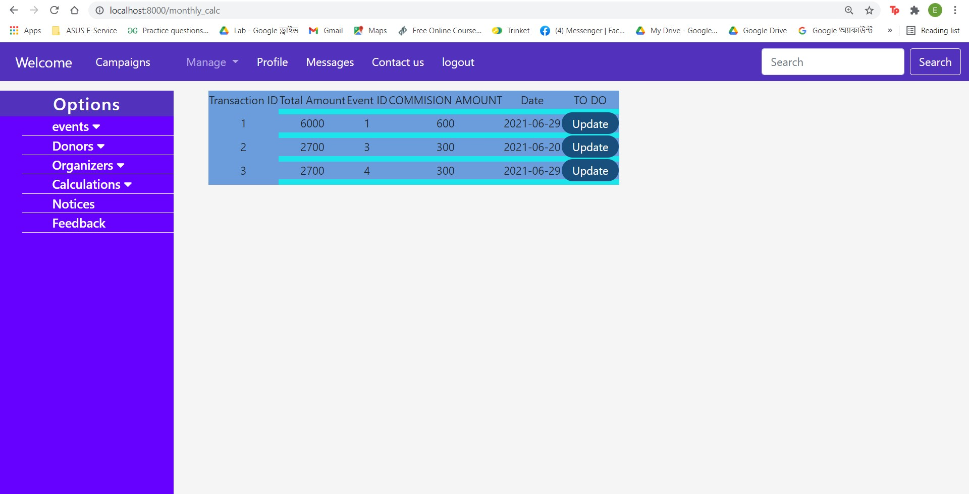

**M23F2:(Manager monthly calculation module):**

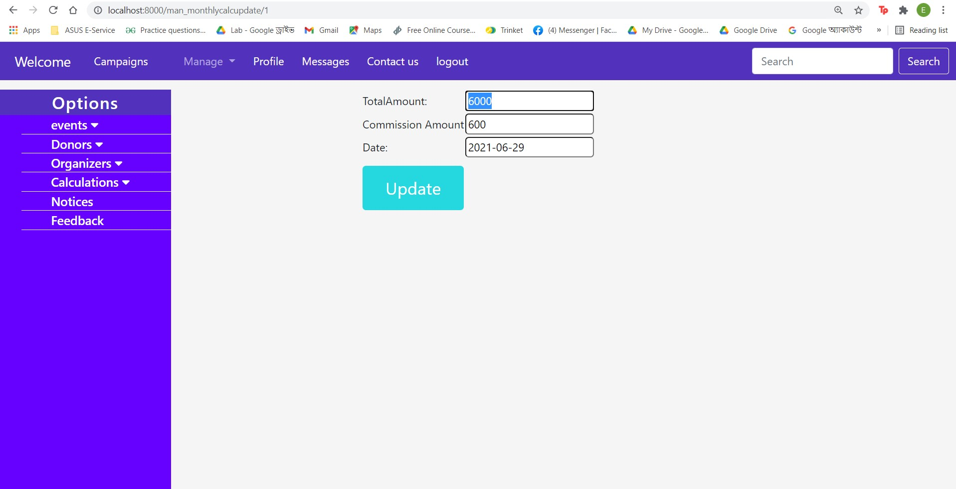

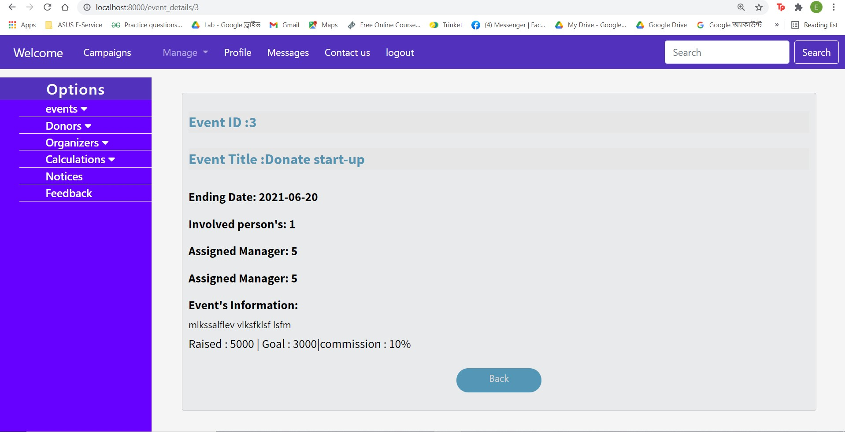

**M24F1:(Manager Annual calculation module):**

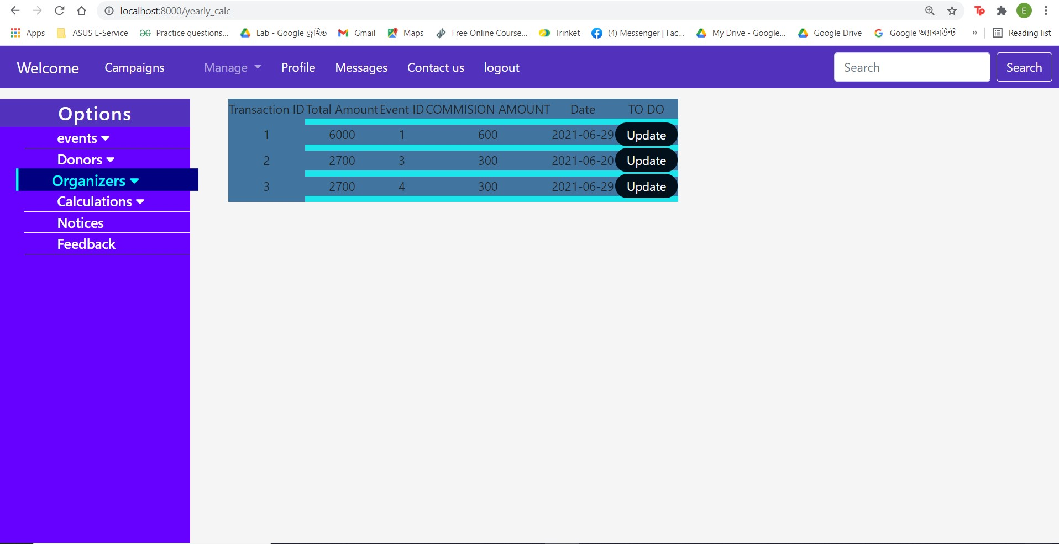

**M24F2:(Manager Annual calculation module):**

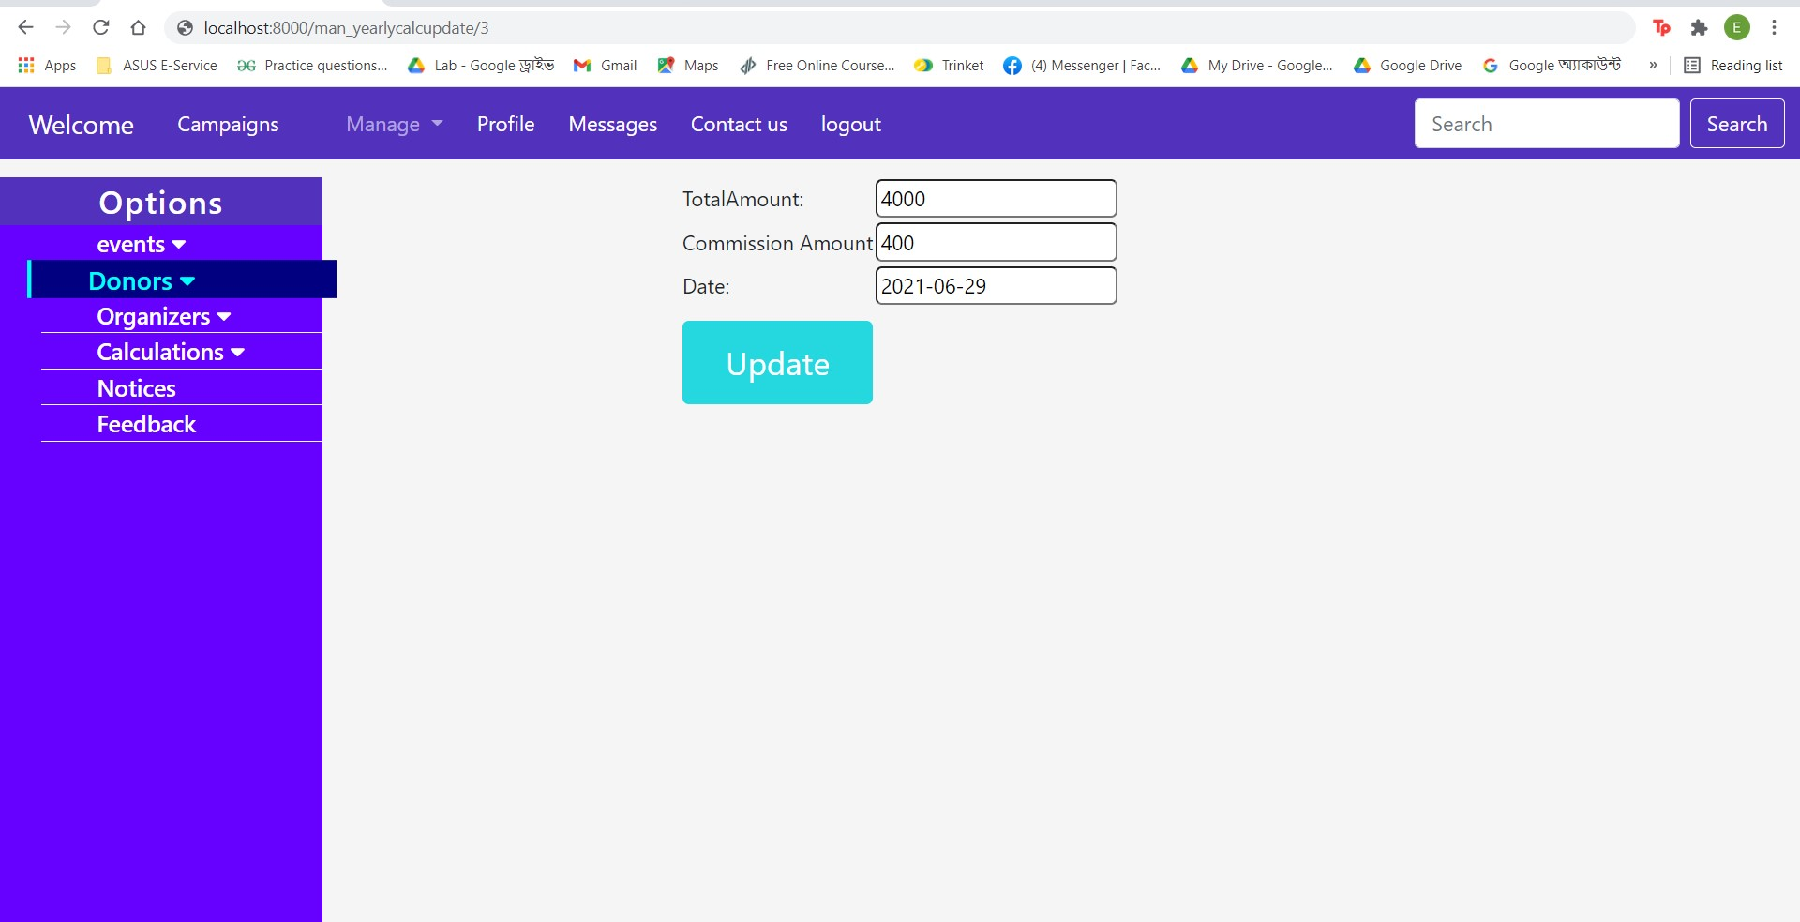

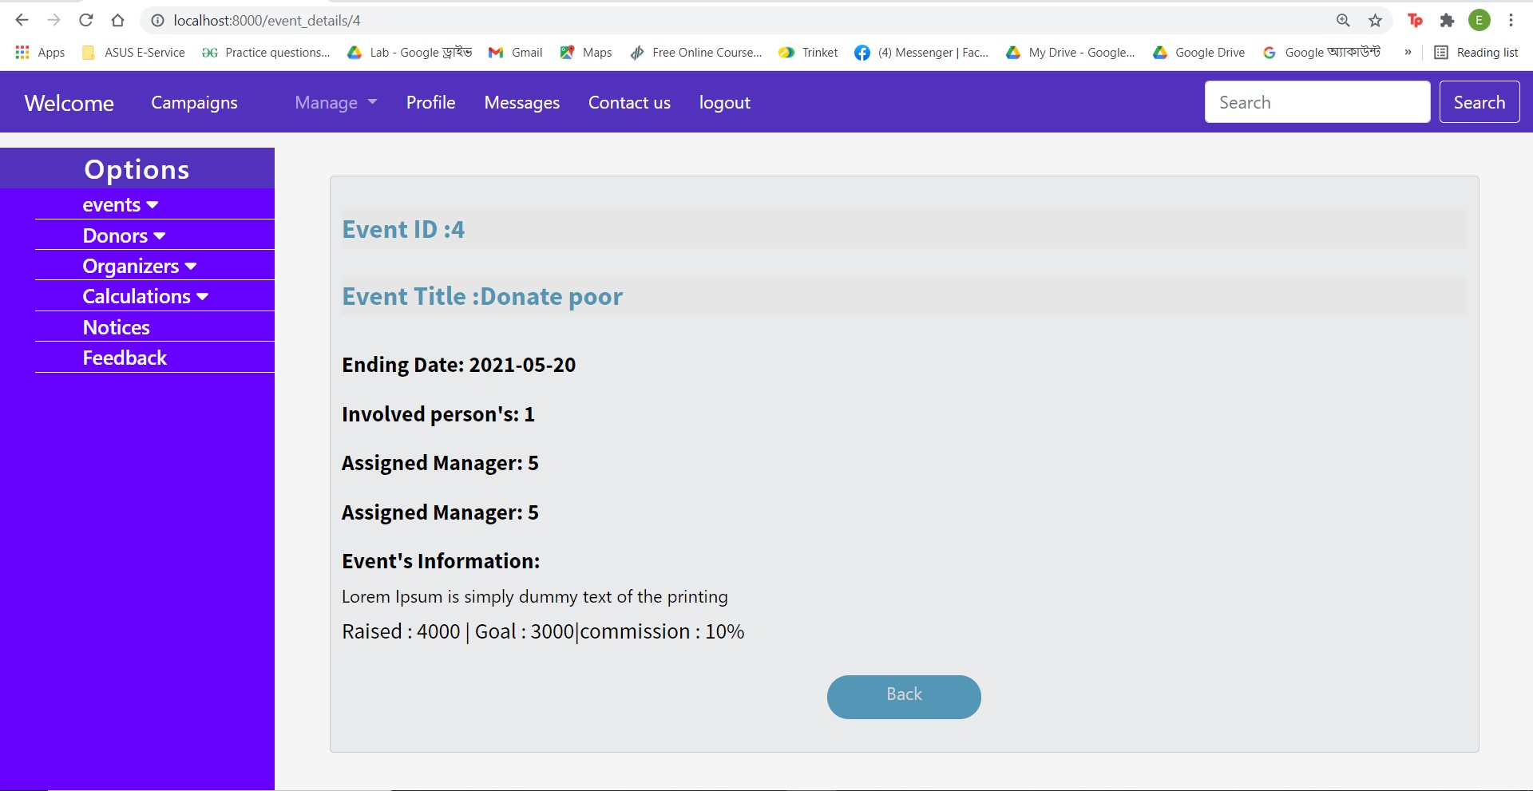

**M25F1:(Manager notices module):**

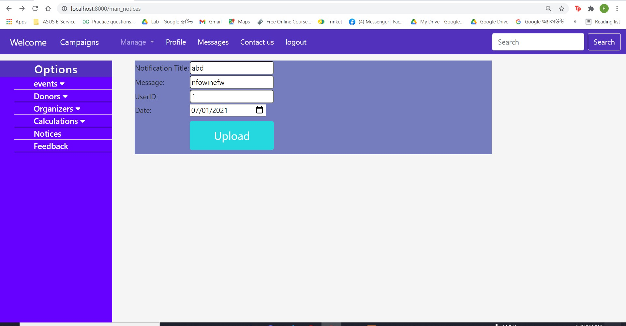

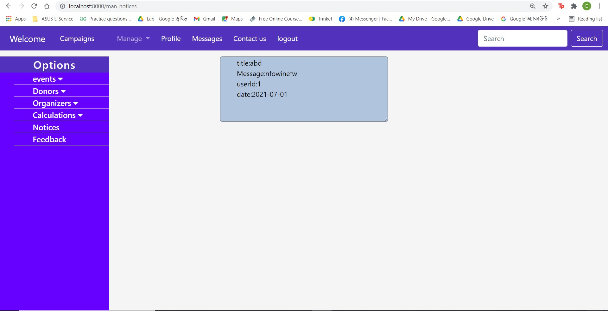

**M26F1:(Manager feedback module)**

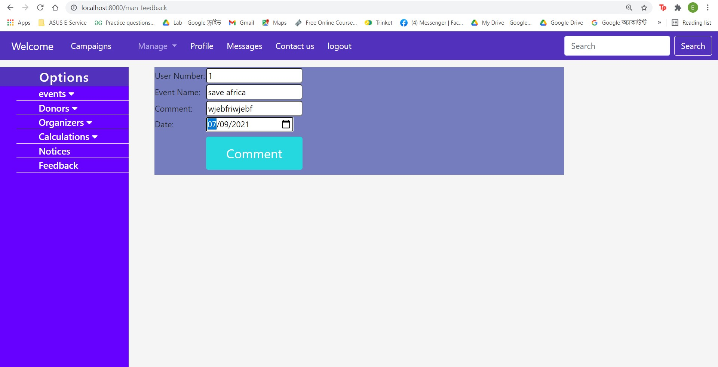

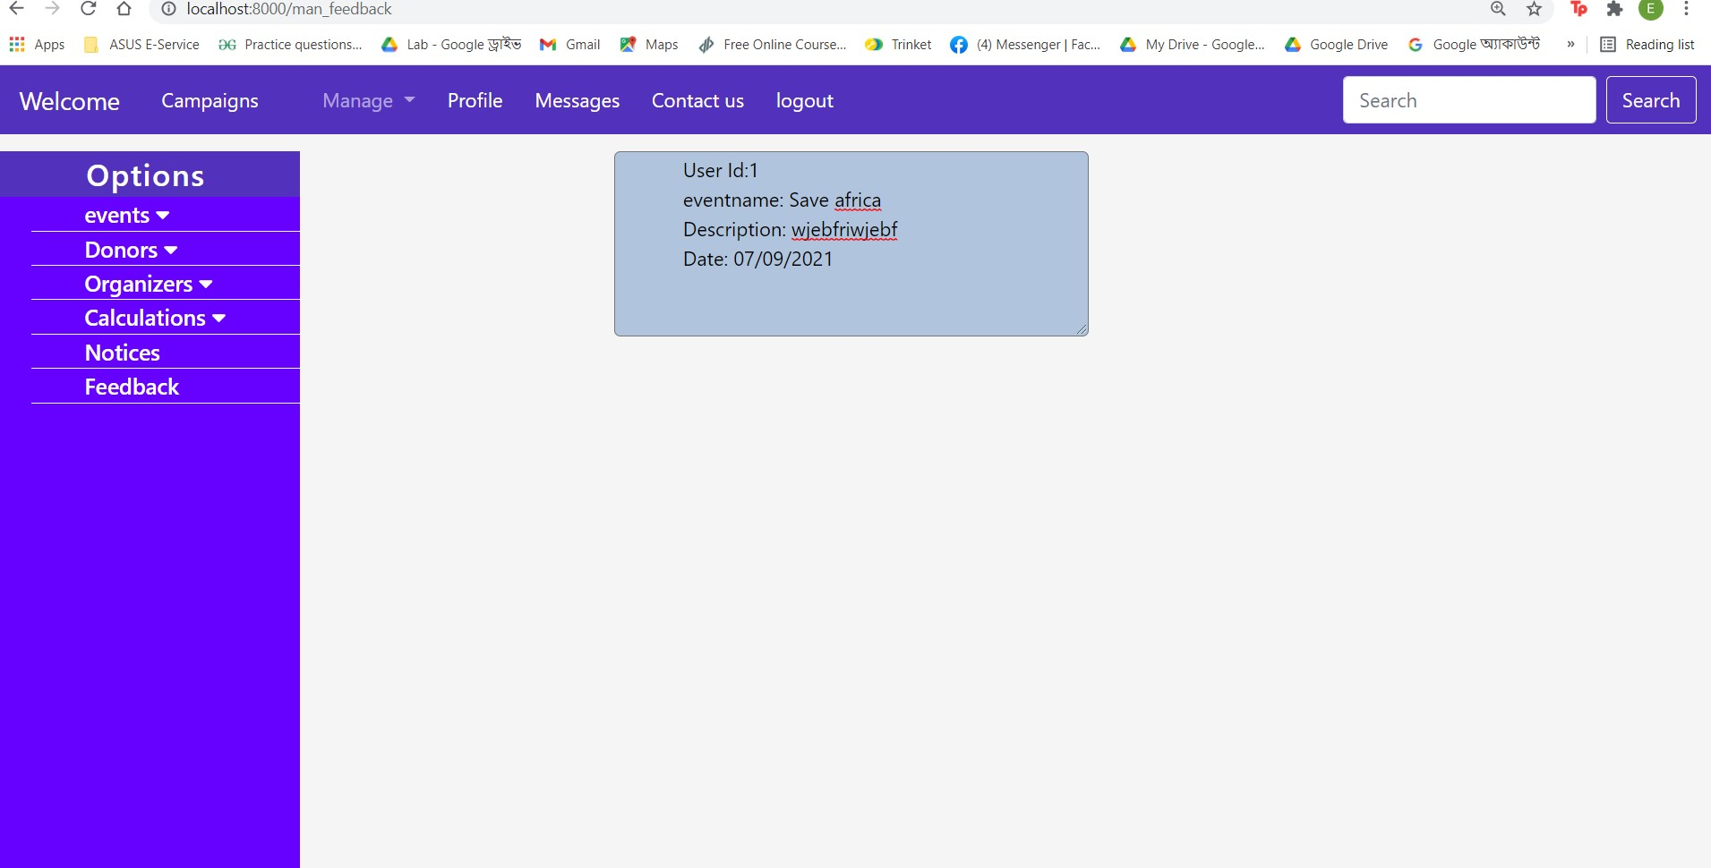

**M27F1:(Manager profile edit module) :**

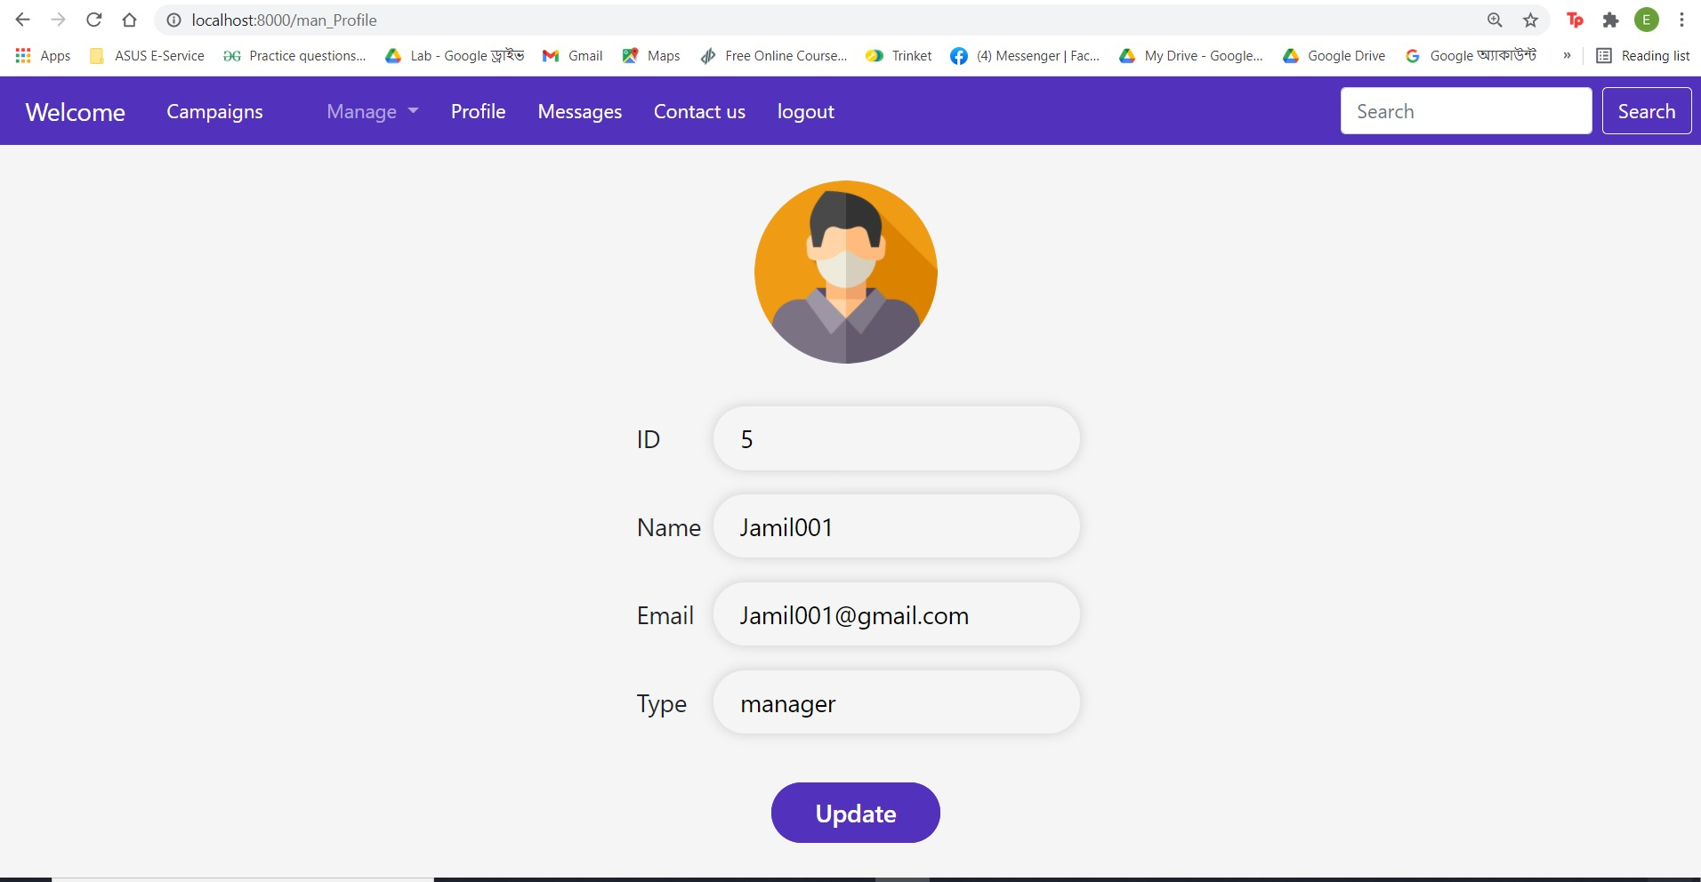

**M27F2:(Manager profile edit module) :**

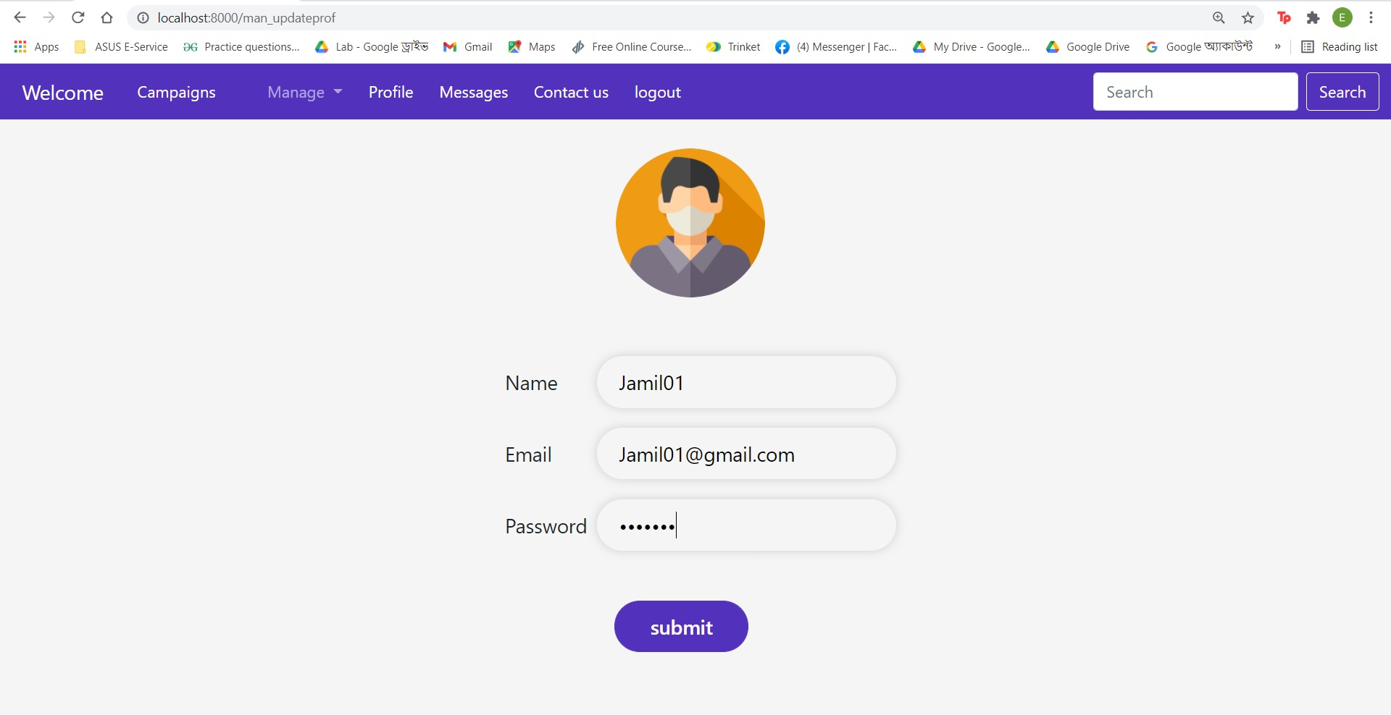

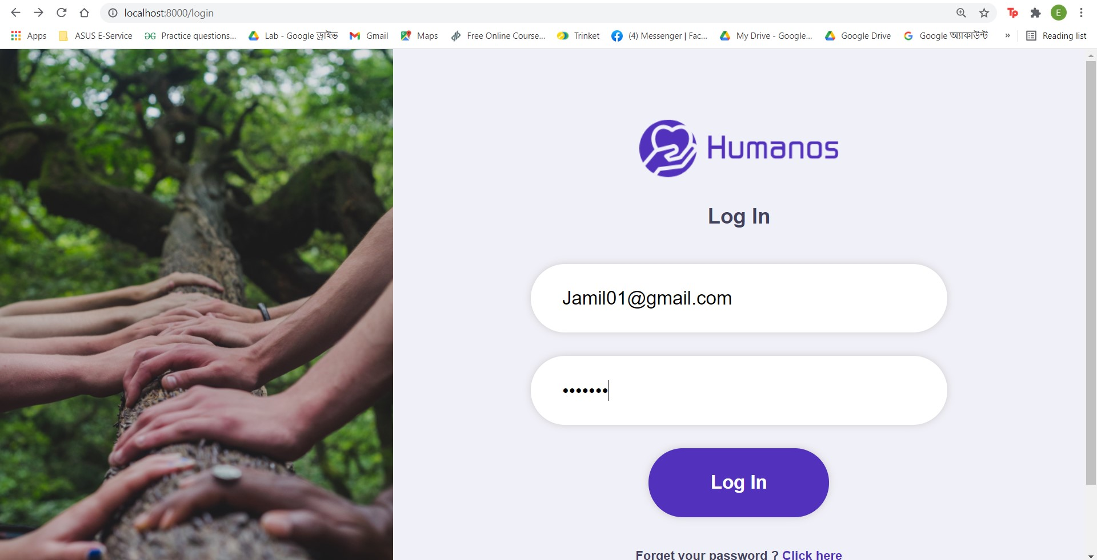

**Admin Dashboard:**

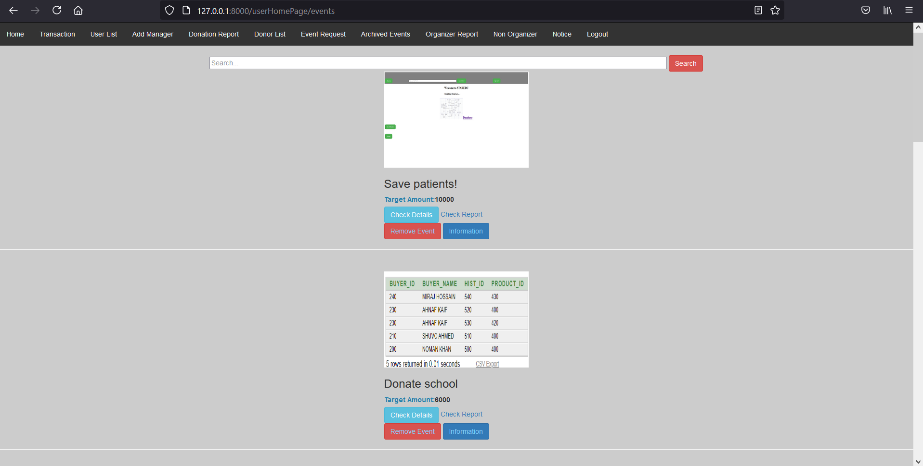

**M28F1: Manager Sign-up done by Admin Module (M28) :  
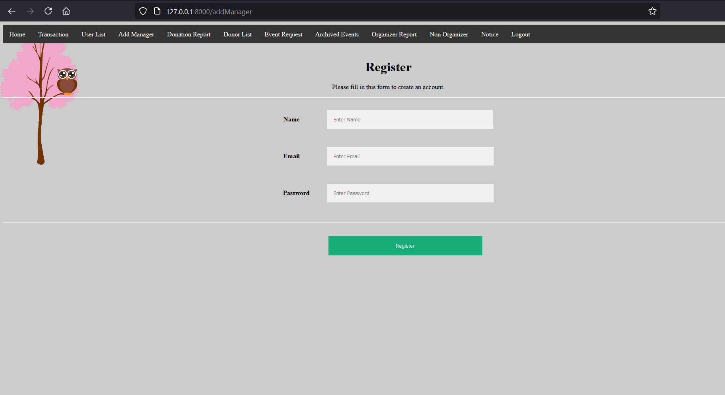**

**M28F3: Manager Sign-up done by Admin Module (M28) :**

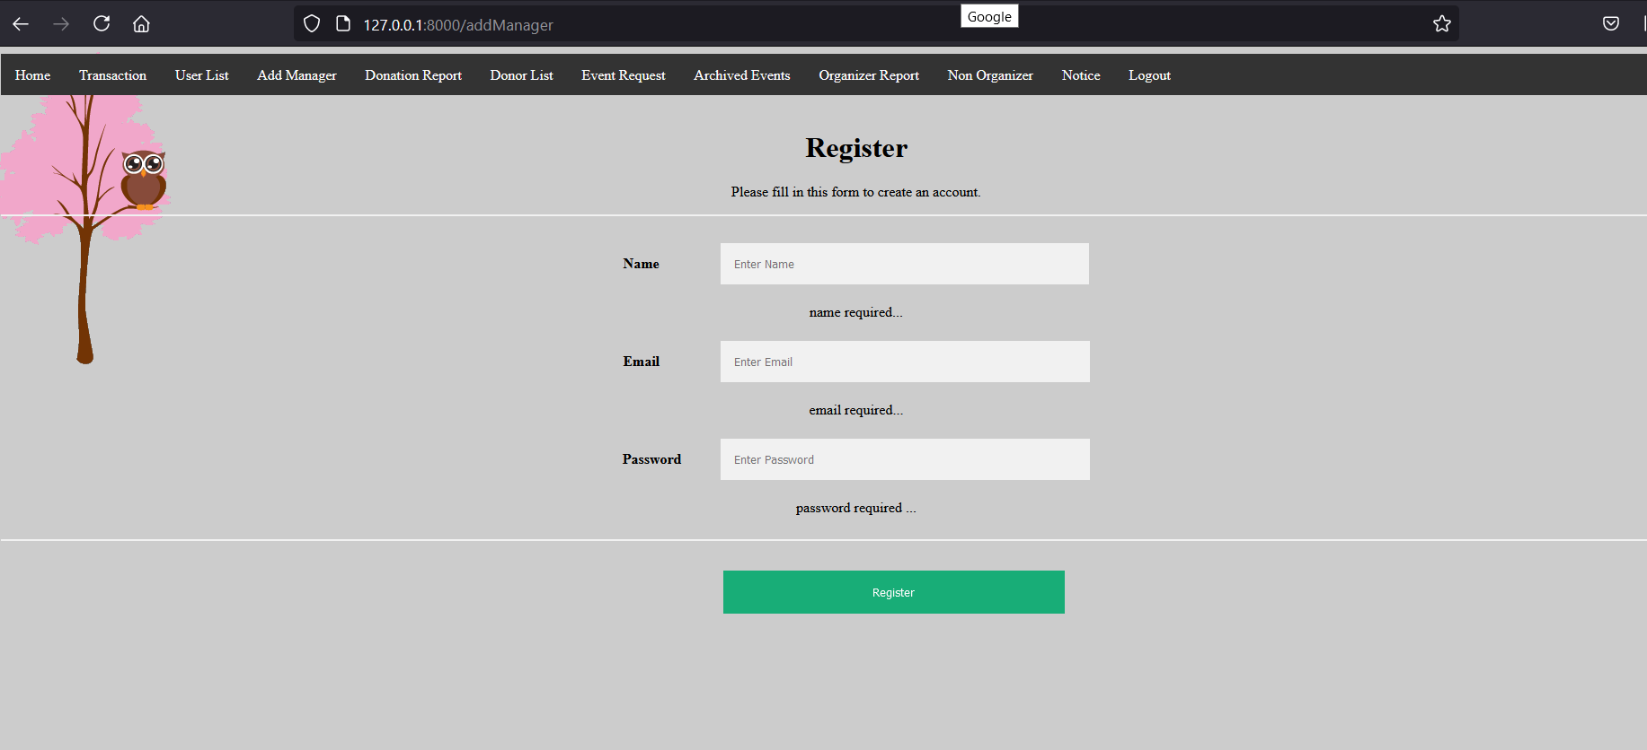

**M28F4: Manager Sign-up done by Admin Module (M28) :**

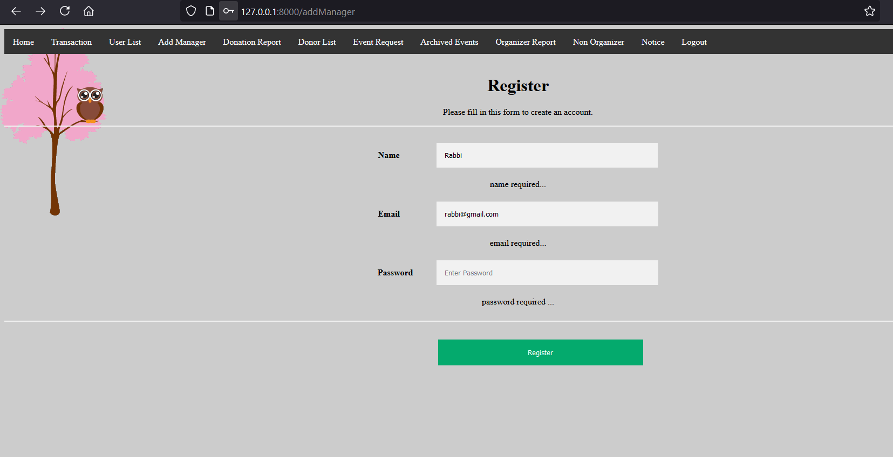

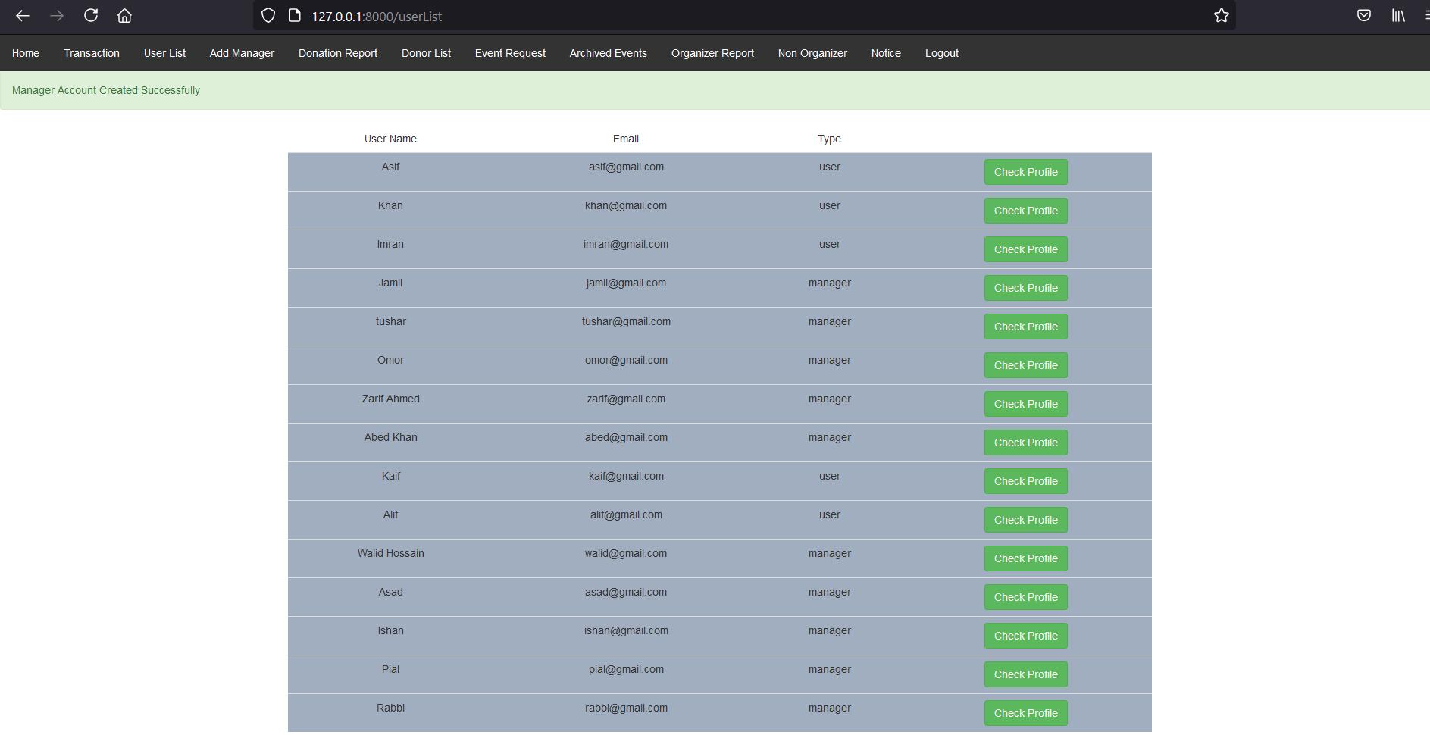

**M29F2: Transaction Report(M29) :**

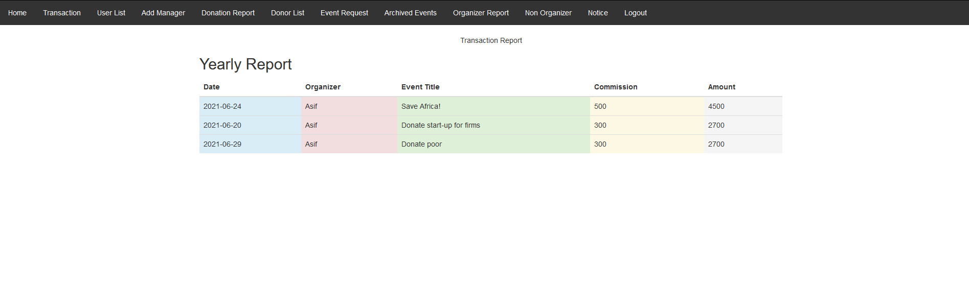

**M30F2: User List (M30) :**

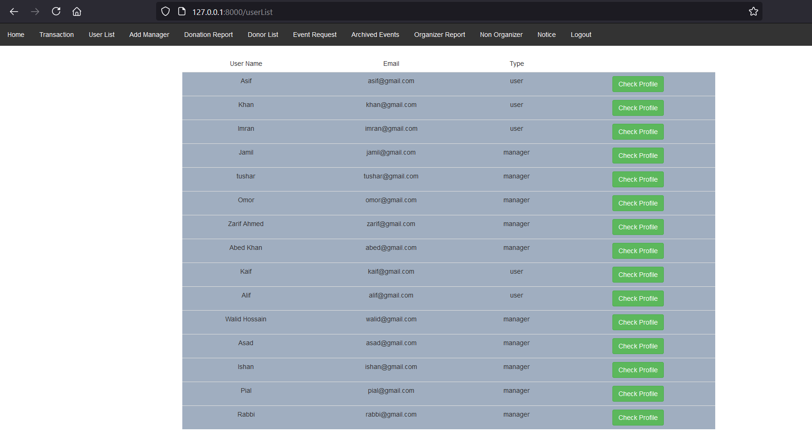

**M31F1: Check user Profile and Change User Status (M31) :**

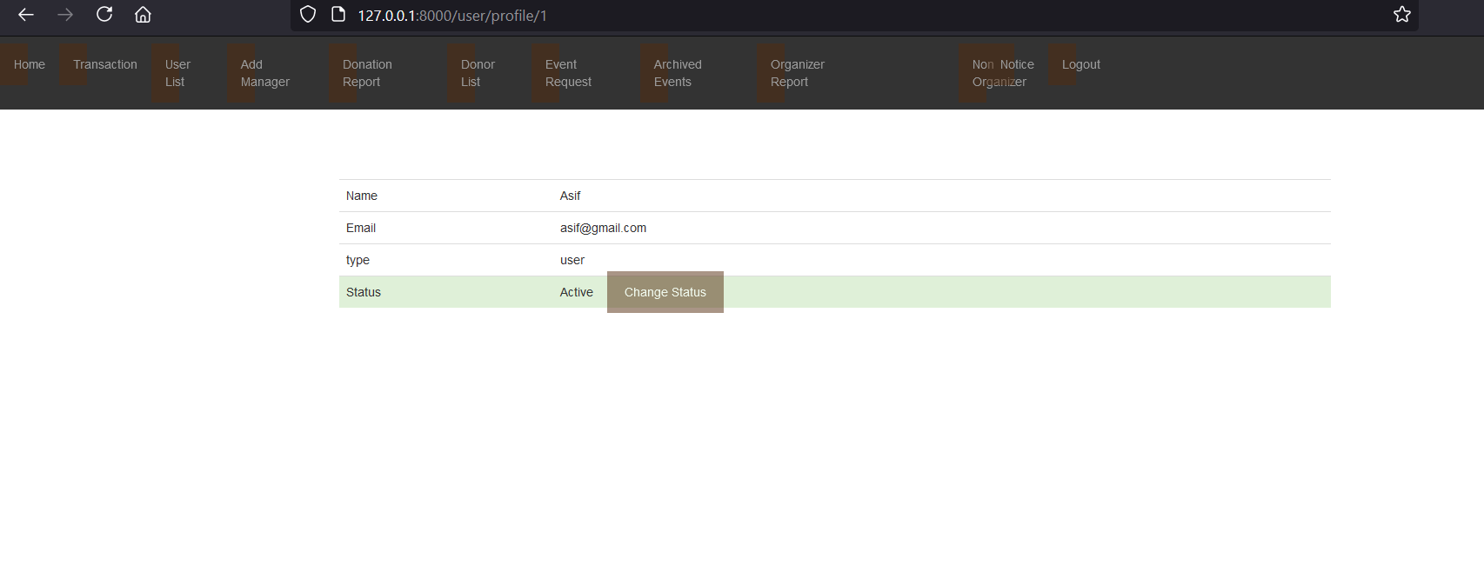

**M31F2: Check user Profile and Change User Status (M31) :**

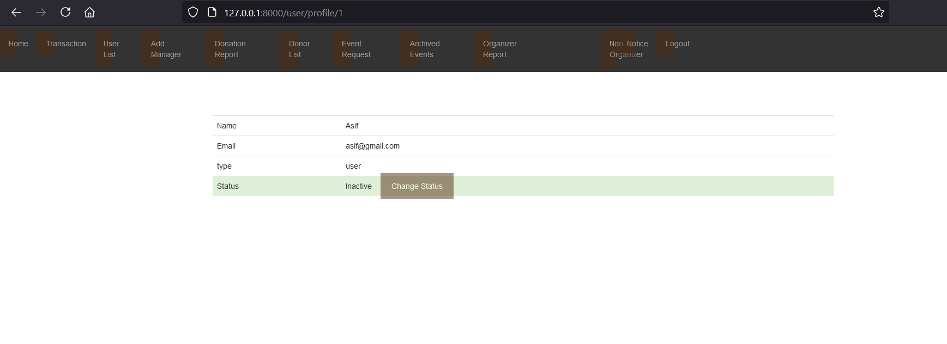

**M32F2: Donation Report (M32) :**

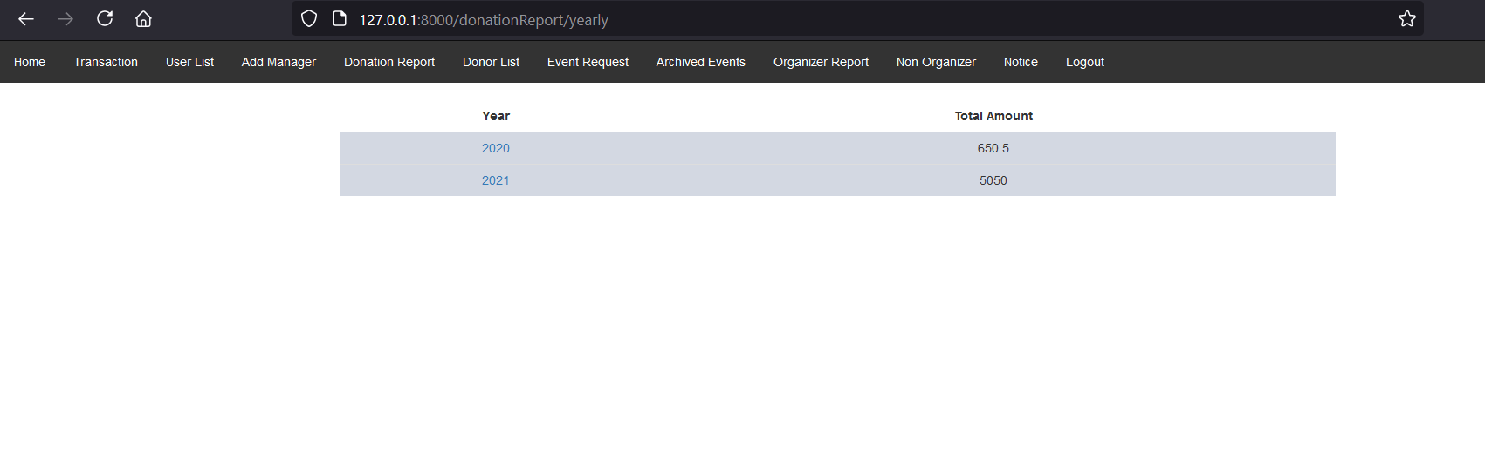

**M32F3: Donation Report (M32) :**

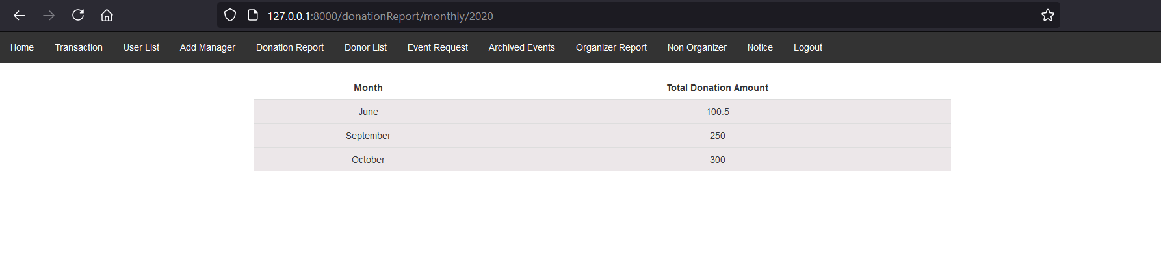

**M32F2: Donor List (M33) :**

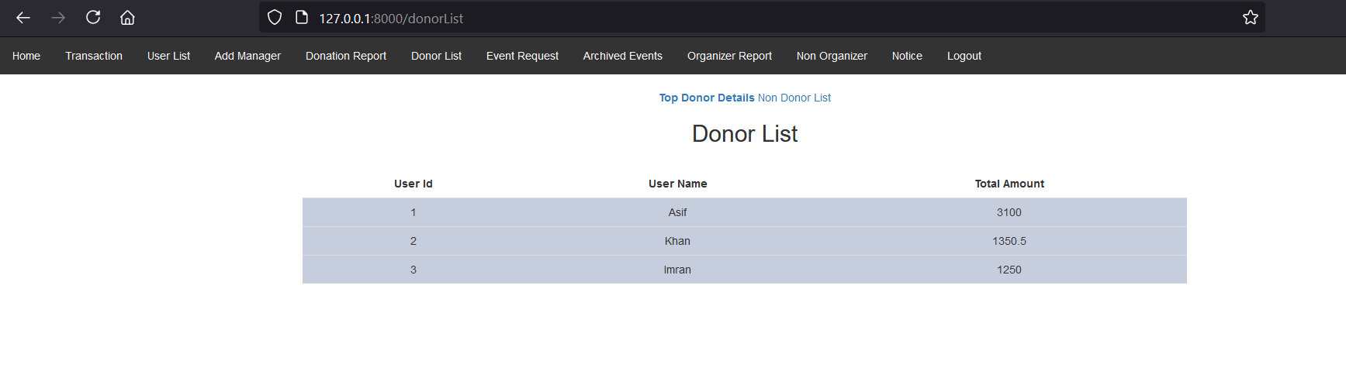

**M34F1:Top Donor Details (M34) :**

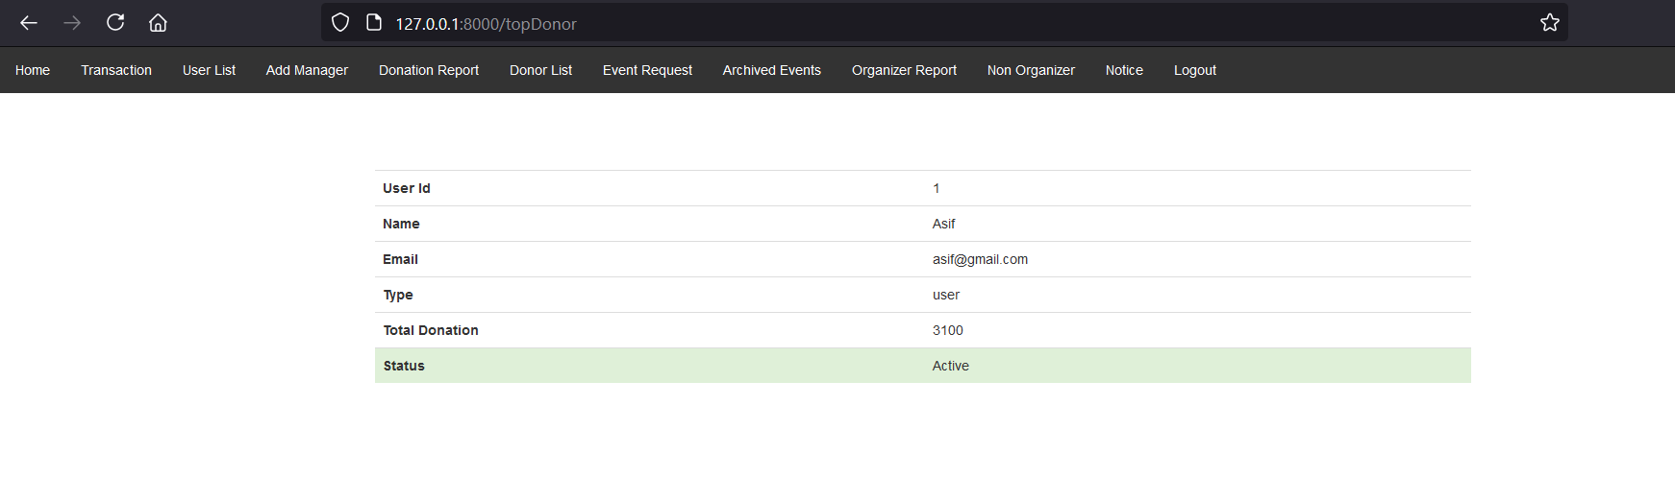

**Non Donors (M35) :**

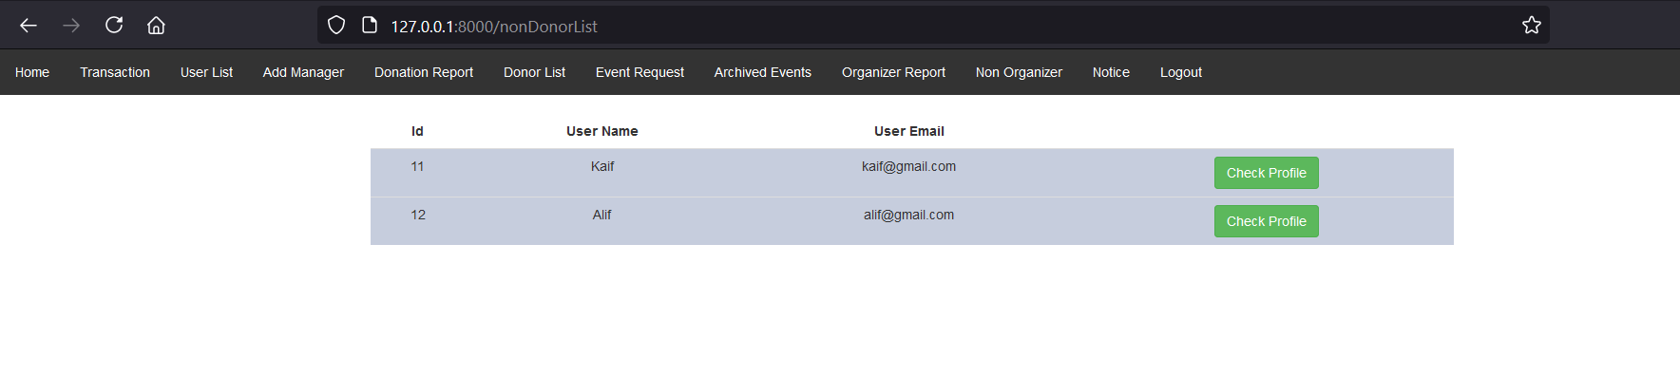

**M36F2: Organizer list (M36) :  
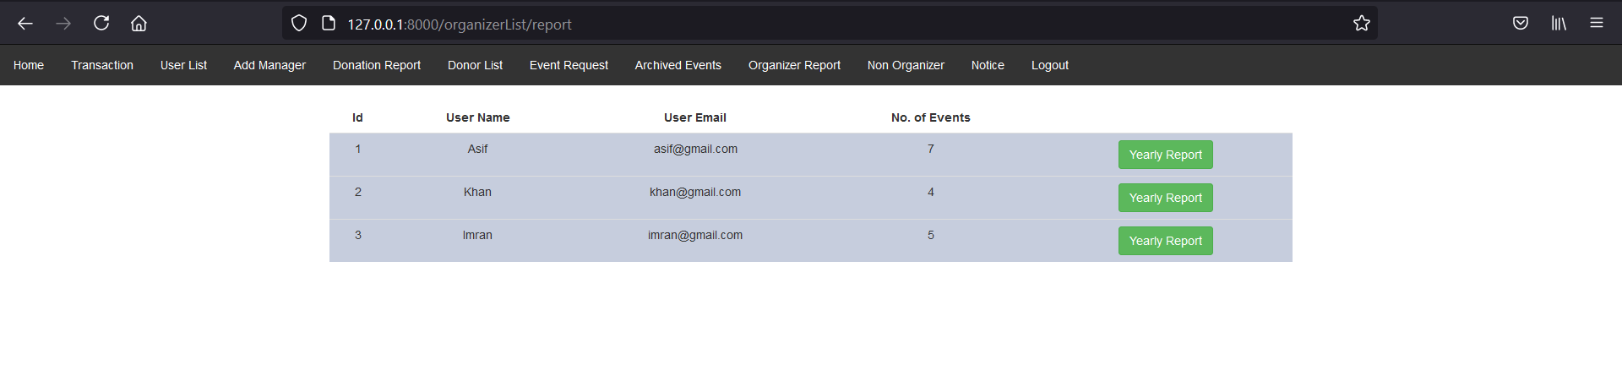**

**M36F4: Organizer list (M36) :**

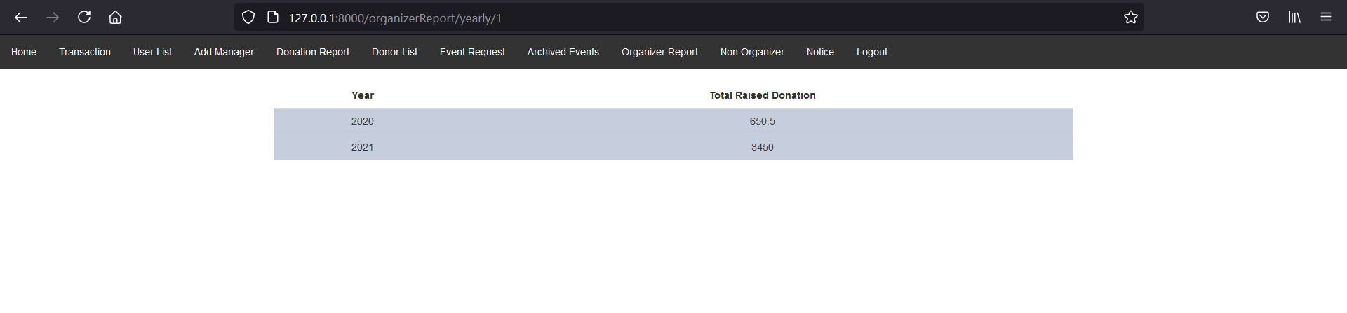

**M37F2: Non Organizer (M37) :  
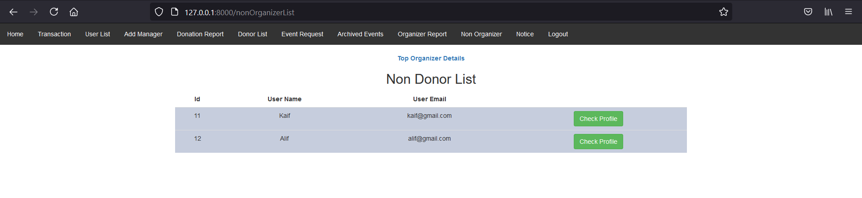**

**Top Organizer Details (M38) :**

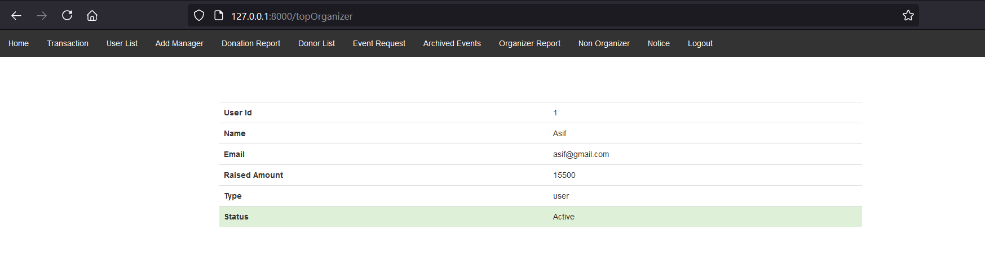

**M39F2: Notification (M39) :**

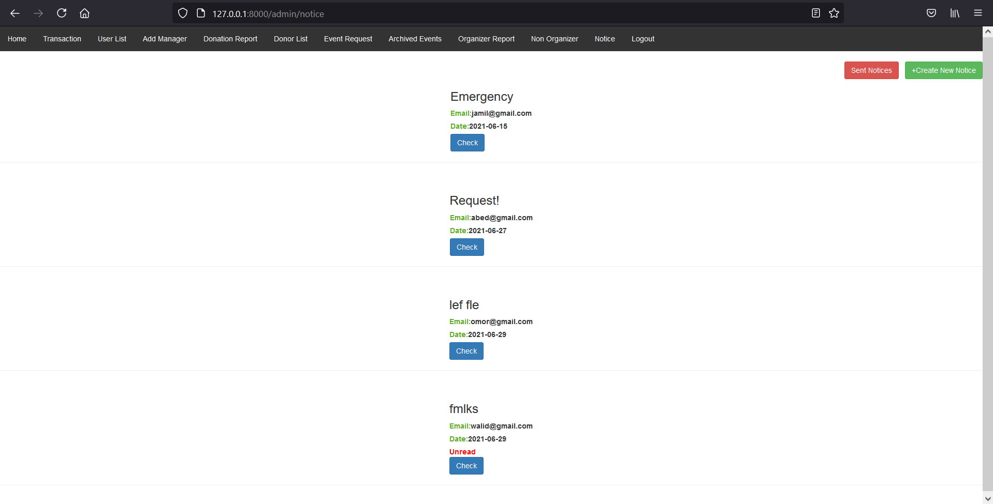

**M39F3: Notification (M39) :**

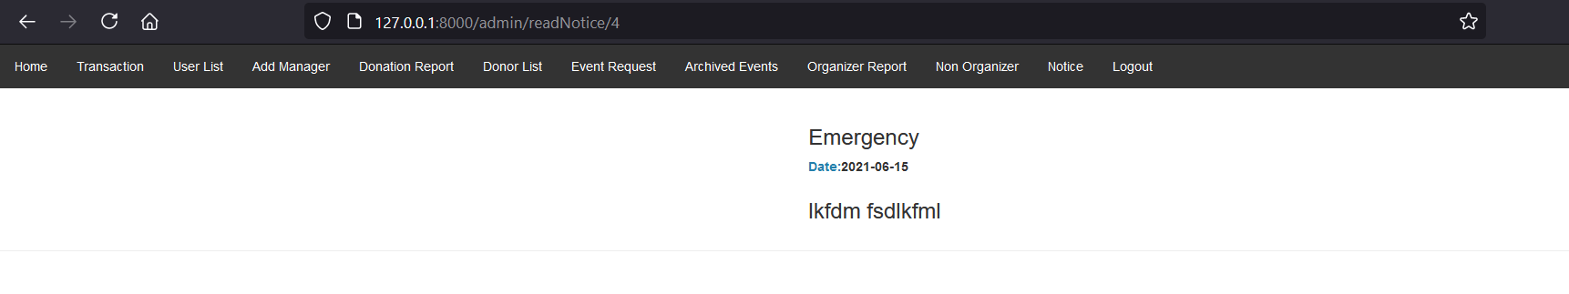

**M40F2: Sent Notification (M40) :**

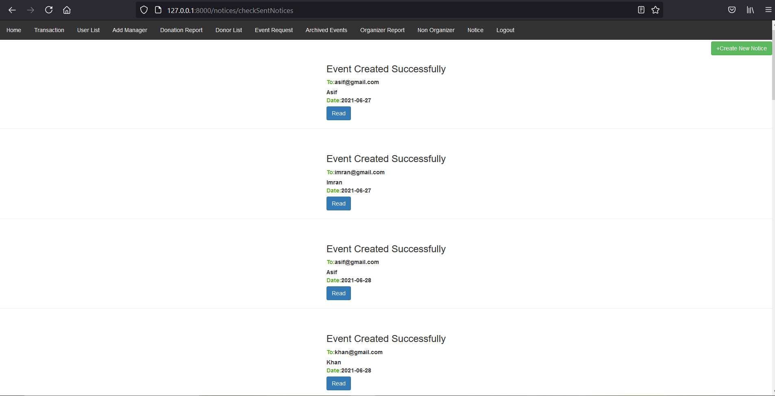

**M40F3: Sent Notification (M40) :**

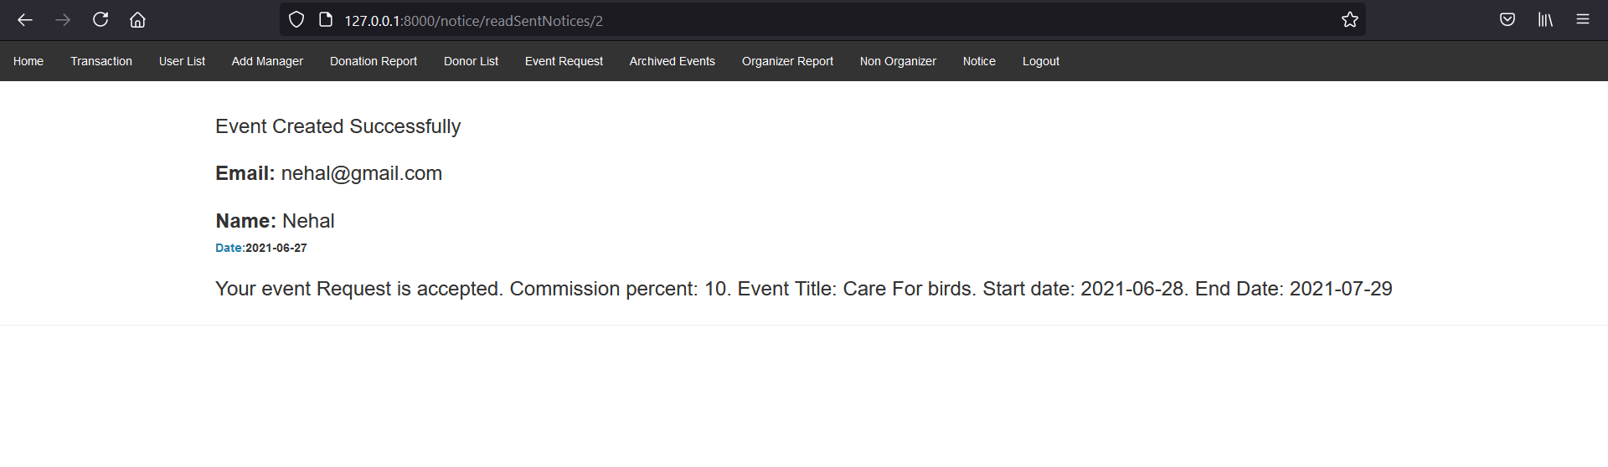

**M41F2: Create New Notification (M41) :**

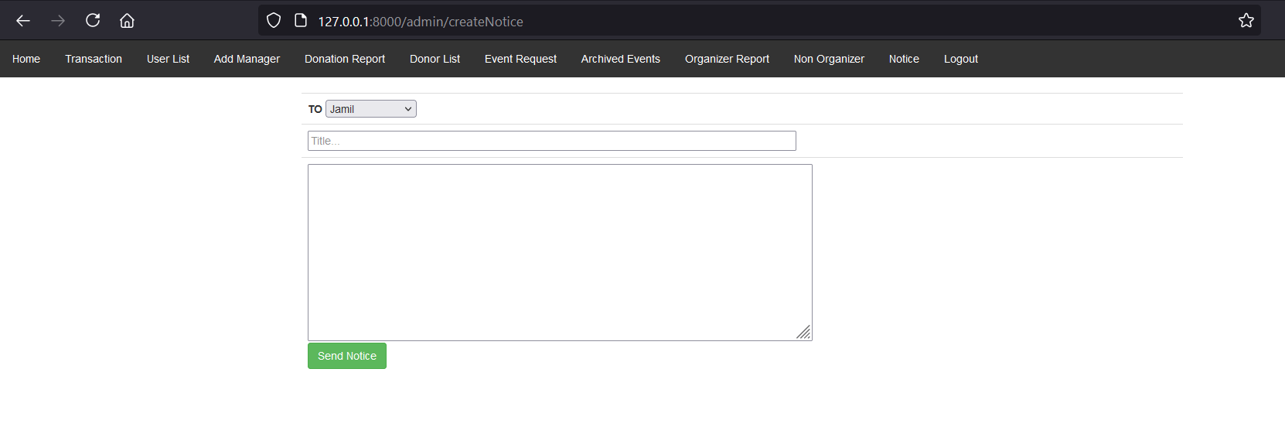

**M41F3: Create New Notification (M41) :**

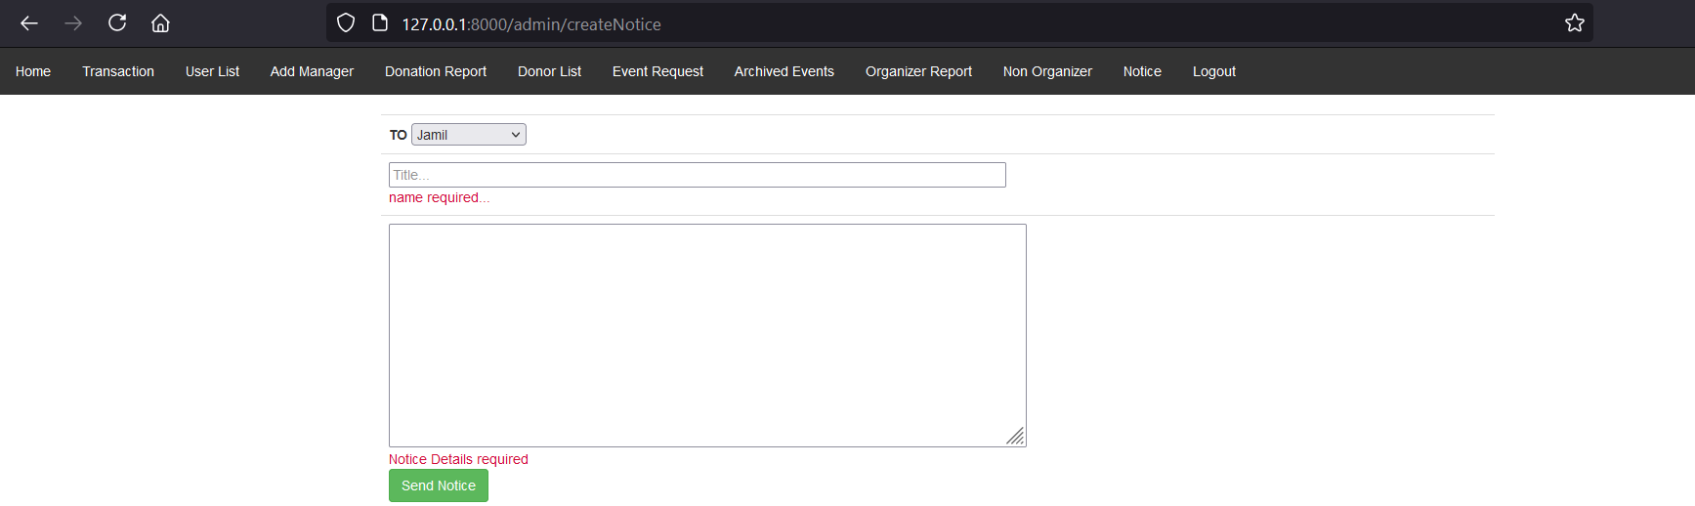

**M41F4: Create New Notification (M41) :**

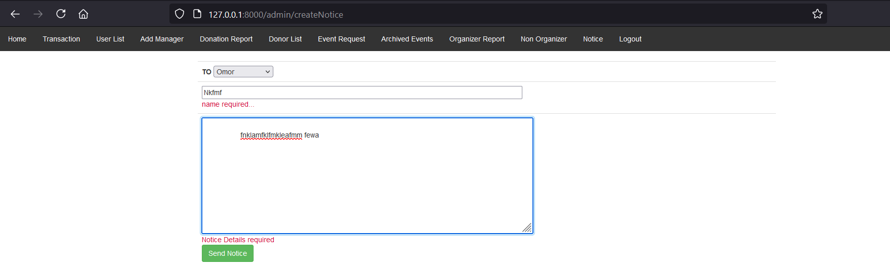

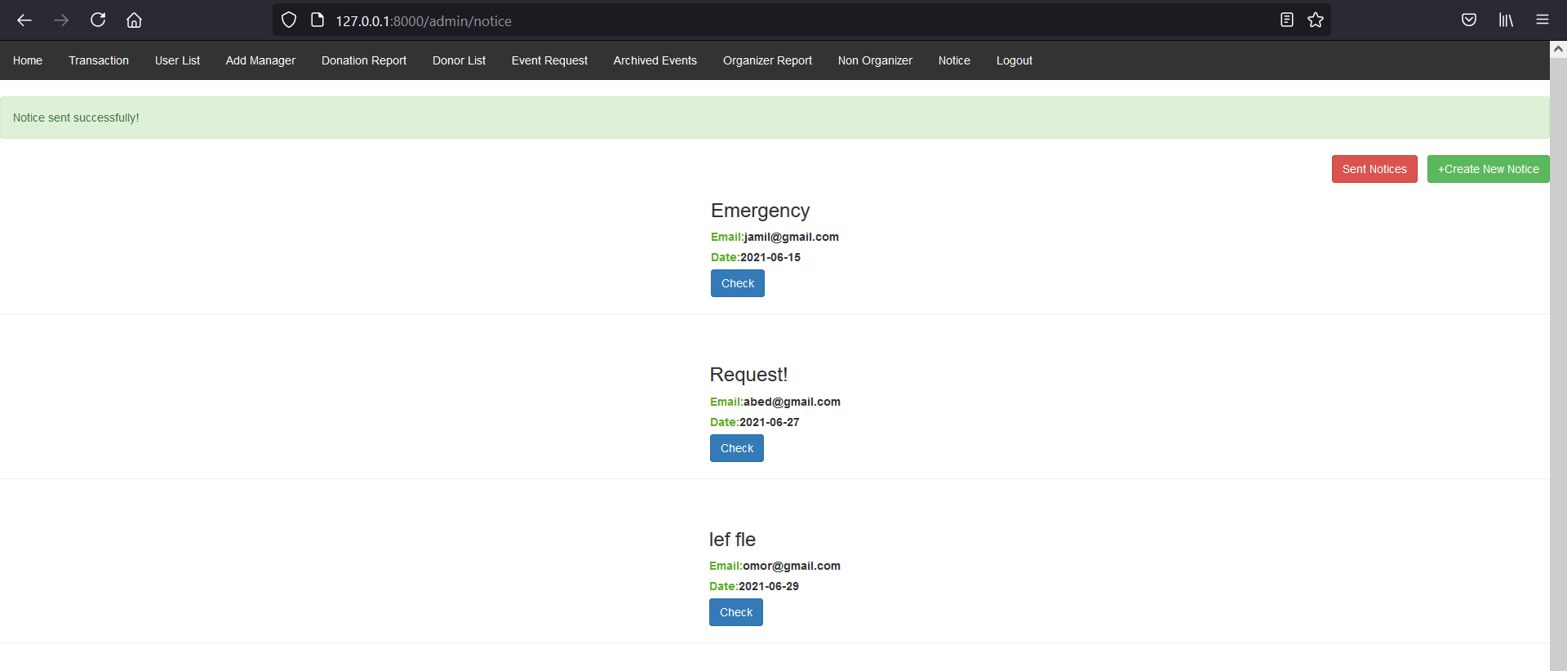

**Event Search (M42) :**

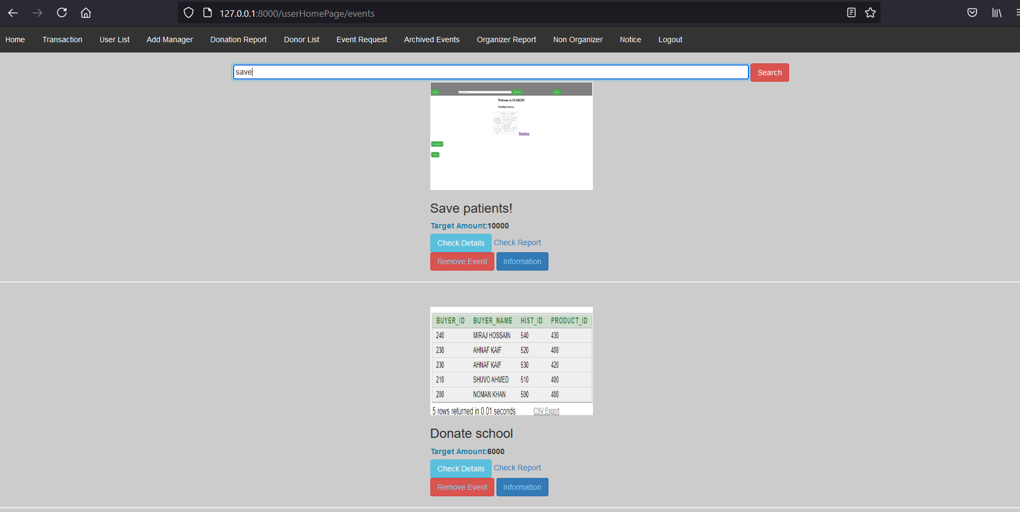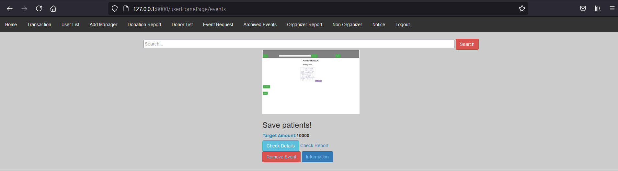

**M434F4: Event details and Report (M43) :  
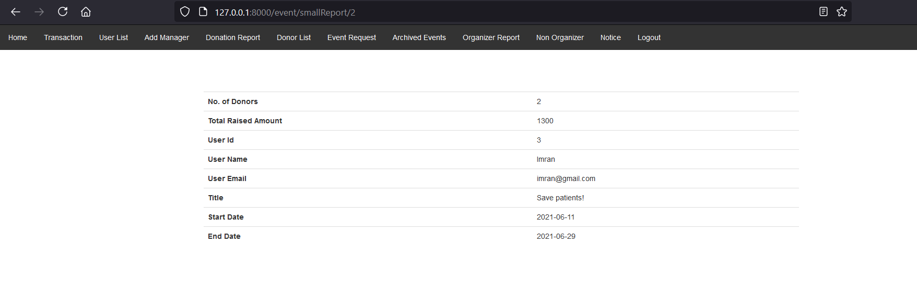**

**M44F2: Remove Comment (M44) :  
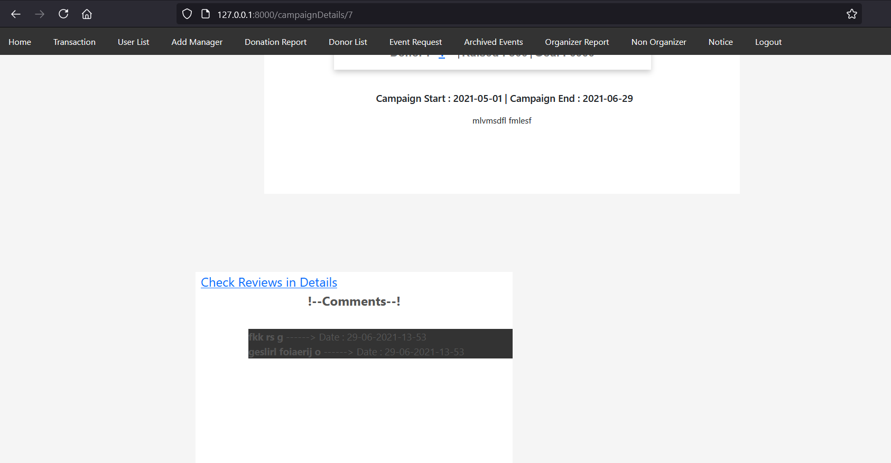**

**M44F3: Remove Comment (M44) :**

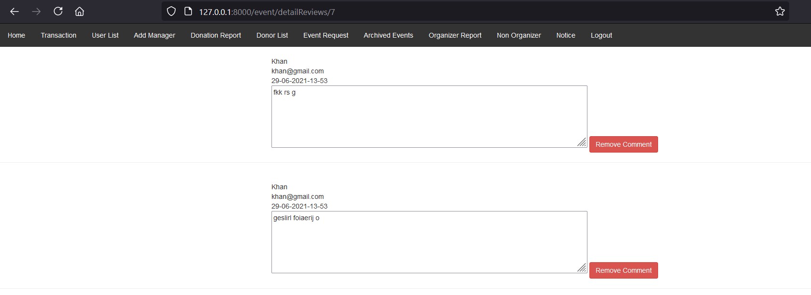

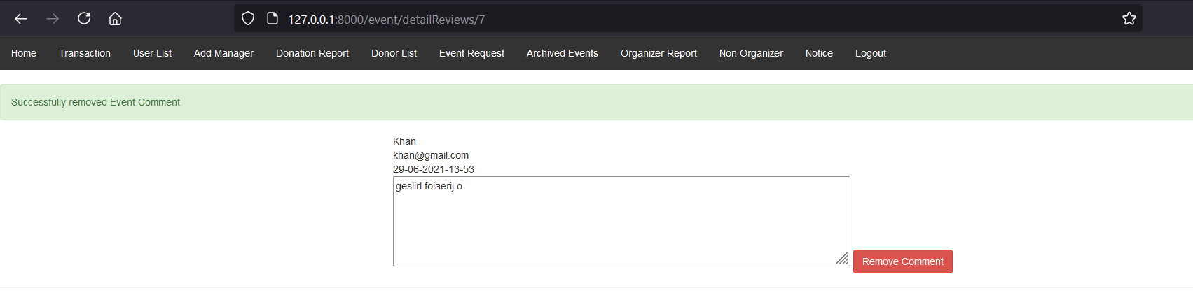

**M45F2: Archived Event (M45) :  
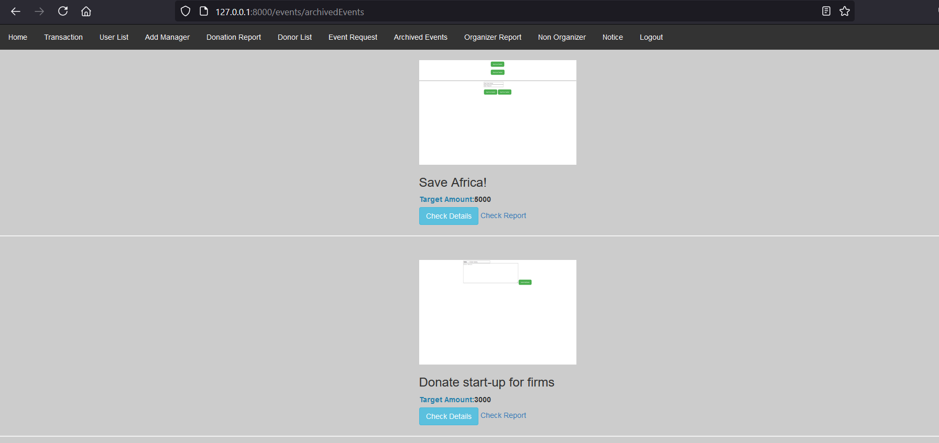**

**M46F2:Approve Event (M46) :  
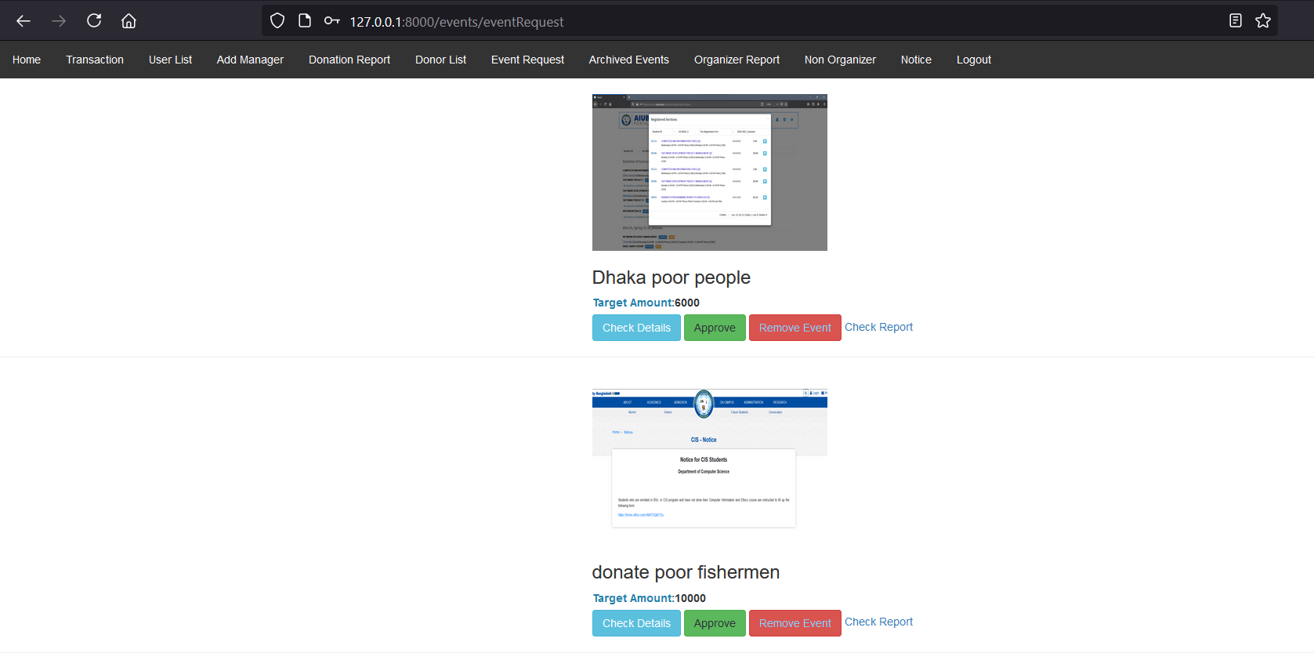**

**M46F4:Approve Event (M46) :**

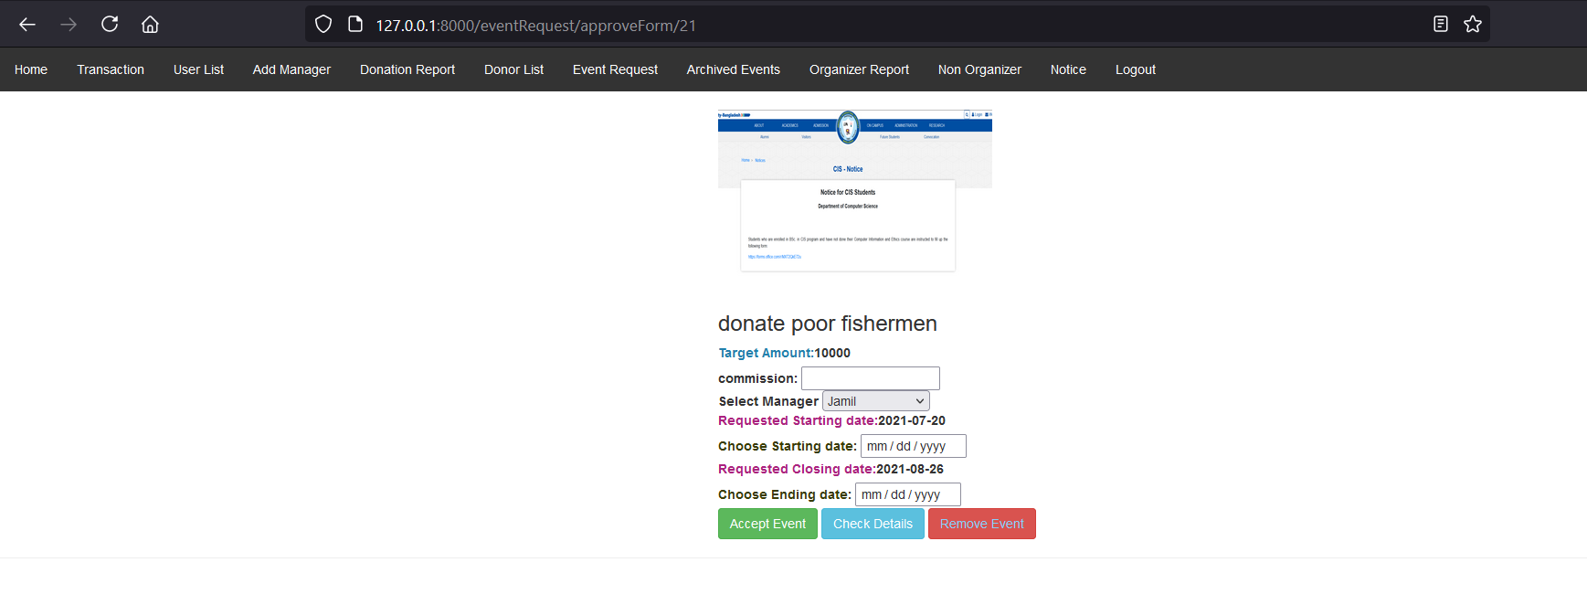

**M46F5:Approve Event (M46) :**

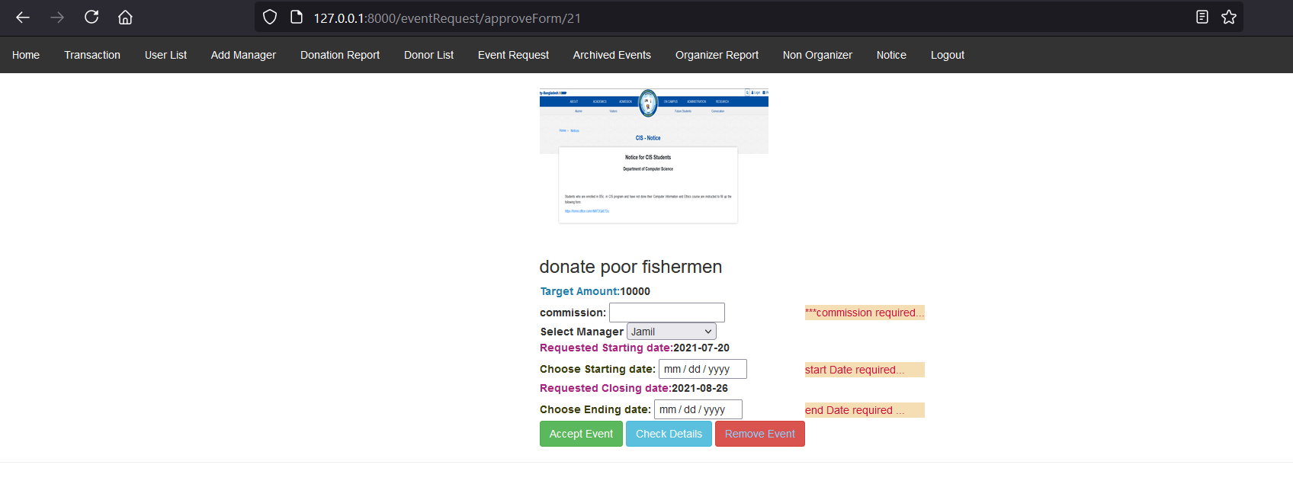

**M46F6:Approve Event (M46) :**

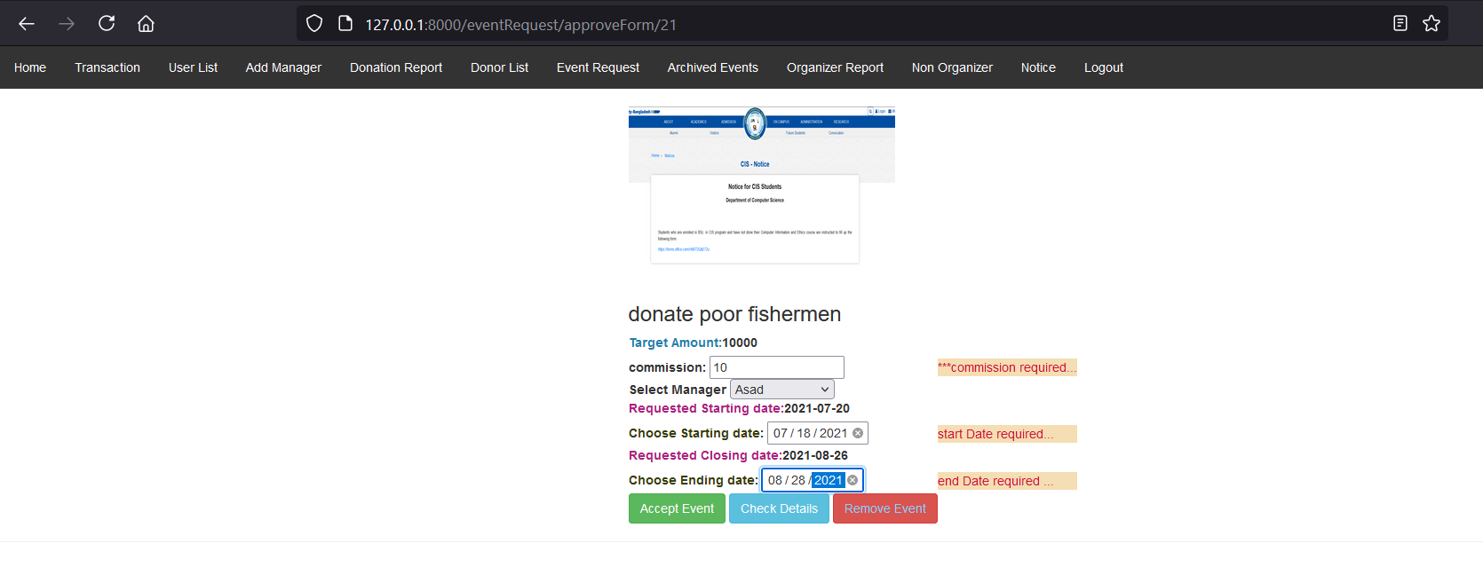

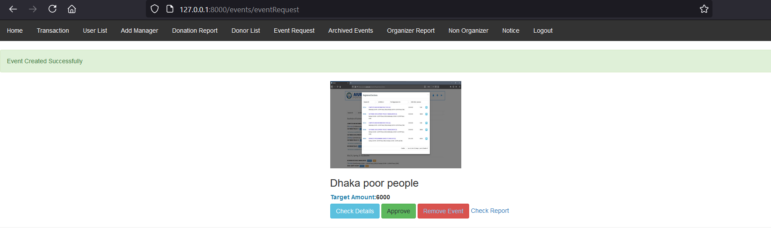

**M47F2: Remove Event (M47) :  
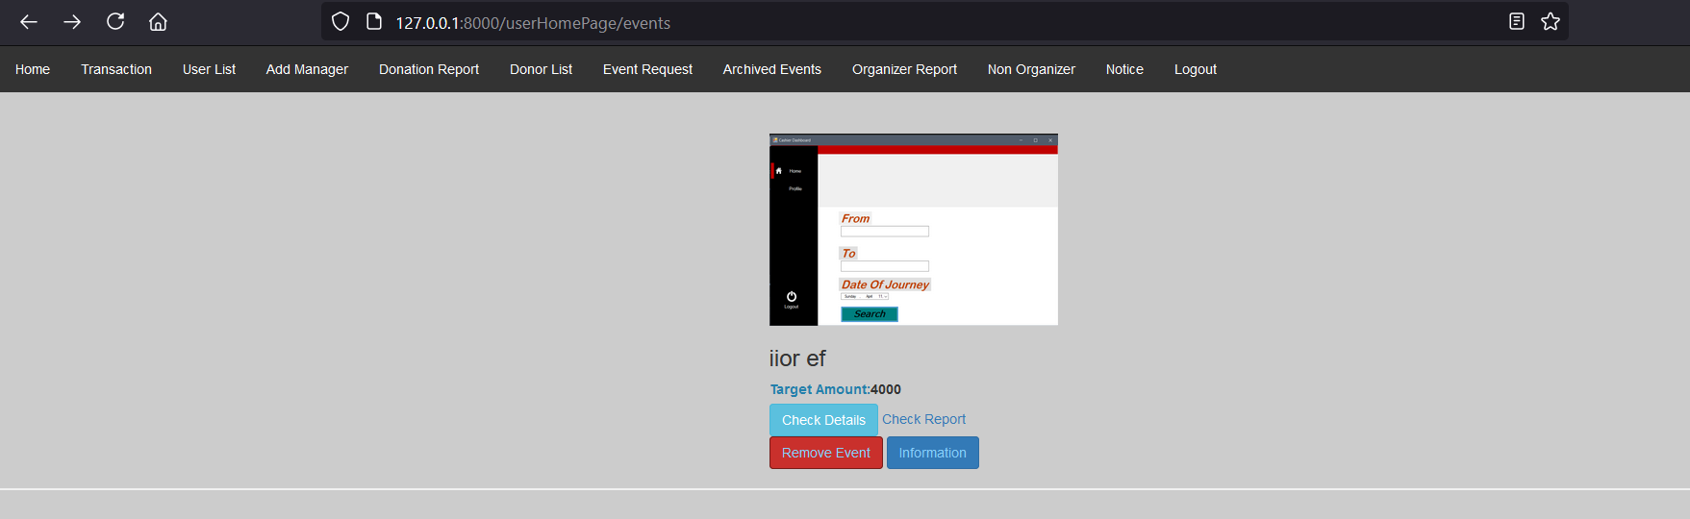**

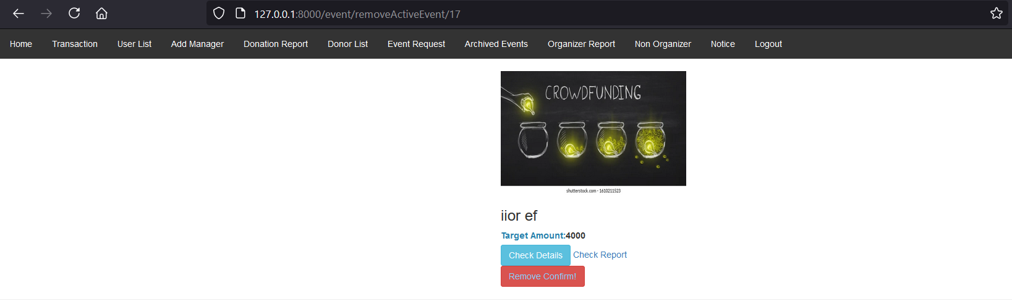

**M47F3: Remove Event (M47) :**

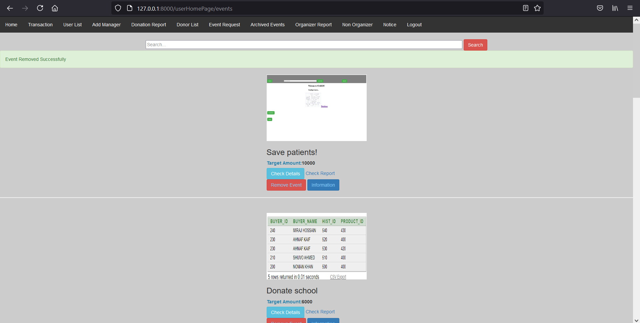

**M48F1: Update Event by assigning Manager(M48)**

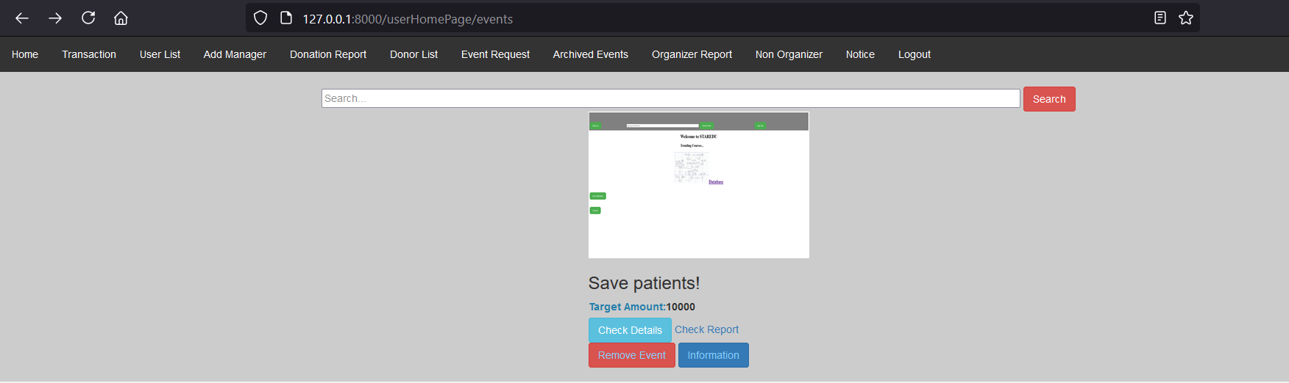

**M48F2: Update Event by assigning Manager(M48) :**

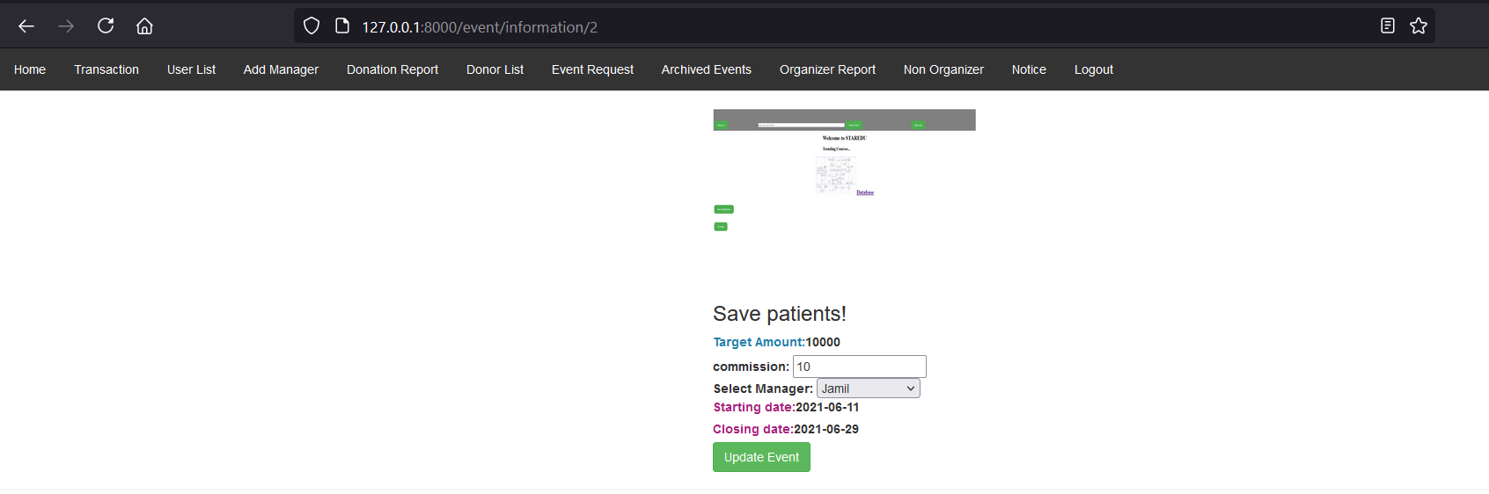

**M48F3: Update Event by assigning Manager(M48)**

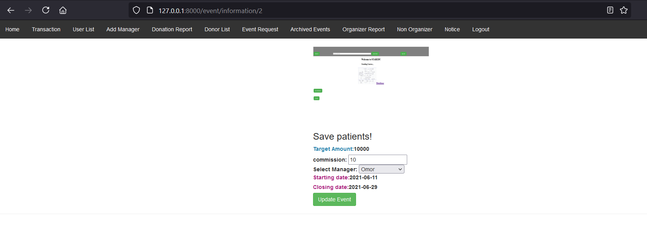

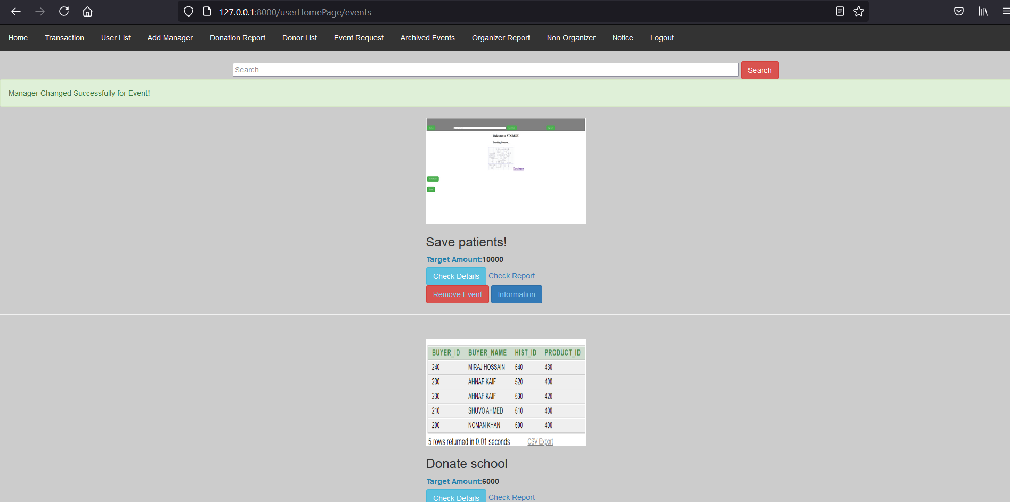

**M50: Donor Dashboard Module**

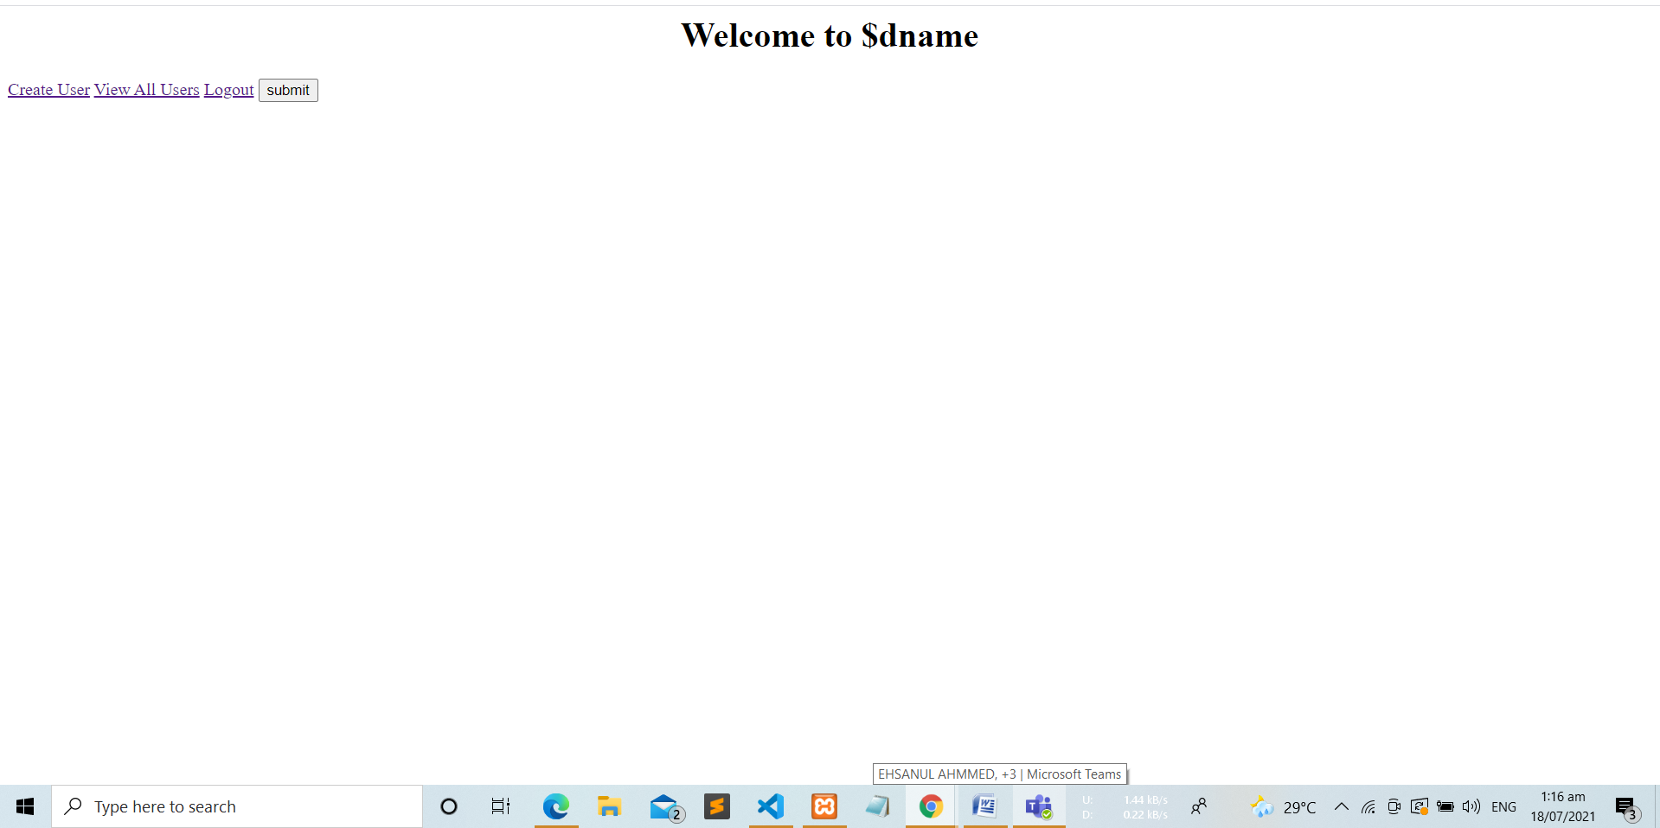

**M51: Modify Profile Information Module**

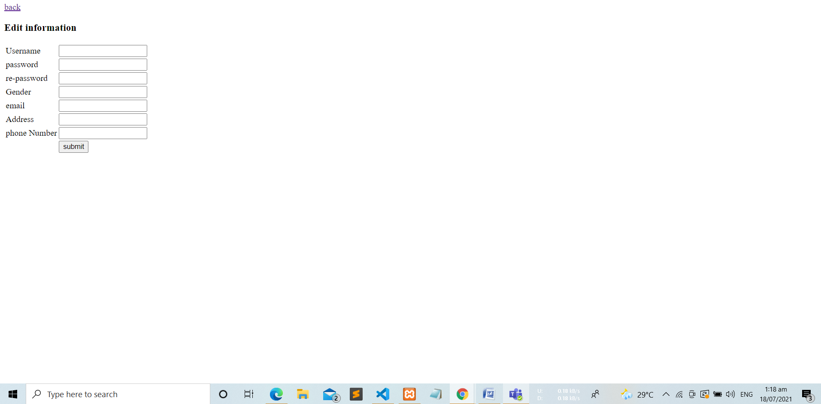

**M53:Doner Information Delete**

